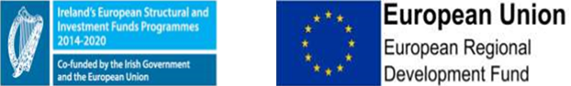

Grant funding of €1.1m has been made available from the European Regional Development Fund for Dun Laoghaire Baths Project under the Designated Urban Centre Grant Scheme (DUCGS).

