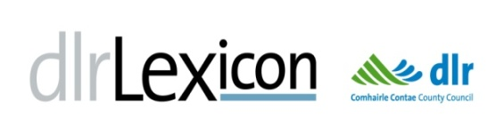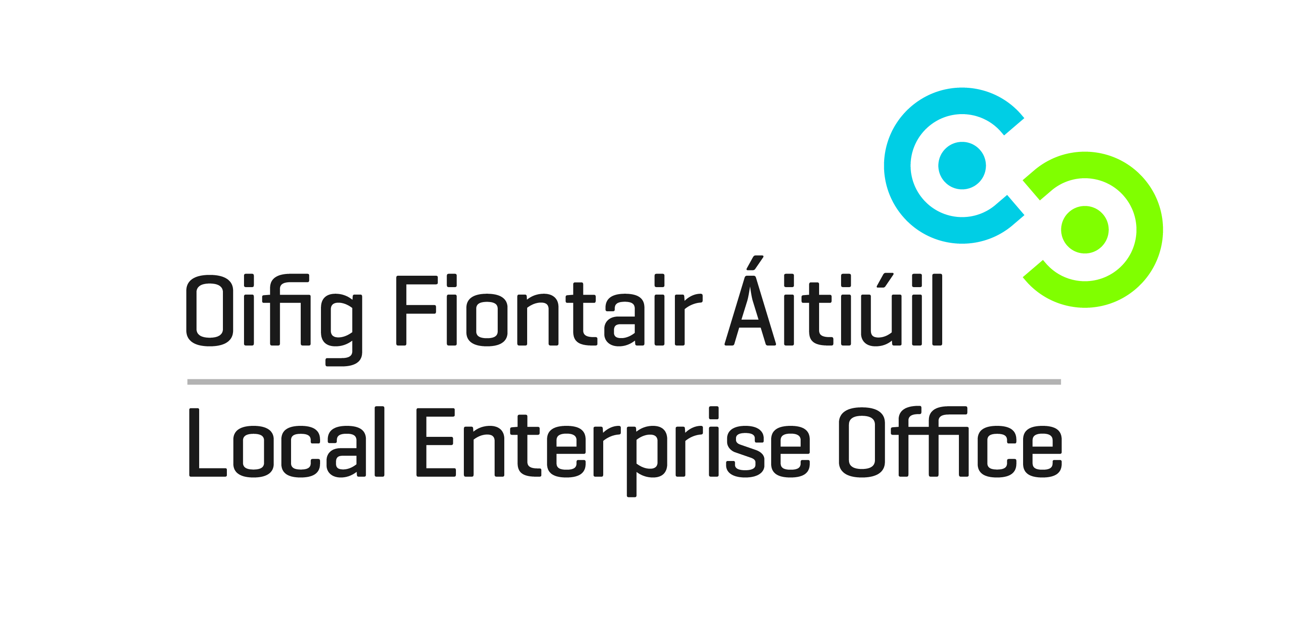
Teen Entrepreneur STEM Camp
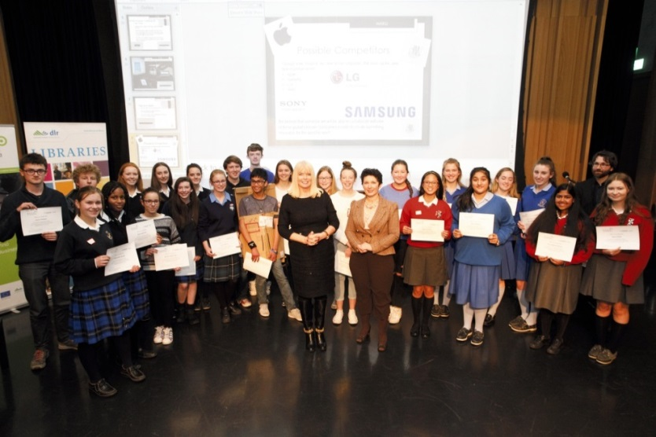
OPEN TO TY STUDENTS IN DLR SECONDARY SCHOOLS ONLY
Certification and Celebration
with
Mary Mitchell O’Connor T.D.
Minister for Jobs, Enterprise and Innovation

At STEM SHOWCASE;
November 30th 2016.

Students reported that the Camp encouraged and developed their STEM and entrepreneurial skills.

A New Camp is being held in October and November 2017 - We are inviting teachers to APPLY BY WEDNESDAY, MAY 31st. There are 24 places for Transition Year students from 8 schools (a limit of 3 students per school). There is no charge.
Dún Laoghaire-Rathdown Libraries and Local Enterprise Office Dún Laoghaire-Rathdown (LEO DLR) are delighted to host a second Student Entrepreneur Learning Camp in STEM subjects (Science, Techology, Engineering and Maths) for Transition Year students this Autumn. The venue is again the dlr LexIcon LAB, a space which offers programmes on coding, computer programming, 3D printing, robotics and other creative technologies to people of all ages. The camp consists of weekly sessions running from October to November 2017 and will include Workshops; Guest Entrepreneurs and Project Maker Days. The camp will culminate in a Show and Share Event in November 2017 at which participants will demonstrate their projects to school peers and community members. Exact dates to be announced in early September.

Camp Objectives
- Guide participants through a structured program of building blocks and skills that cover STEM subjects (Science, Technology, Engineering and Maths), using coding, basic electronics, robotics and design software
- Develop student STEM skills by introducing them to the practical uses and possibilities of new creative technology outside a classroom environment, while promoting problem-solving skills
- Encourage and support entrepreneurial skills in all participants through workshops and talks
- Foster teamwork, collaboration and learning through hands-on making sessions, all vital for today’s workplace
Workshop Topics
- Coding; Python, Arduino, Makey Makey
- Electronics and programming; Raspberry Pi and Arduino
- 3D Design and Printing; CAD
- Prototyping; Design thinking and paper

Learning Outcomes
- Acquire basic coding skills for developing apps and controlling computer systems
- Learn how to design and print simple 3D objects using CAD
- Achieve greater understanding of how technologies such as electronics and programming can be used to create solutions to everyday problems
- Apply problem-solving skills using coding and electronics and appreciate their relevance to considering career options including enterprise creation and self-employment opportunities
- Develop greater communication, collaboration and presentation skills through group learning

School Subjects Relevance
Applied Maths Curriculum; Business/Enterprise; Woodwork, Science Subjects
Art and Design; Mechanical Drawing; Technology and Engineering; Career Guidance
Pedagogy
The four workshops are student-centred with an active learning pedagogy marrying theory and practice. To complete the learning cycle student teams will be challenged to develop a project to integrate and apply their learning which will be shared at a final presentation event with their peers in late November. To enrich this experience students will encounter and learn from new technology developers and entrepreneurs who will share insights into STEM career options.

INDICATIVE CAMP PROGRAMME (Specific dates to be announced in September 2017; maximum 5 hours per week)
October 2017: Week 1 | Workshop 1: Coding; Scratch, Makey Makey
October 2017: Week 2 | Workshop 2: Electronics & programming; Raspberry Pi & Arduino
October 2017: Week 3 | Workshop 3: 3D Design and Printing; CAD
October 2017: Week 4 | Workshop 4: Prototyping; Design thinking and paper prototyping
Mid Term: 30th October to 3rd November 2017
November 2017: Week 5 |  | Q&A Session with a Guest Entrepreneur  (Introduced by Local Enterprise Office DLR)
November 2017: Week 6 |  | Maker Day 1
November 2017: Week 7 |  | Maker Day 2; Finish on presentation of projects to peer group.
November 2017: Week 8 |  | Showcase of projects and Camp event

HOW TO REGISTER YOUR SCHOOL FOR
Teen Entrepreneur STEM Camp Autumn 2017
DEADLINE WEDNESDAY, MAY 31ST 2017

Please email Maeve McElligott, dlr Libraries:
Your Name, School and Contact Details (Email & Mobile)
To: librarybookings@dlrcoco.ie AND cc. joseph.keating@gmail.com
Using Subject line: ‘Teen Entrepreneur STEM Camp / Autumn 2017’

Queries to
Maeve McElligott, dlr Libraries librarybookings@dlrcoco.ie
or
Joseph Keating, Enterprise Education Co-ordinator,
LEO DLR joseph.keating@gmail.com / 087 9956150

