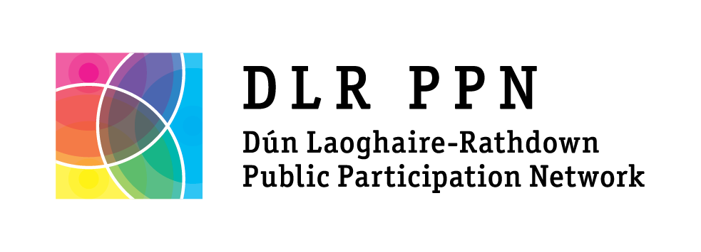

Membership Application Form (please use block capitals)
Online applications can be made at www.dlrppn.ie/register

What is the name of your group / organisation?

Tell us a bit about your group / organisation and its aims:

Do you consider your main activities to be? (Tick one)

☐ Community: (Local Development, Sports, Arts, Residents, Social groups etc.)
☐ Environmental : (Focused on protecting the environment and sustainability)
☐ Social Inclusion : (Focused on people experiencing disadvantage and inequality)
In which electoral area are your activities mainly focused? (Tick one)

☐ Blackrock ☐ Killiney-Shankill
☐ Dundrum ☐ Stillorgan
☐ Dun Laoghaire ☐ County-wide
☐ Glencullen-Sandyford ☐ National

How is your group structured? (Tick one)

☐ Affiliated ☐ Association ☐ Charity
☐ Committee ☐ Co-operative ☐ Limited company
☐ Set of Rules ☐ Trust ☐ None
☐ Other (please describe) ____________________________________________________________________________
What year was your group/ organisation established? _________________
Is your group governed by rules or a constitution? YES NO
How many members do you have? __________
How many paid staff does your organisation have? _________
How many volunteers does your group / organisation have? ____________

What is your website address? _________________________________________
What is your Facebook page? __________________________________________
What is your Twitter account? __________________________________________

Main address for correspondence:

Name of Main Contact:

Main Contact email address:

Main Contact phone number:

Alternate Contact name:

Alternate Contact email address:

Alternate Contact phone number:
Data Protection information:

The information you provide in this form will only be used by Dún Laoghaire-Rathdown Public Participation network (DLR PPN) or its agents to carry out the remit of DLR PPN.

This includes sharing relevant information with DLR PPN members via our Ezine, by email and text message, assisting PPN members to connect and network, organising meetings and events for members and supporting the participation of members in local decision and policy-making structures.

DLR PPN may be asked to confirm a group/organisation's membership of the PPN with Dún Laoghaire-Rathdown County Council as part of DLRCC’s grant funding criteria.

I agree to allow DLR PPN to store my group/organisation's contact details on a database held by DLR PPN and/or its agents for the purposes listed above.

Name: _____________________________ Position: ___________________________

Date: ______________________________

Please return the completed form to:

DLR Public Participation Network
The Old Post Office,
7 Rock Hill,
Main Street,
Blackrock,
Co. Dublin

Or Scan and Email completed form to secretariat@dlrppn.ie

If you have any queries, please contact DLR PPN manager Laura Howe on 087 6394506 or email laura@dlrppn.ie

