

Additional Requirements for Recreational/Events - Commercial Application

Form for Beaches for Trial Sauna Event

This document outlines certain requirements that will apply to sauna events and must be completed in conjunction with the Recreational/Events - Commercial Application Form for Beaches.

Please submit your application within 3 weeks' notice.

Please note all requirements outlined within the Recreational/Events - Commercial Application Form for Beaches must also be supplied.

A surface permit must be applied for. Please visit <https://www.dlrcoco.ie/travel-transport/roads/road-maintenance-application-forms> for full details.

Locations where parking bays will be affected will be subject to parking bay reservation fees.

Trial events will only be accepted for dates between the following dates. Note that trial events may not start before 7am and must conclude by 7pm.

* Wednesday 27th November – Wednesday 18th December inclusive
* Monday 13th January – Friday 31st January inclusive (Applications for this period must be submitted before Friday 20th December)

Please provide the location for the Sauna event (locations outside of the following will not be approved; Dun Laoghaire Baths, Forty Foot Bathing Place, Killiney Beach, see additional information on locations at the end of this document)



Please indicate if the business plan will include operations in the water. (Note: A lifeguard is required if your business is operating in the water)



Please indicate the size of area required for the vehicle to provide sauna facilities (subject to maximum of 10m2 in locations not requiring parking bays, or 2 standard parking bays in carpark locations)



Please provide an event management plan including expected numbers, waste management, water management, first aid provision and booking process. The facility and users may not impinge on public access to the surrounding area. Generator sets (with combustion engines) should not be used to provide power.



Please note the following mandatory requirements

* Only 1 sauna unit is allowed per event
* Facilities must be manned at all times
* Vehicles and all equipment must not remain onsite overnight/outside of operating hours
* Locations must be left clear, clean and tidy at the end of each day.
* Saunas must be wood fire only (gas will not be considered)
* Trial sauna events will be held for a maximum of 3 days, only 1 day of which may be a weekend.
* A maximum of 3 events may be applied for. Applications for more than 3 events will not be considered during this trial period of events.
* Each individual event requires a separate application

A person who applies to the Council for an event permit shall furnish to the Council the information requested in the application form together with such other information as the Council may request for the purpose of the exercise of its powers and functions under the 2012 Beach Bye Laws.

A permit granted by the Council shall not relieve from personal responsibility or liability any person(s) to whom such permission was granted in respect of any criminal, unlawful, illegal, wrongful or negligent act or omission for which such person(s) may at any time be sued or charged.

A permit granted by the Council shall in no way be deemed to implicate or involve the Council, its officers or employees or agents in any liability or responsibility in respect of any criminal, unlawful, illegal, wrongful or negligent act or omission done by any person(s) to whom such permission was granted or by their servants or agents or employees.

The Council may, by notice in writing, revoke, alter, suspend, amend or limit the terms and any conditions of an issued license. The Council can provide an alternative location as required.

**Locations**

Forty Foot

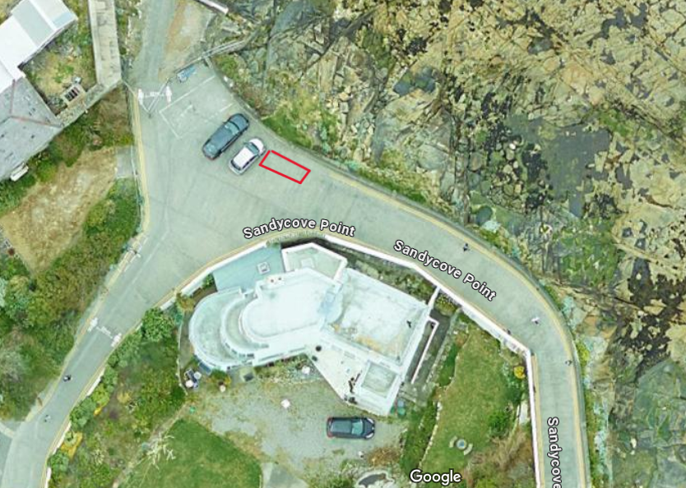

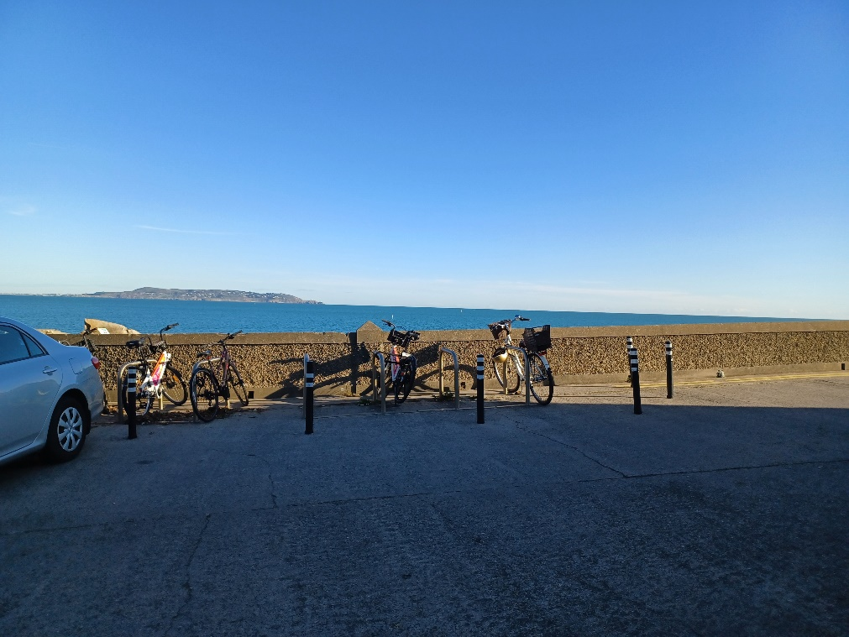

Dun Laoghaire Baths

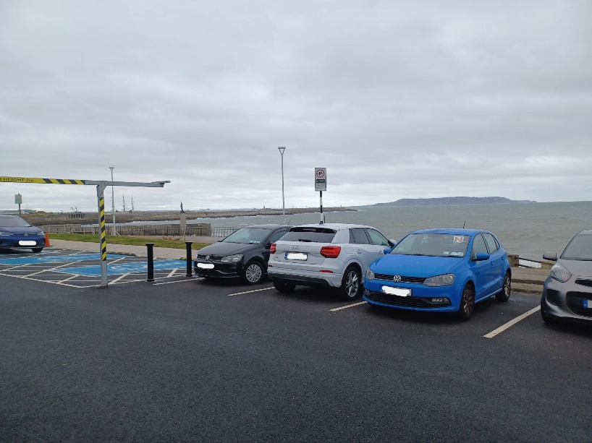

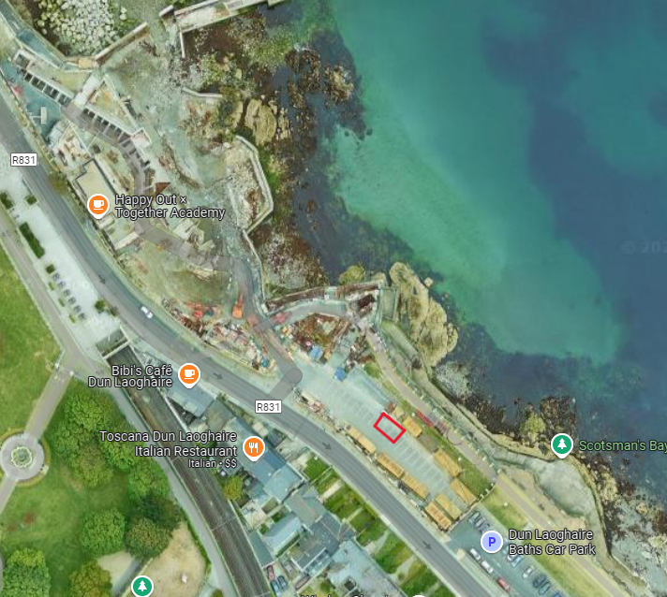

Killiney Beach

Location 1

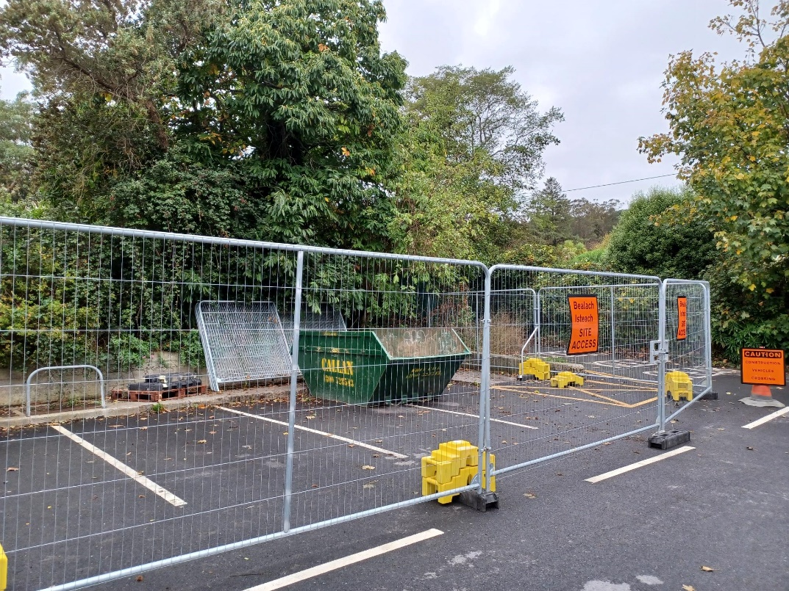 Location 2

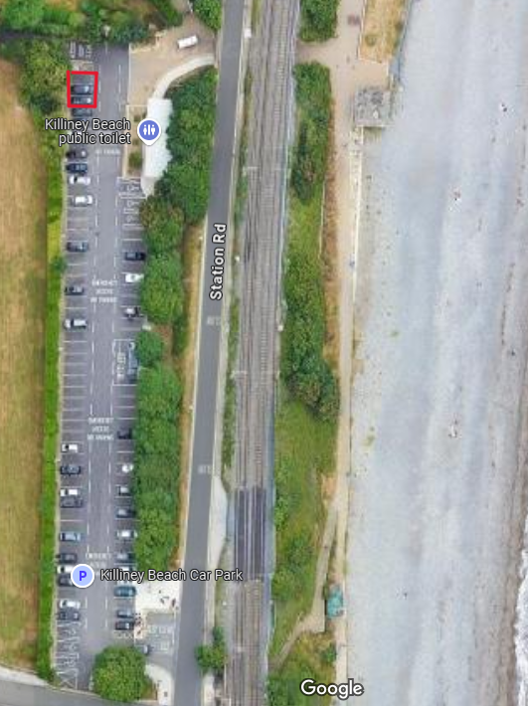 Location 2