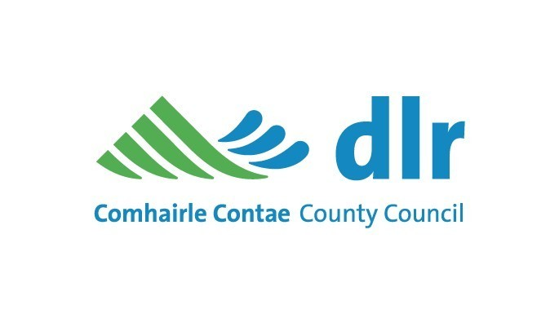
Recreational Activities/Events – Commercial
Application Form for Beaches
(Section 6 of the Beach Byelaws 2012)

314994 F______________________________

Application Fee

A non-refundable application fee of €10.00 applies to all applications and should the application be approved, additional fees will apply, depending on the type and extent of the proposed activity.

Applications are to be sent to Helen Smirnova, Environment Section, Dun Laoghaire-Rathdown County Council, Ballyogan Operations Centre, Ballyogan Road, Dublin 18, D18 CV97 together with payment of the application fee.

For additional assistance please telephone 01 205 4748.

Applicant’s Details

Please provide the following details of the person and company/organisation responsible for the activity.

Name: _____________________________________________________

Address: _____________________________________________________

_____________________________________________________

Telephone: ___________________

E-mail: ____________________________________________________________

Applicant’s Signature: ____________________ Date: _____________________

Description of the Activity

Provide clear details of the proposed activity (if necessary, please attach additional information).

Public Liability Insurance

Each successful applicant must submit evidence of Public Liability Insurance cover; the level of indemnity to be not less than €6.5 million in respect of any one incident and Dun Laoghaire-Rathdown County Council must be specifically indemnified.

Employers Liability of €13 million is also required where organisations are employing people to facilitate the event.

Location Requirements
The location/s of the proposed activity should be clearly described, and a sketch plan of the proposed area is to be attached.

Location | Duration – hours/dates/weeks | Dates/Times | Number of persons in group

Environmental Amenity and Public Safety
Activities in a public place must not result in a nuisance or danger to nearby residents or the public, particularly in relation to noise, public safety, convenience and anti-social behaviour.

Booking Fee

A fee of €63.00 per calendar year applies for most activities.

A larger fee for some events/activities is required and the level of this fee depends on the extent of the event/activity.

Notes
- Application fee of €10.00 (payable by cheque, Postal Money Order or Bank Draft) must be paid at time of lodgement of the application.
- Booking fee and evidence of insurance must be submitted prior to commencement of event.

Office use
Activity | Number of Hours | Fee Payable | Date

Other Requirements

- Site specific risk assessment (consider bathing area/yellow buoys)
- Copy of relevant certificates - water rescue/first aid/instructor
- Relevant permission from Department of Marine (i.e. passenger boat license)

Please Return completed application form including all required documentation to:

Application Forms for Recreational Activities/Events on Beaches should be submitted to:

Helen Smirnova, Infrastructure & Climate Change
Dún Laoghaire-Rathdown County Council,
Ballyogan Operations Centre, Ballyogan Road, Dublin 18. D18 CV97Email: info@dlrcoco.ie
Tel: 01 2054817

