DÚN LAOGHAIRE RATHDOWN

July to September
QUARTERLY MANAGEMENT REPORT

21st June – 30th September 2024
CONTENT
DIRECTORATES

CORPORATE AFFAIRS Page 3
Director: Stephen Brady

FINANCE AND WATER SERVICES Page 10
Director: Helena Cunningham

HOUSING Page 15
Director: Catherine Keenan

PLANNING & ECONOMIC DEVELOPMENT Page 23
Director: Aidan Blighe

FORWARD PLANNING INFRASTRUCTURE Page 42
Director: Anne Devine

INFRASTRUCTURE AND CLIMATE CHANGE Page 48
Director: Paul Kennedy

ARCHITECTS Page 64
County Architect: Andree Dargan

COMMUNITY CULTURAL SERVICES, & PARKS Page 65
Director: Therese Langan

Corporate Affairs
CRM Statistics

CRMS Logged
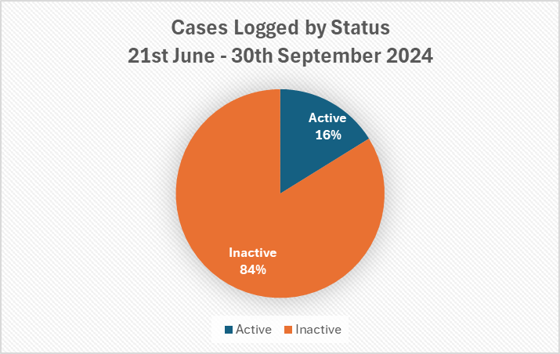
Open | 1648
Closed | 8539

Section/Department | Active | Inactive | Total
Architects | 9 | 13 | 22
Ballyogan Depot | 2 |  | 2
Comms & Civic Hub | 19 | 1267 | 1286
Community | 5 | 11 | 16
Corporate Services | 6 | 16 | 22
dlrcoco | 65 | 96 | 161
Enterprise |  | 4 | 4
Environment | 6 | 6 | 12
Finance | 39 | 742 | 781
Forward Planning Infrastructure |  | 3 | 3
Harbour | 1 | 27 | 28
Housing | 69 | 529 | 598
ICC | 913 | 4466 | 5379
IT | 1 | 6 | 7
Libraries | 1 | 9 | 10
Parks | 458 | 1246 | 1704
Planning | 9 | 40 | 49
Property | 6 | 25 | 31
Transportation |  | 1 | 1
Water Services | 39 | 32 | 71
Grand Total | 1648 | 8539 | 10187
*This does not fully reflect the interaction of the Housing Department as they also directly deal with calls, emails and post.

Civic Hub Activities:
Phone Statistics | Answered Directly | Transferred to overflow
 | 17,848 | 2876

Emails received | Info@ | Reps@ | Oireachtas | Total Emails
 | 8523 | 213 | 874 | 9610

Counter Interactions | Civic Hub | Appointments | Total
 | 951 | 176 | 1127

DLR Civic Hub:
In Quarter 3 of 2024, the Civic Hub has dealt with over 31,461
customer interactions:

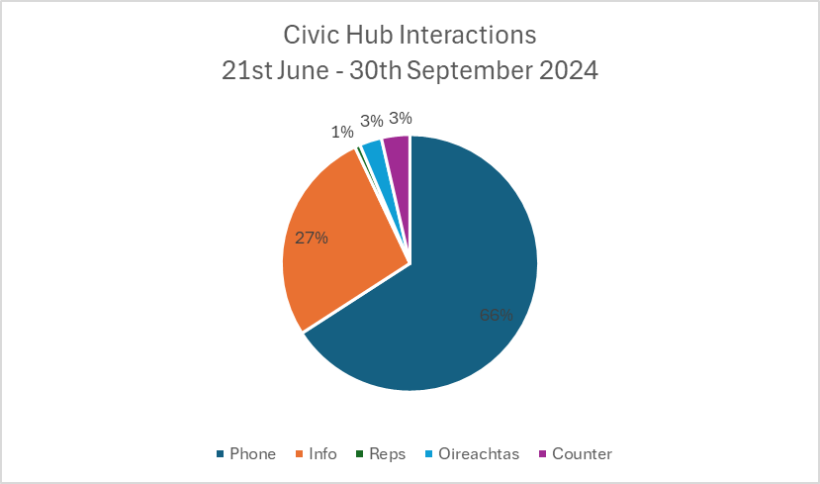

Communications Office

The Communications Office oversees communications for the organisation and is responsible for all internal and external communications, public relations, corporate branding, creative graphic design, crisis management, advertising, event promotion and marketing extending across all service departments.

We publish four editions of the dlr Times in Irish/English which is distributed to every household in the County (70k).

We also manage the Irish Office and the Office of An Cathaoirleach.

June 21 – Sep 30 2024 - Monthly Report for dlrcoco.ie and dlrlibraries.ie

Website Activity – Page views and number of users

Website | Page Views | Users
dlrcoco.ie | 724,879 | 307,096
dlrLibraries | 41,251 | 16,213

Compared to 28 March – 20 June
Website | Page Views | Users
dlrcoco.ie | 780,860 | 316,747
dlrLibraries | 40,924 | 15,165

Top viewed pages on dlrcoco.ie
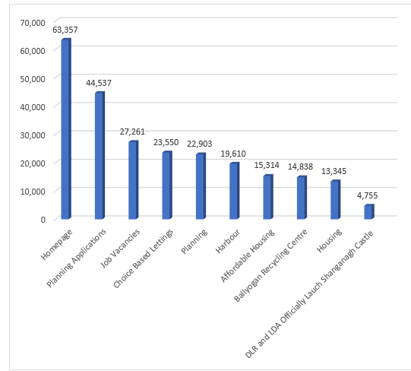

Press Releases

We issued 21 Press Releases from June 20 - September 30

Highest Performing News Stories

- DLR and LDA officially launch Shanganagh Castle – Views 11,675
- Public Consulation: Blackrock DART to Park Active Travel Scheme – Views 3,714
- Draft Traveller Accommodation Programme 2025-2029 – Views 3,077

Click here to view all News Listings
Press Queries: 65

Public Consultations: 27

Social Media Activity

Highest performing social media posts on Facebook
- Video for multihog at Sandyford Village
- Regal Princess
- Columba Park Opening

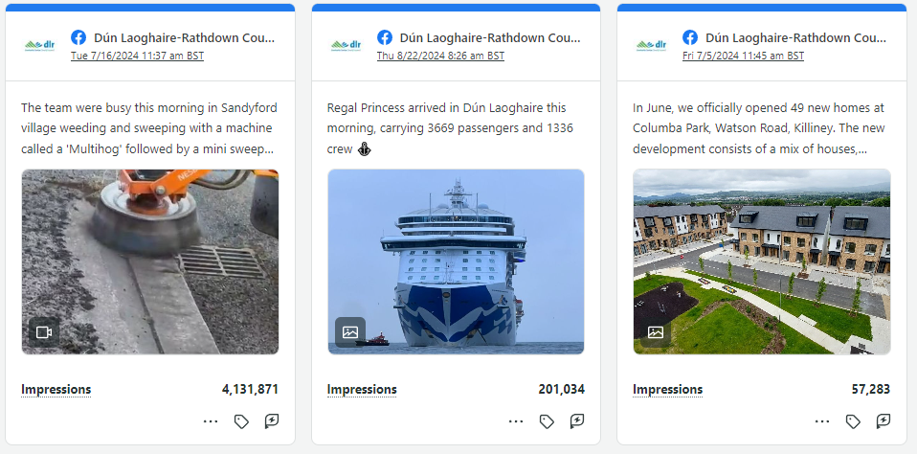

Highest performing social media posts on LinkedIn
- Harbour Masterplan Public Consultation
- Dundrum Central announcement
- Shanganagh Castle Estate

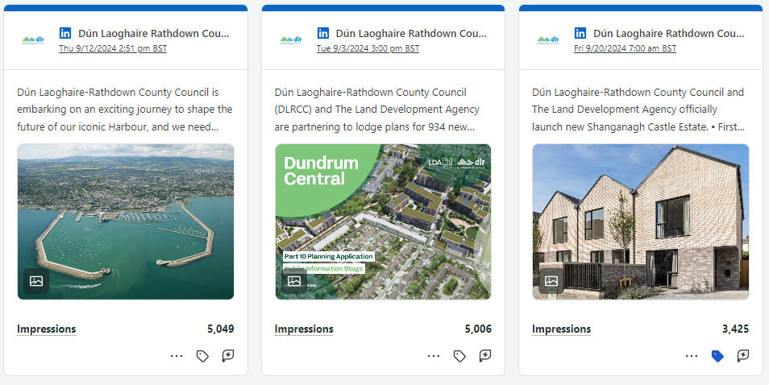
Highest performing social media posts on Instagram
- Killiney beach advisory notice
- Bathing water
- Free Harbour Boat Tour – DLR Harbour Masterplan Public Consultation

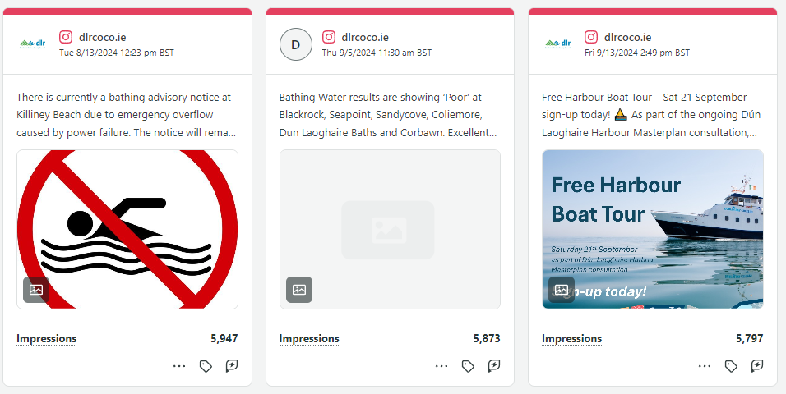

Highest performing Reels on Instagram
- Video for multihog at in Sandyford Village
- Harbour Boat Tour
- Sean O’Kelly trying out the new accessibility ramp at Dún Laoghaire Baths

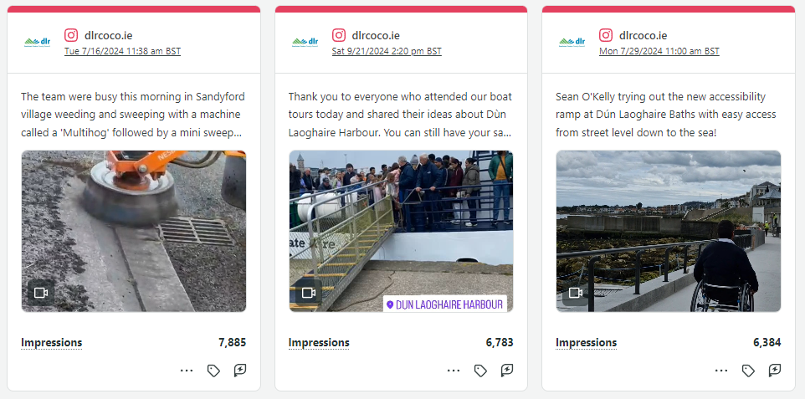

Highest performing social media posts on X
- Video for multihog at in Sandyford Village
- Local Elections results
- First wheelchair user Siobhan Keane, and Aoife Keane at the Baths

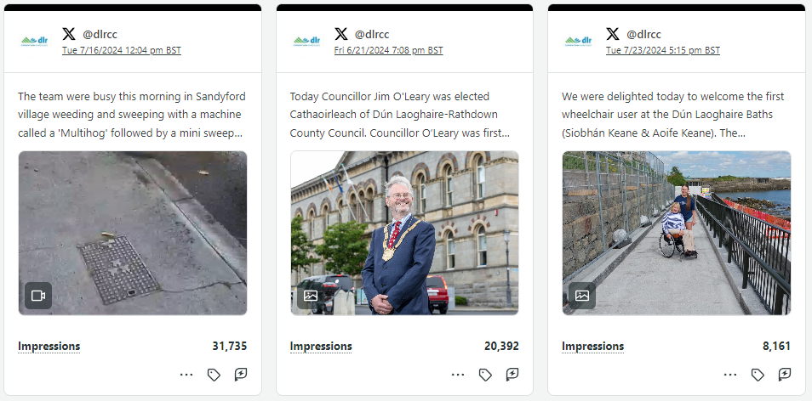

Highest Performing Facebook Event Listings
- The metals event
- The Grand Parade of Classic Sail as part of Coastival
- Emergency Services Open Day

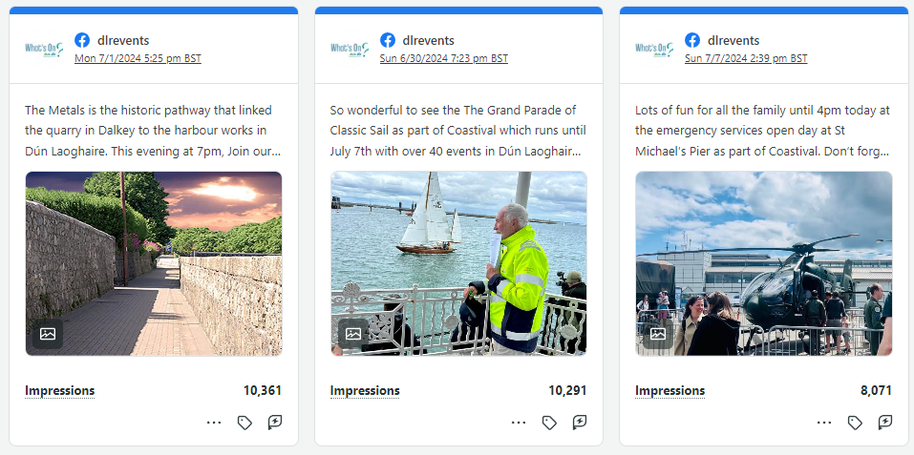

Social media statistics

We have over 100k followers across all social accounts including the corporate account, dlr events, dlr arts, libraries, LEO office, dlr heritage and dlr Sports Partnership.
We published 2,597 posts from June 20 – 30 September 2024. Further breakdown below of the accounts and performance.

Audience growth since March – June 19 2024

- Dún Laoghaire-Rathdown County Council Facebook increased by 3,059 followers
- Dún Laoghaire-Rathdown County Council Instagram increased by 898 followers
- Dún Laoghaire-Rathdown County Council X increased by 37 followers

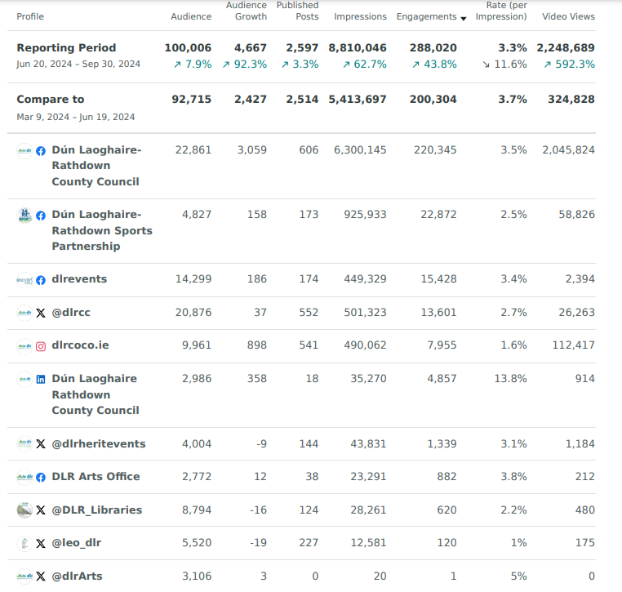

Finance and Water Services
Rates
The Local Government Rates and Other Matters Act (LGROMA), 2019 was passed by the Oireachtas and enacted on 11th July 2019. Only certain provisions of the Act relating to rates commenced in 2019. The Historic and Archaeological Heritage and Miscellaneous Provisions Act, 2023 was identified as the vehicle for carrying Rates Act amendments. That Act was signed into law by the President on 13th October 2023.

Main Process Changes resulting from the commencement of the LGROMA 2019
  - Removal of two moieties – there will now be a single bill for the year. The due date is 1st January of each year.
  - Amendments to a valuation list will be effective immediately i.e.:
    - Revisions;
    - Additions and Removals; and
    - Appeals (Valuation Tribunal and Courts).
  - There will now be provision for pro-rata liability and billing where occupation ends or begins mid-year.

Notice of Consideration of a Scheme for the Abatement of Rates in Respect of Vacant Properties
On the 10th July, 2024 the Minister of State at the Department of Housing, Local Government & Heritage published the ‘Local Government Abatement Of Rates In Respect Of Vacant Properties Regulations 2024’

These regulations state that a local authority shall consult with the public in its administrative area in relation to its consideration of making, or amending of an existing, abatement scheme.

As per the regulations, a notice was placed in the Irish Times on Thursday 1st August welcoming written submissions from the public specifically covering the potential effects of a scheme providing for the abatement of rates in respect of vacant properties on businesses, individuals and on local authority services. This notice was also placed on our website and displayed in County Hall and also at our Dundrum Offices. Alerts issued via X and Facebook. The closing date for submissions was midnight on 23rd August, 2024.

Four submissions were received, all via Citizen Space. Of these four submissions, one was from a landlord who is not resident in DLR who is in favour of an abatement, while the other three state they are by residents, with one also being an employee who are not in favour of an abatement.

The Council continues to facilitate businesses who are experiencing difficulties paying their rates and where possible payment plans are entered into which are mutually acceptable to the business and the Council. There has been a continued increase in the number of accounts paying monthly instalments by direct debit.

We have increased enforcement proceedings, including the use of a Debt Collection Agency, in respect of non-compliant rate payers.

Ratepayers Support Grant
The Council’s Budget for 2024 retained numerous Grants and Supports for Businesses including the Ratepayers Support Grant for eligible ratepayers whose 2024 rates bill is less than €20,000. Grant payments are graduated depending on the level of rates payable and the grant varies from 8% to 14%.
Any qualifying commercial ratepayers who have paid their accounts in full by 1st July 2024 or who have entered into a Direct Debit Agreement by that date will have the Grant paid into their account at the end of 2024.
ICOB
The Increased Cost of Business (ICOB) grant was introduced as part of the 2024 Budget. This one-time grant, amounting to €257 million, was to be disbursed to small and medium-sized businesses nationally from the start of the second quarter of 2024.
This grant was intended as a one-time financial aid to help businesses with increased costs associated with running a business. This scheme was not a waiver for commercial rates, and businesses were expected to continue paying their commercial rates as usual.
Eligibility for the grant required businesses to operate from a commercially rateable location, to be compliant with their rates arrangements with their local authority and have had a 2023 rate bill not exceeding €30,000.
A total of 2,790 application for the grant were received and processed in DLR with €10.8 million in grants approved for businesses in DLR and paid out between April and August 2024. 2,550 local businesses benefited from the initial grant with 1,052 businesses also receiving a second grant per the Departmental guidelines.

Accounts Payable
Accounts Payable continues to work to ensure suppliers are paid as quickly as possible to assist with their cash flow requirements. Invoices from over 3,200 suppliers, totaling €308m, have been processed to date in 2024.

Financial Management
Budgets and cash flow continue to be monitored closely. Work is progressing on the preparation of the draft 2025 Revenue Budget and the Report on the Capital Programme 2025 – 2027.

Overdraft Facility
The Council agreed a resolution at the Council meeting held on 9th September to keep the overdraft facility in place for 2025 with a limit of €10m. Sanction to do so will now be applied for to the Minister.

Annual Financial Statement 2024
The unaudited Annual Financial Statement for 2023 was prepared and submitted to the Department of Housing Local Government and Heritage in March and The Local Government Auditor completed the audit of the accounts in August 2024.

LPT
The provisional LPT allocation for 2025 was notified by the Department and indicates an increase of €0.6m in the amount of discretionary and baseline LPT income, pre-variation.

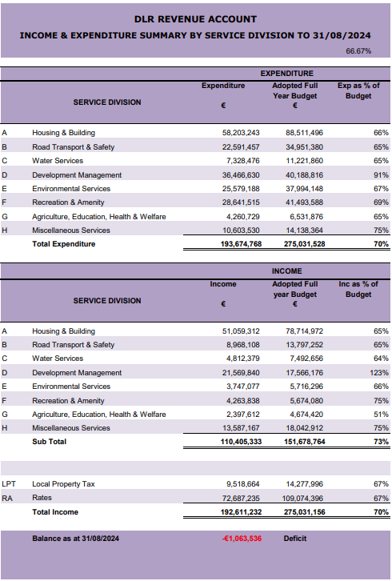
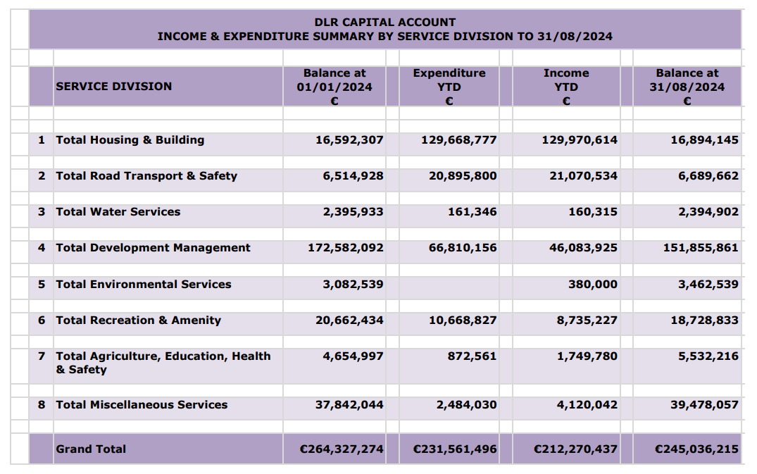

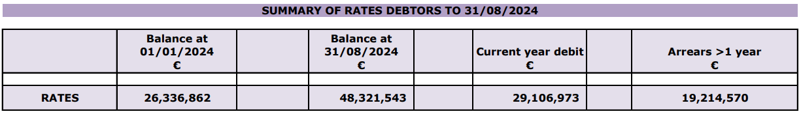

Water Services

Drainage & Flood Alleviation
Engineering and environmental consultants were appointed in December 2019 for Flood Risk Management Works on the Deansgrange Stream. Stages I and II of the project, namely Option Selection/Preliminary Design and Planning are now completed. Public consultation for the Part 8 Planning process on the proposed scheme ended in August 2023. The Chief Executive report for Part 8 was brought to, and approved at, the December 2023 Council Meeting, subject to approval from An Bord Pleanala (following an EIA determination direct request) and also a survey of SuDS opportunities being carried out in the wider catchment. An Bord Pleanala have recently determined that no EIAR is required.

Water Services are now progressing with detailed design. It is planned to progress the overall scheme in smaller projects to reduce the risk of significant cost overruns and also delays due to environmental/stakeholder issues. Glenavon Park Ponds/Wetlands project will progress initially and advance works are already underway - invasives burial, otter surveys, archaeological surface digging etc. The design work on the upgrade to the critical Seafield culvert screen will also commence shortly.

Engineering and environmental consultants have also been appointed in 2020 for Flood Risk Management Works on the Carrickmines/Shanganagh Rivers. Preliminary design of a preferred option is completed. A Public Engagement Event took place on the 13th of December 2023. Comments have been incorporated into the final option, where appropriate, and the EIAR report is substantially completed and will include final details from the environmental/ecological surveys. It is planned to submit planning documentation to An Bord Pleanala in November 2024.

The options for the Dodder Phase 3 FRS were recently presented to the Councillors in advance of a Public Consultation Day for the final options on the scheme. A Public Engagement event is scheduled for the end of October. Ground investigation work is currently underway which will inform the designs.

Water Pollution Control

Misconnections
There have been 655 misconnection surveys carried out in the County.
345 of these were carried out by DLR staff directly.

The remaining 310 were carried out on our behalf by the Dublin Urban Rivers Life Project (DURL.) The DURL is an EU funded project in which we are partners with SDCC. They are the project lead.

The surveys have been carried out in 3 river catchments:
- The Carrickmines/Shanganagh Catchment (DURL)
- The Brewery Stream between the N11 and Carysfort Pond.
- The Deansgrange Stream in the Watsons estate area.

Septic Tanks
The EPA require us to do 2 septic tanks inspections in 2024. Both have been done.
To date we have done 6 inspections. This figure includes inspections in relation to the new Septic Tank grant Scheme.

Trimleston Wetland
The wetland is designed to take approximately half the flow of the stream in dry weather and the first flush (20 minutes or so) during rainfall. The stream is moderately polluted from misconnections, a UE overflow just off Foster’s Ave and urban runoff especially from a section of the N11 that drains into the stream. The wetland is part of the Dublin Urban Rivers Life Project. SDCC have built 4 wetlands as part of the Project. The wetlands were all partly funded by the EU under the EU Life Scheme Fund.

The wetland civil construction works were completed on 18th August. The wetland was planted and flooded the following week and has been in operation since. Total cost for the project including consultancy, construction and planting is just over €100,000. It is intended to hand the rest of the site over to the Council’s Biodiversity Officer to create a biodiversity preserve. Works are planned to commence in Spring 2025.

Uisce Eireann
It is anticipated that 50% of the staff members working under the MCA with Uisce Eireann will have transferred to DLR departments by the end of the year.”

Housing

- Executive Summary

1.1 Overview

In accordance with Guidelines issued by the Department of Housing, Local Government and Heritage and the Council’s Corporate Plan, this Report is produced to give an overview of the Housing portfolio at Dún Laoghaire-Rathdown County Council. The report covers the provision, maintenance and management of housing stock and the housing supports available for those who need them.

The data included in this report covers data for Q1 2024 from 1st January to 15th March, Q2 from 18th March to 7th June and Q3 from 8th June to 20th September inclusive. The data regarding the activity of this department prior to this report can be found on our website at https://www.dlrcoco.ie/housing/housing-statistics.

The Government’s new housing plan, Housing for All, was published on 2nd September 2021. The plan can be found at https://www.gov.ie/en/publication/ef5ec-housing-for-all-a-new-housing-plan-for-ireland/.

This Report considers the following areas:

Housing Delivery
Build
Acquisition
Part V
Social Leasing
Traveller Specific Accommodation
HAP / RAS
Cost Rental
Affordable Purchase

Support
Management, Maintenance and Improvement of Housing Stock
Retrofitting
Housing Adaptation Grants
Allocations & Assessments
Choice Based Letting
Homeless Services
Private Rented Housing Standards
Tenancy Management & Anti-social Behaviour
Local Authority Home Loan Scheme
Tenant Purchase Scheme

- Housing Delivery

2.1 Overview

The Social Housing Target 2022-2026 for delivery by this Council is 1,994 homes.

Table 1: Homes Delivered
 |  | 2024  Q1 | 2024  Q2 | 2024  Q3 | 2024  Total | 2024 Target
DLR Build |  | 0 | 4 | 0 | 4 | 372
DLR Part V |  | 0 | 8 | 0 | 8
AHB Build |  | 0 | 34* | 0 | 34
AHB Part V |  | 0 | 0 | 1 | 1
DLR Acquisitions (includes Tenant-in-Situ) |  | 7 | 5 | 18 | 30
AHB Acquisition | CAS | 1 | 0 | 2 | 3
 | CALF | 0 | 6* | 0 | 6
Total Build & Acquisition |  | 8 | 57 | 21 | 86
DLR Lease |  | 0 | 0 | 0 | 0 | 101
AHB Lease |  | 0 | 0 | 0 | 0
RAS |  | 6 | 6 | 5 | 17
HAP - Standard |  | 29 | 24 | 41 | 94
HAP - Homeless |  | 16 | 16 | 29 | 61
Total RAS & HAP & Leasing |  | 51 | 46 | 75 | 172
Total Delivery – all social housing delivery streams excluding bad relets |  | 59 | 103 | 96 | 258
*4 AHB CALF acquisitions were counted as AHB Build in Q2 but the bottom line figure remains the same.

Table 2: Traveller Specific Accommodation
 | 2024  Q1 | 2024  Q2 | 2024  Q3 | 2024  Total
Refurbishment Works and New Sites | 0 | 0 | 0 | 0
Casual Vacancies/Relets | 1 | 0 | 0 | 1
Standard Housing | 0 | 1 | 2 | 3

2.2 Housing Construction
The Housing Department recognises the importance of managing the development process as part of the effort to achieve the targets set by the Department of Housing, Local Government and Heritage (DHLGH). To this extent, the schemes are closely monitored from inception through to completion.

DLRCC CONSTRUCTION PROGRAMME 2022 – 2026
Includes SHIP, Major Refurbishments and AHB New Build

The following tables provide an overview of the different schemes under the Housing Construction Capital Programme, their current status and estimated completion date. It should be noted that dates indicated for handover are estimates and are subject to change. In some cases, the figure includes social and affordable housing. Schemes being delivered under the Planning and Development (S.179a) Regulations 2023 are identified.

Table 3: Schemes on Site
Site Name | No. Units | Status Detail | On Site Date | Handover (estimated)
Rockville Green | 13 | On site 21st June. | Q2 2024 | Q3 2025
Park House | 4 | On Site | Q3 2022 | Q4 2024
Shanganagh Residential Lands | 597  (200 social) | On Site, first units to be delivered Q4.  Affordable scheme portal opens 9th October. | Q3 2022 | Phased delivery from  Q4 2024
37A Rollins Villas (infill) | 1 | Nearing completion | Q1 2023 | Q4 2024
St. Laurence’s Park | 88 (48 social) | On Site | Q4 2023 | Q4 2025
Roebuck Road Infill | 4 | On Site | Q1 2024 | Q1 2025
Total | 707

Table 4: Schemes with Part 8 Planning Approval
Site Name | No. Units  (estimated) | Status Detail | On Site Date estimated | Handover estimated
Ballyogan Rise (Phase 2) | 52 | Stage 3 submitted for approval. | Q1 2025 | TBC
Woodpark TAU | 3 | Stage 4 approval received. Contractor costs being reviewed. | Q4 2024 | Q3 2025
Infill Site at Rockville Drive | 1 | Currently out to tender | Q4 2024 | Q1 2025
St Michaels TAU | 3 | Part 8 Approved February 2023 Council Meeting. Tender documents being progressed. | Q4 2024 | Q2 2025
Total | 59

Table 5: Schemes at Design/Tender Stage
Site Name | No. Units  estimated | Status Detail | On Site Date estimated | Handover estimated
27 Patrick Street Infill (Formerly Cross Ave) | 4 | Stage 2 approved. Site investigation work carried out. S179a | Q4 2024 | Q3 2025
Old Connaught TAU | 6 | Stage 2 approved. 179a published 7/10/2024 | Q4 2024 | Q2 2026
Blackglen Road Phase 1 | 125 | Stage 2 Approved. Preliminary Design stage. | Q4 2024 | Q4 2026
Balally PPP – Bundle 5 | 52 | Being developed under S85 Agreement. | TBC | 2026
Lambs Cross PPP – Bundle 5 | 25 | Being developed under S85 Agreement. | TBC | 2026
Ballyman | 300 (includes 150 for Affordable) | Accelerated Delivery Site Stage 1 Approved. | Q4 2024 | 2026
Lehaunstown | 80 | Accelerated Delivery Site Stage 1 Approved. S179a published and closed. | Q4 2024 | 2026
Old Connaught Avenue Housing site | 62 | Accelerated Delivery Site Stage 1 Approved. | Q4 2024 | Q1 2027
Mount Anville | 24 (Affordable) | At design stage. | Q4 2024 | Q1 2026
Total | 678
OVERALL TOTAL | 1,444

- Housing Support

3.1 Management, Maintenance and Improvement of Housing Stock

Table 6: Re-lets and Retrofits
Re-lets & Retrofits | 2024  Q1 | 2024  Q2 | 2024  Q3 | 2024  Total
Non-Standard Voids | 0 | 2 | 0 | 2
Re-lets | 26 | 27 | 28 | 81
Retrofits - Energy Upgrade Works completed | 18 | 24 | 19 | 61
Retrofits – Energy Upgrade Works in progress |  | - | 33 | -
Planned Maintenance works completed |  | 197* | 543 | 740
Stock Condition Surveys completed | 277 | 148 | 187 | 612
*Q2 data updated to include works completed in Q2 which were not confirmed as completed at the time of the Q2 report.

Table 7: Maintenance Requests
Routine Maintenance | 2024  Q1 | 2024  Q2 | 2024  Q3 | 2024  Total
Requests received | 2,035 | 1,621 | 2,397 | 6,053
Requests in progress | 243 | 28 | 383 | -
Requests completed | 1,792 | 1,593 | 2,014 | 5,670*
* this is the total number of requests received this year (6,053) less the number of requests outstanding (383) at the end of Q3.

Table 8: Disabled Persons Alteration Scheme
 | 2024  Q1 | 2024  Q2 | 2024  Q3 | 2024  Total
Works on hand at beginning of quarter | 162 | 171 | 157 |  | _
Works Requests Received | 47 | 40 | 61 | 148
Works Completed/Closed | 38* | 54 | 69 | 161
Works on hand at closing | 171 | 157 | 149 | _
*the figure supplied in the Q1 report was incorrect.

3.2 Allocations
Table 9: Allocations
Allocations | 2024  Q1 | 2024  Q2 | 2024  Q3 | 2024  Total
Social Housing List | 90 | 105 | 123 | 318
Transfer List | 54 | 75 | 113 | 242
Total Allocations | 144 | 180 | 236 | 560

  - Choice Based Letting (CBL)

Table 10: CBL Adverts by Area of Choice
 | 2024  Q1 | 2024  Q2 | 2024  Q3 | 2024  Total
Area 1 (South West of M50) | 11 | 2 | 10 | 23
Area 2 (Between M50 & N11) | 6 | 8 | 14 | 28
Area 3 (North West of N11) | 16 | 18 | 16 | 50
Total | 33 | 28 | 40 | 101
Note: Figures shown are for adverts which may represent multiple properties. Under the new Allocation Scheme there are now three areas of preference as shown above.

3.4 Homeless Services

Table 11: Homeless Services
 | 2024  Q1 | 2024  Q2 | 2024  Q3 | 2024  Total
No. of Homeless Families | 86 | 96 | 97 | -
No. of Homeless Individuals | 150 | 159 | 173 | -
No. of Allocations to homeless individuals/families | 17 | 10 | 32 | 59
No. of social housing offers made to homeless individuals/families who have signed for or accepted a tenancy (still residing in EA) | 16 | 16 | 29 | -
No. of Housing First Tenancies | 2 | 2 | 6* | 10
*a further 15 Housing First Tenancies are being progressed; however, we are awaiting the appointment of the new Housing First provider which is being co-ordinated by the Housing Agency for the 4 Dublin Local Authorities.

  - Housing and Disability Steering Group

A meeting of the Steering Group was held on 4th September 2024. Up to the 26th August 22% of all housing allocations were made to Disabled People. The Group continue to progress the actions of the Strategic Plan for Housing People with a Disability 2021 – 2026. This Plan can be found here.

3.6 Grant Assistance to Older Persons and Disabled People

Table 12: Breakdown of Grant Assistance to Older Persons and Disabled People

Housing Adaptation Grant for Disabled People
Housing Adaptation Grant for Disabled People | 2024  Q1 | 2024  Q2 | 2024  Q3 | 2024  Total
No. of Applications received | 31 | 55 | 76 | 162
Provisional approvals issued | 29 | 58 | 47 | 134
Grants paid | 29 | 41 | 45 | 115
Value of Grants paid | €351,903 | €367,533 | 419,593 | €1,139,029

Housing Aid for Older Persons
 | 2024  Q1 | 2024  Q2 | 2024  Q3 | 2024  Total
No. of Applications received | 26 | 27 | 42 | 95
Provisional approvals issued | 25 | 38 | 26 | 89
Grants paid | 19 | 30 | 21 | 70
Value of Grants paid | €72,187 | €132,606 | 121,378 | €326,171

Mobility Aids Grant
 | 2024  Q1 | 2024  Q2 | 2024  Q3 | 2024  Total
No. of Applications received | 13 | 10 | 8 | 31
Provisional approvals issued | 5 | 12 | 6 | 23
Grants paid | 5 | 7 | 11 | 23
Value of Grants paid | €20,013 | €34,482.25 | 57,446 | €111,941

2024 Budget - Update
Budget Provision (3 Schemes) | €2,570,000
Budget Spent to date | €1,577,141
Budget % Spent | 61.37%
Note: Some applications may be received in one year and processed in the following year as it can take some time before full documentation is submitted by the applicant.

3.7 Rent Arrears

Table 13: Rents
 | 2024  Q1 | 2024  Q2 | 2024  Q3 | 2024  Total
Rent Charged | €4,013,596 | €4,832,244 | €5,326,396 | €14,172,236
Rent Payments Received | €3,978,557 | €4,325,451 | €5,450,498 | €13,754,506
Accrued Rent Arrears | €17,391 | -€6,620 | €129,641 | €140,412

3.8 Private Rented Housing Standards

Table 14: Private Rented Housing Standards
Private Rental Inspections | 2024  Q1 | 2024  Q2 | 2024  Q3 | 2024  Total
Inspections carried out | 495 | 3,169 | 1,857 | 5,521
Dwellings Inspected | 485 | 1,419 | 1,294 | 3,198
Dwellings Inspected Compliant with Housing Regulations | 114 | 610 | 321 | 1,045
Dwellings Inspected non-Compliant with Regulations (this may include more than one inspection) | 371 | 809 | 973 | 2,153
Note: Dwellings deemed compliant in a quarter are only deemed compliant with
the Regulations at a particular point in time.

Tenancy Management and Anti-social Behaviour

Table 15: Estate Management
 | 2024  Q1 | 2024  Q2 | 2024  Q3 | 2024  Total
Pre-tenancy courses | 0 | 1 | 1 | 2

Table 16: Anti-social Behaviour
Anti-social cases | 2024  Q1 | 2024  Q2 | 2024  Q3 | 2024  Total
Received | 38 | 40 | 50 | 128
Completed | 28 | 38 | 46 | 112
Ongoing | 10* | 2* | 4 | 16*
Tenancy Warning | 0 | 3 | 5 | 8
Tenancy Notification | 3 | 0 | 2 | 5
Verbal Warning | 3 | 4 | 6 | 13
Advice Given | 17 | 21 | 23 | 61
Refer to Other Depts | 1 | 3 | 6 | 10
No Further Action | 4 | 7 | 4 | 15
Successful Possession Proceedings | 1 | 0 | 0 | 1
Ongoing Possession Proceedings | 1** | 1** | 1** | 1**
Eviction | 0 | 0 | 0 | 0
Successful Excluding Order Proceedings | 0 | 0 | 0 | 0
Ongoing Exclusion Order Proceedings | 1** | 1** | 1** | 1**
*These cases are ongoing and carried over each quarter
** These cases are carried over if ongoing or if not completed

Table 17: Tenancy Management Interviews
 | 2024  Q1 | 2024  Q2 | 2024  Q3 | 2024  Total
Tenancy Management Interviews | 30 | 32 | 42 | 104

3.10 Loans
Table 18: Local Authority Home Loan Scheme
Local Authority Home Loans | 2024  Q1 | 2024  Q2 | 2024  Q3 | 2024  Total
Applications received | 6 | 4 | 5 | 15
Applications approved in principle | 0 | 1 | 3 | 4
Loan Drawdowns | 0 | 2 | 0 | 2
Applications declined | 1 | 3 | 3 | 7
Closed Applications | 2 | 3 | 0 | 5
Applications in Progress | 9 | 4 | 2 | -
Planning & Economic Development
Section 48 and Glenamuck Scheme:

Section 48
21/06/2024 - 30/09/2024 Invoiced= €13,755,826.69 Receipted = €1,533,926.50
21/06/2023 – 30/09/2023 Invoiced= €12,521,065.82 Receipted = €3,333,311.45
21/06/2022 – 30/09/2022 Invoiced= €12,334,428.86 Receipted = €6,676,941.24

Glenamuck
21/06/2024 – 30/09/2024 Invoiced = €0.00 Receipted = €901,283.20
21/06/2023 – 30/09/2023 Invoiced = € 30,326.86 Receipted = €989,494.44
21/06/2022 – 30/09/2022 Invoiced = €5,918,182.11 Receipted = €883,418.20

Large-scale Residential Development (LRD) Applications:
Planning Applications received under Section 5 of the Planning and Development (Amendment) (Large-scale Residential Development) Act 2021.

Case No | Applicant’s Name & Brief Description of Development | Date Application Received | Last Day for Submissions/ Observations | Application  Website | Decision due date by DLR
LRD24A/0740 | Alber Developments Limited are looking for Permission for the development at this site: On lands 1.19ha at Lisieux Hall, Murphystown Road, Dublin 18.  The development will consist of modifications to the permitted Strategic Housing Development (SHD) Reg. Ref. ABP-307415-20 and is a Large-Scale Residential Development (LRD).  The proposed modifications relate to revisions to the boundary wall details as follows: -  (1) Murphystown Road (east of entrance): The existing stone boundary wall will be kept (c.2.2m to 2.6m) in lieu of the previously permitted low stone wall with railing.  (2) Murphystown Road (west of entrance): The proposed boundary (setback as agreed under Condition 2b of Reg. Ref. ABP-307415-20) will comprise of stone wall (c. 1.8m to 2.3m) in lieu of previously permitted low stone wall with railing.  (3) Murphystown Way: The existing stone boundary wall will be kept (c.2.3m to 2.4m) and lowered at the 4no. pedestrian entrances (750-900mm) in lieu of the previously permitted low stone wall.  (4) Kilgobbin Road: The existing stone and concrete boundary wall will be kept (c.2.8m to 2.9m) and lowered at the 3no. pedestrian entrances (c 750mm) in lieu of the previously permitted low stone wall. There are no proposed modifications of the permitted Blocks 1 to 4 or the gross floor area of the development.  'Lisieux Hall' (not within the current application site) is included on the Record of Protected Structures (RPS No. 1662). No works are proposed to Lisieux Hall itself as part of the application. Th application is available at the following website www.lisieuxpark-lrd5.ie | 17/09/2024 | 21/10/2024 | www.lisieuxpark-lrd5.ie | 11/11/2024

https://planning.agileapplications.ie/dunlaoghaire/application-details/100206

Case No | Applicant’s Name & Brief Description of Development | Date Application Received | Last Day for Submissions/ Observations | Application  Website | Decision due date by DLR
LRD24A/0718/WEB | P Lonergan and Sons Limited intends to apply for permission for a Large-Scale Residential Development comprising amendments to a previously permitted Strategic Housing Development (An Bord Pleanála Ref. 312214-21) with a total application site area of c.3.32Ha (with a substantive residential site development area of c. 2.96Ha), on lands located off Enniskerry Road (R117), Kilternan, Dublin 18, principally bounded by existing undeveloped land to the north and east; the adjoining Shaldon Grange residential property and associated lands (Protected Structure) to the south and Enniskerry Road to the west. The application site also includes limited frontage to Glenamuck Road to the south-east.  The proposed development consists of internal and external modifications to the 4 no. apartment blocks (Blocks A, B, C, and D), all located in the northern portion of the subject site, as granted under An Bord Pleanála Ref. 312214-21, comprising: Provision of additional storey at each block (resulting in a maximum height of 5 storeys at these 4 no. blocks) each containing 3 no. new units at new Fourth Floor Level; Amendments to permitted Third Floor layout at each block, to provide 1 no. additional unit at this floor in each block; Minor amendments to layout of Ground Floor to Third Floor Levels including alterations to main entrances, terraces/balconies, location of lift shaft, introduction of smoke shaft, and all associated rationalisation of internal arrangements; Changes to floor-to-ceiling height at each floor; Modifications to elevations (including amendments to opes, materials, and finishes); Revisions to roof arrangement to facilitate the provision of PV panels; Amendments to site layout plan including minor reorientation of blocks and revised cycle and car parking arrangements; and all associated ducting, cabling, site lighting, hard and soft landscaping, changes in levels, and site development works above and below ground.  The proposed 16 no. new apartment units (8 no. 1-bedroom and 8 no. 2-bedroom units) will be in addition to the 130 no. units previously permitted under An Bord Pleanála Ref. 312214-21, resulting in 146 no. residential units in total within the scheme (130 no. permitted units + 16 no. new proposed units).  The proposed amendments also result in an overall revised unit mix comprising 36 no. 1-bedroom, 60 no. 2-bedroom, 11 no. 3-bedroom units, 25 no. 4-bedroom units, and 14 no. 5-bedroom units.  The total gross floor area will increase from c. 16,394 sqm to c. 17,816 sqm as a result of the proposed amendments.  This planning application for the proposed amendments to the permitted Strategic Housing Development (An Bord Pleanála Ref. 312214-21) is a Large-scale Residential Development as defined under Section 2 of the Planning and Development Act 2000 (as amended). The planning application may also be inspected online at the following website: www.grangeoakslrd.com. | 11/09/2024 | 13/10/2024 | www.grangeoakslrd.com | 05/11/2024

https://planning.agileapplications.ie/dunlaoghaire/application-details/100129

Case No | Applicant’s Name & Brief Description of Development | Date Application Received | Last Day for Submissions/ Observations | Application  Website | Decision due date by DLR
LRD24A/0636  /WEB | Red Rock Glenageary Ltd.  The proposed development comprising amendments to the permitted LRD (Ref. LRD23A/0678 / ABP-318921-24) consists of the following:  (a) Reconfiguration and reduction of the basement level layout from approx. 3,411 sqm to approx. 2,242 sqm.  (b) Reduction in total car parking spaces at basement level from 80 no. spaces to 57 no. spaces including 2 no. accessible spaces and 1 no. GoCar parking space.  (c) Reduction of resident bicycle parking spaces from 254 no. spaces to 190 no. spaces and relocation of bicycle stores to the ground floor level at both Blocks A and B.  (d) Relocation of the resident bin stores at basement level serving Block B to the ground floor level of Block B.  (e) Amendments to the ground floor layout and minor modifications to include reduction in commercial / retail unit areas to accommodate bin and bicycle stores at ground floor level in Blocks A and B and addition of stairs to the basement level in Block A. There are no changes proposed to the upper floors.  (f) Alteration of the basement level access ramp from a slope of 1:14 to 1:10.  (g) All associated site development and infrastructural works. | 16/08/2024 | 19/09/2024 |  | 10/10/2024

https://planning.agileapplications.ie/dunlaoghaire/application-details/99892

Case No | Applicant’s Name & Brief Description of Development | Date Application Received | Last Day for Submissions/ Observations | Application  Website | Decision due date by DLR
LRD24A/0597 | Liscove Ltd  For a Large-Scale Residential Development on 2 No. sites, measuring c. 14.2 Ha.,which will be separated by the future Glenamuck Link Distributor Road (GLDR). The western site principally comprises lands at Wayside Enniskerry Road and Glenamuck Road, Kilternan, Dublin 18, which include a derelict dwelling known as ‘Rockville’ and associated derelict outbuildings, Enniskerry Road, Kilternan, Dublin 18, D18 Y199 and the former Kilternan Country Market, Enniskerry Road, Kilternan, Dublin 18 D18 PK09. The western site is generally bounded by the Glenamuck Road to the north; the Sancta Maria property to the north, west and south; a residential development named “Rockville” to the north-east; the Enniskerry Road to the South-west; dwellings to the south; and future GLDR to the east. The eastern site is generally bound by dwellings to the south; the future GLDR to the west; and greenfield land to the north and east.  Road works are proposed to facilitate access to the development from the Enniskerry Road; to the approved Part 8 Enniskerry Road/Glenamuck Road Junction Upgrade Scheme on Glenamuck Road (DLRCC Part 8 Ref. PC/IC/01/17); and to the approved Glenamuck District Road Scheme (GDRS) (ABP Ref. HA06D.303945) on the Glenamuck Link Distributor Road (GLDR). Drainage and potable water infrastructure is proposed to connect to services on the Glenamuck Road, Enniskerry Road and the GLDR.  The development will principally consist of: the demolition of c.740 sq m of existing structures on site comprising a derelict dwelling known as ‘Rockville’ and associated derelict outbuildings (c. 573 sq m) and the former Kilternan Country Market (wooden structure) (c.167 sq m); and the provision of a mixed-use development principally consisting of 487 No. residential units (196 No. houses, 201 No. duplex units and 90 No. apartments) and a Neighbourhood Centre.  The western site will comprise 362 No. residential units and the Neighbourhood Centre, which will provide and anchor retail store (c. 1,3,10 sq m) retail/commercial (c. 3,284 sq m), a restaurant (c. 182 sq m), a creche (c. 691 sq m) café (c. 326 sq m), and a community facility (c.332 sq m ), and the eastern site will comprise 125 No. residential units. The 487 No. residential units will consist of 53 No. 1 bedroom units (35 No. apartments and 18 No. duplexes), 150 No. 2 bedroom units 38 No. houses, 16 No. apartments and 96 No. duplexes), 236 No. 3 bedroom units (110 No houses, 39 No apartments and 87 No. duplexes) and 48 No. 4 bedroom units (48 No. houses). The proposed development will range in height from 2 No. to 4 No. storeys (partially over podium/undercroft level in Apartment Blocks 1, 2 and 3 and Duplex Block T and U on the eastern site).  The development also provides: a pedestrian/cycle route through the Dingle Way from Enniskerry Road to the future Glenamuck Link Distributor Road; 854 No. car parking spaces (125 No. in the undercroft of Apartment Blocks 1,2, and 3 and Duplex Blocks T and U and 729 No. at surface level) including 28 No. mobility impaired spaces, 100 No. electric vehicle spaces, 2 No. car share spaces, and 4 No. drop-off spaces/loading bays; motorcycle parking; bicycle parking; bin storage; provision of new telecommunications infrastructure at roof level of the Neighbourhood Centre including shrouds, antennas and microwave link dishes (18 No. antennas all enclosed in 9 No. shrouds and 6 No. transmission dishes, together with all associated equipment); private balconies, terraces and gardens; hard and soft landscaping; totem pole, sedum roofs, solar panels, boundary treatments, lighting; substations; plant; and all other associated site works above and below grounds. The proposed development has a gross floor area of c. 60,504 sq m above ground, in addition to an undercroft/basement (c.4,485 sq m) containing car parking, bike storage, bin storage and plant under Apartment Blocks 1, 2, and 3 and Duplex Blocks T and U on the eastern site.  An Environmental Impact Assessment Report has been prepared in respect of the proposed developmentwww.kilternanvillagelrd.ie | 06/08/2024 | 09/09/2024 | www.kilternanvillagelrd.ie | 30/09/2024  Decision:  Request Additional Information (F.I.)

https://planning.agileapplications.ie/dunlaoghaire/application-details/99892

Case No | Applicant’s Name & Brief Description of Development | Date Application Received | Last Day for Submissions / Observations | Application  Website | Decision due date by DLR
LRD24A/0578  /WEB | Liscove Limited intend to apply for permission for a Large-Scale Residential Development on 2 No. sites, measuring c. 14.2 Ha., which will be separated by the future Glenamuck Link Distributor Road (GLDR). The western site principally comprises lands at Wayside, Enniskerry Road and Glenamuck Road, Kilternan, Dublin 18, which include a derelict dwelling known as ‘Rockville’ and associated derelict outbuildings, Enniskerry Road, Kilternan, Dublin 18, D18 Y199 and the former Kilternan Country Market, Enniskerry Road, Kilternan, Dublin 18, D18 PK09.  On Enniskerry Road, works are proposed to facilitate 3 No. new accesses for the development along with modifications to Enniskerry Road.  The development will principally consist of: the demolition of c. 740 sq m of existing structures on site comprising a derelict dwelling known as ‘Rockville’ and associated derelict outbuildings (c. 573 sq m) and the former Kilternan Country Market (wooden structure) (c. 167 sq m); and the provision of a mixed-use development principally consisting of 487 No. residential units (196 No. houses, 201 No. duplex units and 90 No. apartments) and a Neighbourhood Centre. The western site will comprise 362 No. residential units and the Neighbourhood Centre, which will provide an anchor retail store (c. 1,310 sq m), retail/commercial (c. 3,284 sq m), a restaurant (c. 182 sq m), a creche (c. 691 sq m), café (c. 326 sq m), and a community facility (c. 332 sq m), and the eastern site will comprise 125 No. residential units. The 487 No. residential units will consist of 53 No. 1 bedroom units (35 No. apartments and 18 No. duplexes), 150 No. 2 bedroom units (38 No. houses, 16 No. apartments and 96 No. duplexes), 236 No. 3 bedroom units (110 No. houses, 39 No. apartments and 87 No. duplexes) and 48 No. 4 bedroom units (48 No. houses). The proposed development will range in height from 2 No. to 4 No. storeys (partially over podium/undercroft level in Apartment Blocks 1, 2 and 3 and Duplex Block T and U on the eastern site).  The development also provides: a pedestrian/cycle route through the Dingle Way from Enniskerry Road to the future Glenamuck Link Distributor Road; 854 No. car parking spaces (125 No. in the undercroft of Apartment Blocks 1, 2 and 3 and Duplex Blocks T and U and 729 No. at surface level) including 28 No. mobility impaired spaces, 100 No. electric vehicle spaces, 2 No. car share spaces, and 4 No. drop-off spaces/loading bays; motorcycle parking; bicycle parking; bin storage; provision of new telecommunications infrastructure at roof level of the Neighbourhood Centre including shrouds, antennas and microwave link dishes (18 No. antennas, all enclosed in 9 No. shrouds and 6 No. transmission dishes, together with all associated equipment); private balconies, terraces and gardens; hard and soft landscaping; totem pole; sedum roofs; solar panels; boundary treatments; lighting; substations; plant; and all other associated site works above and below ground. The proposed development has a gross floor area of c. 60,504 sq m above ground, in addition to an undercroft/basement (c. 4,485 sq m) containing car parking, bike storage, bin storage and plant under Apartment Blocks 1, 2 and 3 and Duplex Blocks T and U on the eastern site. | 29/07/2024 |  |  | Invalid Application

https://planning.agileapplications.ie/dunlaoghaire/application-details/99744

Case No | Applicant’s Name & Brief Description of Development | Date Application Received | Last Day for Submissions/ Observations | Application  Website | Decision due date by DLR
LRD24A/0482  /WEB | Castlethorn Management Services UC Intends to apply for a Permission for a Large-Scale Residential Development comprising amendments to the permitted Strategic Housing Development (An Bord Pleanála Ref. ABP-305844-19 – Woodbrook Phase 1), at this overall site c. 21.9 Ha in the Townlands of Cork Little and Shanganagh, Shankill, Co. Dublin.  The proposed development comprises of amendments to the large courtyard apartment blocks (Blocks A, B & C) within the permitted Strategic Housing Development (under An Bord Pleanála Ref. ABP-305844-19) at its eastern edge involving:  - Block A: An additional 9no. residential units (3no. 1-bed apartments, 2no. 2-bed apartments and 4no. 2-bed duplex units) at ground floor level; amendments to the layout of 3no. permitted duplex units; associated adjustments to elevations; omission of 3no. car parking spaces from the podium car park and increased bicycle parking provision.  Minor amendments are proposed to the site development works of the consented scheme (An Bord Pleanála Ref. ABP- 305844-19) as part of a concurrent planning application under DLRCC Reg. Ref. LRD24A/0382/WEB. None of these works overlap with the work now proposed as part of this amendment to Block A, B and C of An Bord Pleanála Ref. ABP-305844- 19. | 04/07/2024 | 07/08/2024 |  | 28/08/2024  Decision  Grant Permission

https://planning.agileapplications.ie/dunlaoghaire/application-details/99453

Case No | Applicant’s Name & Brief Description of Development | Date Application Received | Last Day for Submissions/ Observations | Application  Website | Decision due date by DLR
LRD24A/0451  /WEB | Viscount Securities Unlimited, intend to apply for planning permission for a Large-scale Residential Development on a site at Clay Farm House (a protected structure), Kilgobbin Road, Dublin 18, and at Clay Farm (Phase 2), Ballyogan Road, Dublin 18. The application site is located to the east of Clay Farm House, a protected structure under RPS Ref.: 2119, and to the west of the Clay Farm Phase 2 residential development (currently under construction).  The proposed development consists of the following:  • Construction of a two storey apartment building, over a lower ground level, comprising 10 no. 2 bedroom apartments. Balconies are provided for all apartments on the north-west and south-west elevations;  • Associated alterations to the Strategic Housing Development permitted under ABP Ref.: 301522-18, as amended under ABP Refs.: 304212-19, 305172-19, 308563-20, 310422-21 and Reg. Ref.: LRD23A/0126, replacing a permitted swale and grassed verge with 10 no. car parking spaces, bin, cycle and external stores, and associated landscaping changes;  • The proposed development includes foul and surface water drainage, communal open space, landscaping, boundary treatment, lighting and all associated site works.  The permitted SHD development (under ABP Ref.: 301522-18, as amended under ABP Refs.: 304212-19, 305172-19, 308563-20, 310422-21 and Reg. Ref.: LRD23A/0126), which is under construction, is for a total of 935 no. residential units (351 no. houses and 584 no. apartments) and the proposed alterations to the SHD permission relate to a permitted swale and grassed verge only. | 26/06/2024 | 30/07/2024 |  | Refuse Permission

https://planning.agileapplications.ie/dunlaoghaire/application-details/99380

Planning Statistics: 21st June 2024 – 30th September 2024
 | Outline Permission | Full Permission
New application Received* | 4 | 469
Decision Deferred |  | 53
Decisions to Grant** | 1 | 327
Decision to Refuse** |  | 38
Issued within 2 months or 8 weeks | 1 | 307
Invalid Applications |  | 111

*Includes 55 Applications for Retention.
*Includes 354 Web Applications ()
- 307 Permission (1 Outline/3 on foot of Outline Permission)
- 2 LRD
- 4 SDZ
- 41 Retention
**Decisions are as follows:
299 Grant Permission (1 Ouline)
12 Grant Permission & Grant Retention
13 Grant Permission for Retention
4 Grant Permission & Refuse Permission are entered in as a decision under both "Decision to Grant" and "Decision to Refuse".

Building Control | 21st June 2024 – 30th September 2024
Fire Safety Certs applications received * | 86
Fire Safety Certs Applications Granted * | 59
Fire Safety Certs Applications Refused/Invalid | 0/0/0
Disability Access Cert Applications Received ** | 42
Disability Access Cert Applications Granted/Refused ** | 36/0
Commencement Notices Validated *** | 237
7 Day Notices received | 52
Completion Certs Validated | 66
*Includes FSCs, Reg Certs & Rev Fire Certs
**Includes DACs, Dispensation/ Relaxation
*** Includes 7 Day Notices

Taking in Charge

Taking in Charge requests are submitted under Section 180 of the Planning and Development Act 2000 (as amended).

TIC Applications Received:  - Anne Field Manor & St Annes, Dundrum, Dublin 14. ABP- 307640-20 D20A/0189 & ABP- 312061-20 D21A/0817 .  - Proby Place, Blackrock - D13A/0312 | 2

Customers to Planning Counter:  21st June – 30th September, 2024 | Customers  679

The Planning and Development (Amendment) Act 2018 (Commencement) Order 2021 (SI 714 of 2021), provides that points of detail relating to a grant of permission be agreed between the planning authority and the person carrying out the development and, accordingly— (a) where for that purpose that person has submitted to the planning authority concerned such points of detail, then that authority shall, within 8 weeks of those points being so submitted, or such longer period as may be agreed between them in writing either-

(i) reach agreement with that person on those points, or
(ii) where that authority and that person cannot so agree on those points, that authority
may—
(I) Advise that person accordingly in writing, or
(II) refer the matter to the Board for its determination,

This came into effect on 17th December 2021.

The following number of compliance submissions have been received in the last quarter:

Month | No. of submissions
July | 107
August | 114
September | 131

Local Area Plans

Since the adoption of the dlr County Development Plan 2022-2028, the Council have been progressing three separate LAPs, as part of the overall six-year programme for the County.

Dundrum Local Area Plan
The Draft Dundrum LAP was made by way of a resolution, with minor amendments at a Special Council Meeting on the 10th of October 2023. The LAP then came into effect, 6 weeks later, on Tuesday, 21st November 2023.

The Dundrum LAP is available to view online at www.dlrcoco.ie/dundrumlap

Old Connaught Local Area Plan
Pre-Draft public consultation for the Old Connaught Local Area Plan finished on the 6th June 2023 and 38 submissions were received. A Chief Executive’s Report on the submissions made to the Pre-Draft public consultation stage was prepared and issued to the Elected Members on 4th September 2023.

The Council have now commenced the preparation of a Draft LAP for Old Connaught, taking into consideration the submissions made during the Pre-Draft public consultation stage. Once prepared, the Draft LAP will be placed on public display this year for a further period of public consultation.

Kiltiernan/Glenamuck Local Area Plan
The Pre-Draft public consultation stage for the Kiltiernan/Glenamuck Local Area Plan concluded on the 17th of October 2023. A total of 109 submissions / observations were received following well attended public consultation events.

A Chief Executive’s report on the submissions / observations received was circulated to the Elected Members in Q4 2024 and is available to view online at https://www.dlrcoco.ie/KGLAP2024. Work on the Draft LAP has now commenced with a view to having a Draft Plan ready for public display in September.

Active Land Management

Housing Task Force
The Housing Supply Coordination Task Force, established by the DHLGH, tracks the quantum of residential development in the four Dublin Local Authorities on a quarterly basis for residential schemes consisting of 10 or more homes. The data has been collected since 2016 and provides detailed insight into planning and construction activity in the residential sector. The Housing Returns exclude all Part 8 planning applications.

Dublin Local Authorities ‘Tier 1’ Housing Task Force Returns – Q2 2024
The most up-to-date data available for the 4 no. Dublin Local Authorities relates to Q2 2024. The Table below details the Q2 2024 Returns for the four Dublin Local Authorities as published by the DHLGH. The data comprises residential developments (schemes consisting of 10 or more homes) where a final grant of planning permission has been obtained from the Local Authority or An Bord Pleanála. The data includes schemes that are both commenced and not commenced but does not include schemes which have been completed.

The data indicates a slight decrease in construction activity in DLR since Q1. At Q2 2024, there were 2,814 homes under construction in DLR which comprised a rate of c. 16.1% of all homes under construction across the four Dublin Local Authorities.

Tier 1 (Permissions) Subcategories
 | Total Number of |  | Total Number |  | Total Number of Units Under Construction |  | Total Permitted
 | Permitted Units |  | of Units Built to Date |  |  |  | but not Commenced
 | Houses | Apartments | Houses | Apartments | Houses | Apartments | Houses | Apartments
DCC | 453 | 2,9352 | 81 | 1,094 | 229 | 6,602 | 143 | 21,656
DLRCC | 1,806 | 14,433 | 689 | 1,778 | 452 | 2,362 | 665 | 10,293
SDCC | 4,646 | 10,370 | 1,755 | 713 | 1,012 | 3,832 | 1,879 | 5,825
FCC | 6,806 | 14,834 | 2,007 | 856 | 1,458 | 1,572 | 3,341 | 12,406
Total | 13,711 | 68,989 | 4,532 | 5,551 | 3,151 | 14,368 | 6,028 | 50,180

* 2,843 of the 10,958 units in DLR classified as ‘Permitted but not Commenced’ at Q2 2024 are currently caught up in Judicial Review proceedings.

DLR ‘Tier 1’ Housing Task Force Returns – Q2 2024
The following Table details the confirmed Housing Task Force Returns for DLR at Q2 2024.

 | Total Number of Permitted Units |  | Total Number of Units Built to Date |  | Total Number of Units Under Construction |  | Total Permitted but not Commenced
 | Houses | Apts. | Houses | Apts. | Houses | Apts. | Houses | Apts.
DLR | 1,806 | 14,433 | 689 | 1,778 | 452 | 2,362 | 665 | 10,293
Total | 16,239 |  | 2,467 |  | 2,814 |  | 10,958
* 2,843 of the 10,958 units in DLR classified as ‘Permitted but not Commenced’ at Q2 2024 are currently caught up in Judicial Review proceedings.

DLR ‘Tier 2A’ Housing Task Force Returns – Q2 2024
The following Table details the data relating to sites in DLR which were subject to a ‘live’ planning application for residential development at Q2 2024. The data relates to sites where: a planning application was lodged with the Planning Authority (Local Authority or ABP); or was within the appeal period of 4 weeks of the date of the decision of the Local Authority; or was the subject of an appeal to An Bord Pleanála.

At Q2 2024, there were planning applications in the system for 5,607 potential new homes. 1,913 of the units in the planning system at Q2 2024 were for Build-to-Rent residential schemes. The ratio of houses to apartments for units in the planning system was 1:10.28.

 | Houses | Apartments | Total
DLR Q2 2024 | 497 | 5,110 | 5,607
(% mix) | (9%) | (91%) | (100%)

Based on the Q2 2024 Housing Task Force Returns for DLR, the following is noted:

- There were 375 residential units completed in DLR, in schemes of 10 units or more, in Q2 2024. A total of 3 residential schemes were recorded as fully completed in Q2 and there were residential completions recorded in 7 other schemes that remain under construction.

- Compared to the year previous, there was a no change in the number of sites with planning permission (114) from Q2 2023 to Q2 2024. In terms of the total number of units with planning permission, there was a 8% decrease from 17,662 in Q2 2023 to 16,239 units in Q2 2024.

- Compared to the year previous, there was a 33% decrease in the number of active sites from 48 sites in Q2 2023 to 32 sites in Q2 2024, and a 36% decrease in the number of units under construction from 4,399 in Q2 2023 to 2,814 in Q2 2024. These decreases reflect a moderation in residential commencement levels (see chart below).

- At Q2 2024, there were 8,115 homes that had the benefit of planning permission which were not commenced and could be progressed to implementation stage. This figure excludes residential schemes subject to Judicial Review proceedings.

- At Q2 2024, there were planning applications in the system for c. 5,607 potential new homes. This represents a 40% decrease from the 9,421 units that were in the system at Q2 2023.

- In terms of housing mix, the ratio of houses to apartments for permitted units at Q2 2024 was approximately 1:8. The ratio of houses to apartments for units in the planning system was 1:10.28.

Housing Trends
The following section illustrates housing trends in DLR using data from a range of data sources. Each data source is referenced and is based on its own methodology.

Residential Completions in DLR
The following chart details new housing completions in DLR for the period Q2 2020 to Q2 2024. The data is sourced from the CSOs ‘New Dwelling Completions’ database which comprises a comprehensive data set capturing all completions in the County.

In Q2 2024, there were 440 residential completions recorded in DLR (6.4% of the national total). 45% of the completions in Q2 were apartments (197 units).

There were 2,698 residential completions in DLR in the last 12 months (from the end of Q2 2023 to end of Q2 2024). This comprises 8.6% of the national total over the same period.

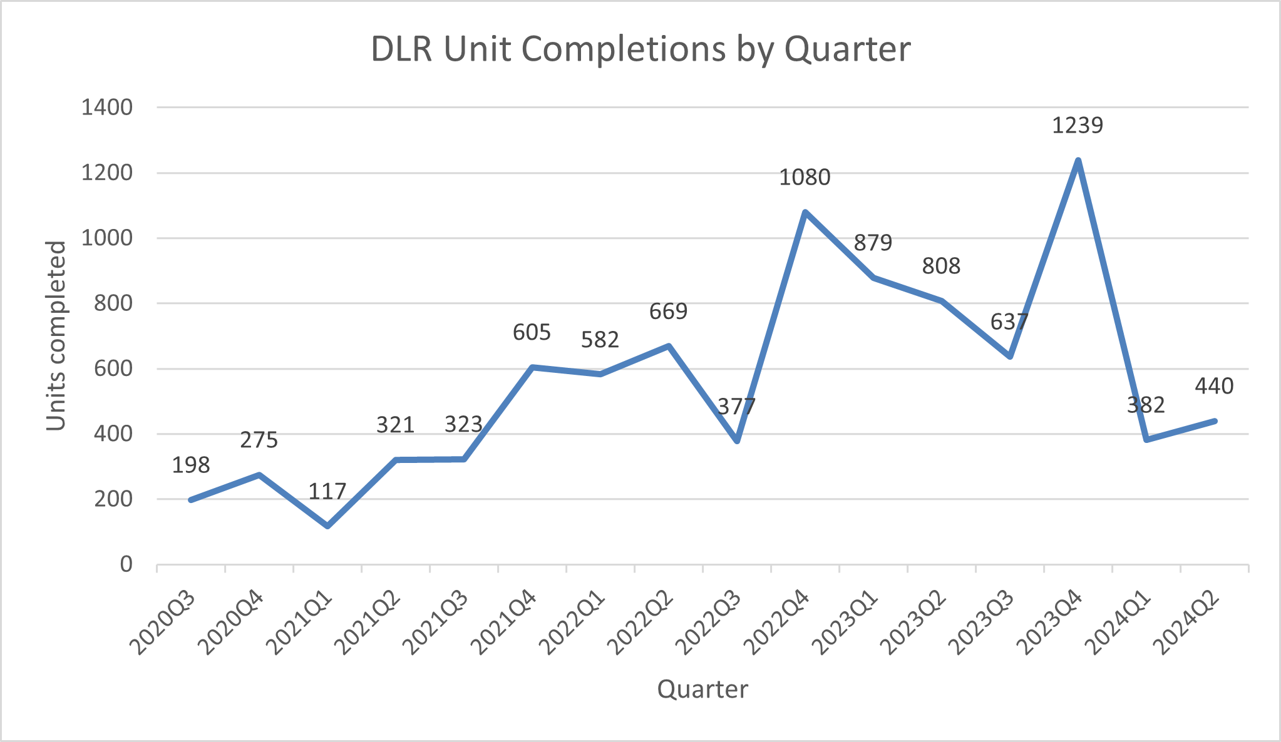

Source: CSO New Dwelling Completions (Table NDQ06: https://data.cso.ie/table/NDQ06)

Residential Commencements
The following data comes from the Building Control Management System and is based on Commencement Notices recorded on a rolling 12-month average basis.

Compared to the post pandemic spike in commencements, the more recent level of commencements in DLR has been somewhat moderated yet remains robust with 2,426 commencements recorded in the 12-month period up to the end of June 2024. This comprises 3% of the national total, over the 12-month period.

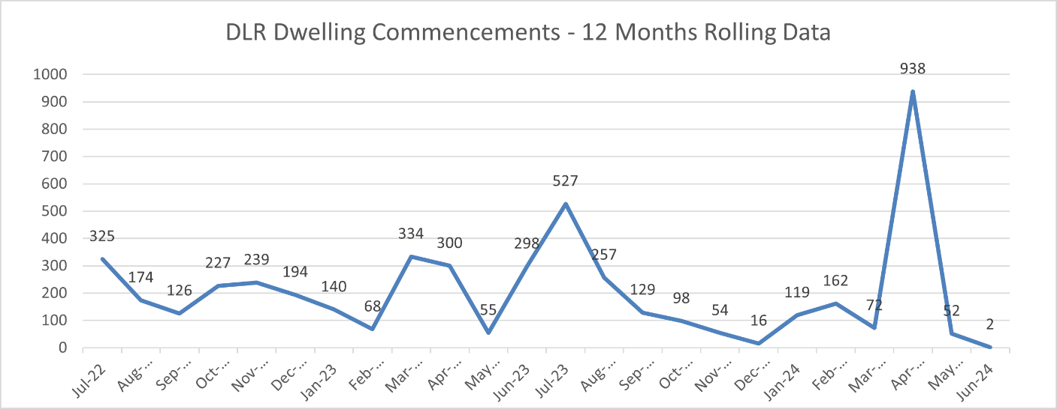
Source: CSO – Commencement Notices (Table HSM13: https://data.cso.ie/table/HSM13)

Residential Construction Activity
The data in the following chart is taken from DLR’s Housing Task Force Returns for Q2 2024 and illustrates the number of homes under construction in the County at each Quarter from Q4 2020 to Q2 2024.

The graph illustrates an upward trend in the number of homes under construction in DLR from c. 3,126 at Q4 2020 to a high of c. 5,844 at Q2 2022. At Q2 2024, c. 2,814 homes were under construction in the county. The decrease in the number of units under construction in DLR between Q2 2023 and Q2 2024 reflects a moderation in residential commencement levels.

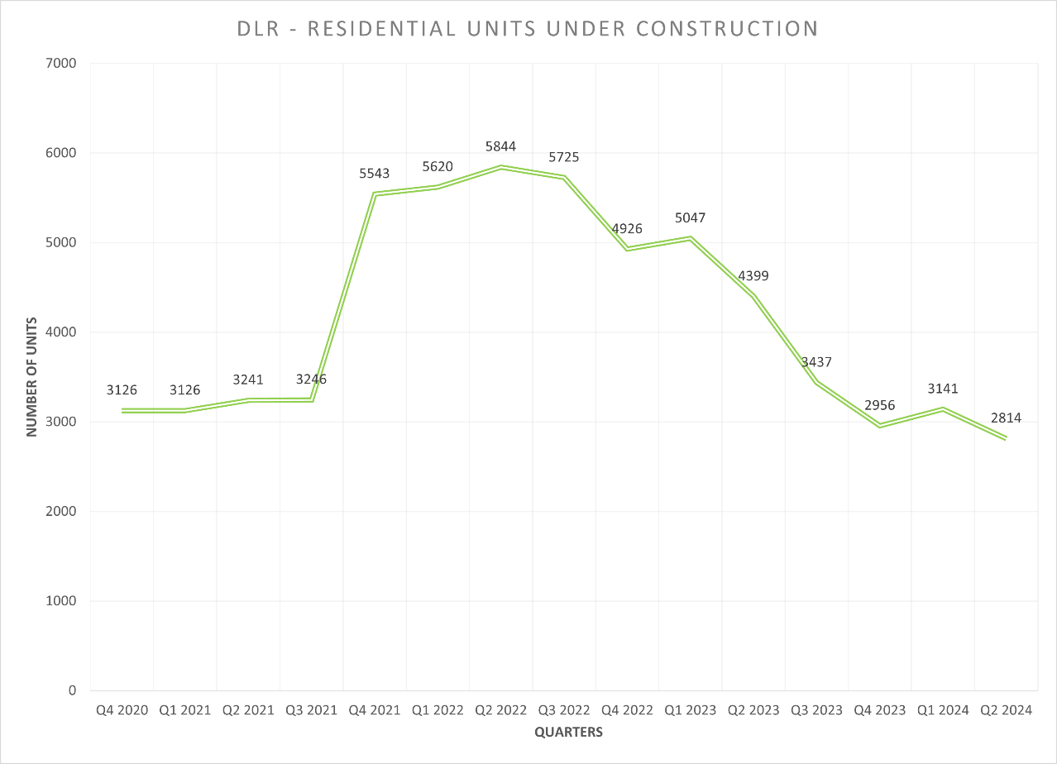
Source: DLR Housing Task Force Returns

Planning Applications in the System Pending Decision
The data in the following chart is taken from DLR’s Housing Task Force Returns (HTF Tier 2A) and illustrates the number of residential units in the planning system pending decision from Q4 2020 to Q2 2024. The graph indicates a relatively high number of units in the planning system with c. 5,607 units awaiting decision at Q2 2024. However, this is a 40% decrease on the 9,421 units in the planning system awaiting decision at Q2 2023.

This trend reflects both the high number of planning applications submitted before the ending of the SHD process with an indication that the backlog of cases awaiting decision with An Bord Pleanála is being reduced as SHD figures awaiting decisions has lowered.
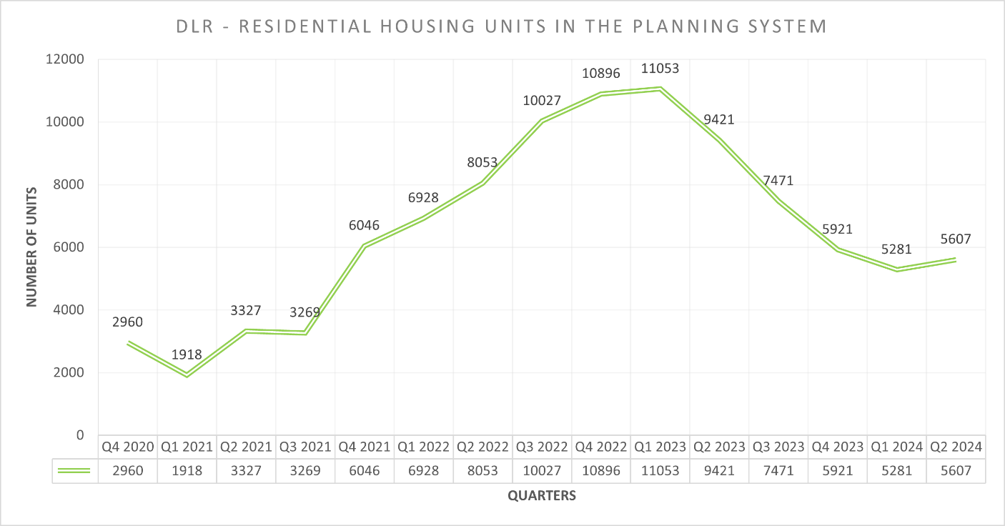
Source: DLR Housing Task Force Returns

Residential Zoned Land Tax
Under the Taxes Consolidation Act 1997 (as amended) the Planning Authority have a statutory requirement to prepare mapping identifying lands that will be subject to the new Residential Zoned Land Tax (RZLT). The administration of the tax is then a matter for the Revenue Commissioners. Although existing residential properties are included on the map they are not liable for RZLT.

A Draft Map was prepared and placed on display in late 2022 and a Supplemental Map, showing additional land, was placed on display mid-2023. Following a process of submissions and appeals, the Final Map for 2024 was published on 1st December 2023. However, following changes announced by the government in budget 2024, the tax will not now become liable until February 2025 to allow for another round of submissions and possible rezoning requests.

The legislation requires that the mapping is reviewed annually and the display of the first draft annual map took place from 1st February 2024 until 31st May 2024. Submissions on whether land should be included or excluded from the map could be made until 1st April and rezoning submissions could be made up until 31st May. 21 submissions seeking an exclusion from the mapping were received within the time period. No rezoning submissions were received. Of the 21 submissions received, 13 were repeat submissions from landowners who had previously sought to have their lands removed under an earlier process. Determinations must be issued by 1st July and those submitters who are aggrieved by dlr’s determination have until 1st August to appeal those determinations to An Bord Pleanála. The outcome of those appeals is awaited. Following those decisions the final map for 2024 will be updated.

Economic Development and Local Enterprise Office

Empowering Business for Climate Action
The 'Empowering Business for Climate Action' event, hosted by Dún Laoghaire-Rathdown County Council and supported by the Local Enterprise Office, Sandyford BID, and Dún Laoghaire-Rathdown Chamber of Commerce, took place at the Dynamic Space in Sandyford Business District on 10th September. The event was brought together businesses of all sizes and sectors to engage in discussions on achieving a net-zero future and to acknowledge their critical role in reducing the carbon footprint of their operations. It also featured guest speaker Colm O'Regan, a renowned comedian and author who captivated the audience with his insights on climate action.

LEO Client & Students Visit the National Ploughing Championship 17th – 19th September 2024
The Local Enterprise Village, an initiative of the Local Enterprise Offices, housed over 30 small businesses which were located at the heart of this year’s National Ploughing Championships.

Representing LEO Dun Laoghaire Rathdown, Chic Tote (www.chictote.com), dedicated to crafting premium-quality canvas totes that embody style, sustainability, and endurance was given the opportunity to exhibit at the Local Enterprise Village to almost 300,000 people.

As part of the Student Enterprise Programme, LEO Dún Laoghaire also arranged for 90 students from 3 schools to attend and see the various businesses on show.

The Student Enterprise Programme empowers students with innovative business ideas and provides them with valuable guidance to refine and develop their concepts. It is open to 1st - 6th years and entries to the mini-business competition are sought in the junior, intermediate and senior categories. These efforts culminate in the county awards which take place on March 27th 2025, and the National Finals on May 8th 2024 in Mullingar.

Dargan Forum
Dún Laoghaire hosted the very well-attended Dargan Forum, supported by Economic Development in DLRCC, in July.

The Dargan Forum seeks to explore technology and social innovation, bringing together speakers and experts to share insights on how technology can be harnessed for the benefit of localities, small businesses and communities across Ireland. Speaker in 2024 included Danish Ambassador to Ireland Lars Theussen, Emma Jones, Founder of Enterprise Nation, Allan Mulrooney, CEO of the Western Development Commission, and Ministers Dara Calleary and Ossian Smyth.

Planning is already underway for the 2025 Forum.

Launch of DLR Local Economic and Community Plan 2023-2028
The Local Economic and Community Plan 2023-2028 was launched on Wednesday September 26th by An Cathaoirleach, Councillor Jim O’Leary.

The Local Economic and Community Plan (LECP) was adopted by Council in April 2024 and is a six-year plan that sets out the objectives and actions needed to promote the community and economic development of Dún Laoghaire-Rathdown’s neighbourhoods and communities. It will give Dún Laoghaire-Rathdown County Council, businesses, community and voluntary groups, and local communities a roadmap to follow over the period to 2028.

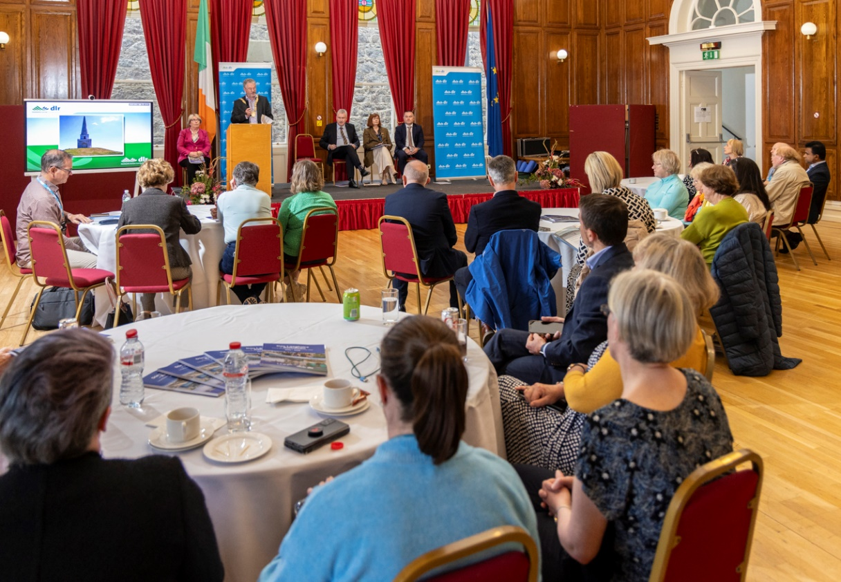

DLR Tourism Development

Events and Festivals in the county supported by DLR

- Coastival 2024 – July 2024
- Ukulele Festival – 2 days live music event taking place in various locations across the town over 24/25th Aug
- Irish Fest in Malwalkee – dlr Tourism contributed to the contingent that represented Dublin county at the huge event in the US. The biggest of its kind in the US it attracts American holiday goers for the last 43 years with an interest in all things Ireland for 4 days every August.
- Dalkey Lobster Festival – August 2024
- GAP Downhill Miniseries – Sept 2024

Our Transition Year Brochure of activities 2024/2025 was published online and emailed to TY coordinators around the county and surrounding counties. The brochure has 15 activities in the county on offer to TY students with Ski Club and Trapeze in Stillorgan being unique to DLR and the only offering in the country.

Seaside Discovery Bus operational June, July & August 2024 bringing cruise guests and locals from the harbour around Dun Laoghaire town, Sandycove. Glasthule and returning to Georges St Dun Laoghaire.

2nd Ezine of the year went out in August with events and tourism news in the county.
Participation in both admin & expert’s group online of the POST (Interreg Atlantic) project focused on the group’s strategic focus finalisation.

Cruise calls Q3
14 calls in July. 21,000 guests and 8,500 crew
13 calls in Aug 25,000 guests and 10,000 crew
6 calls in Sept 10,500 guests and 4,500 crew.

Totalling - 56,500 guests and 23,000 guests

Dún Laoghaire Harbour
Cruise Ship Business
The 2024 Cruise season is underway with 85 vessels currently booked into Dún Laoghaire Harbour. We are working with the Tourism Section, the Dún Laoghaire Business Association and the Dún Laoghaire Chamber of Commerce to maximize the local benefits of the cruise visitors. The Economic Section is working on a town shuttle bus trial for the summer months in an effort to facilitate visitors in travelling into and around Dun Laoghaire Town.

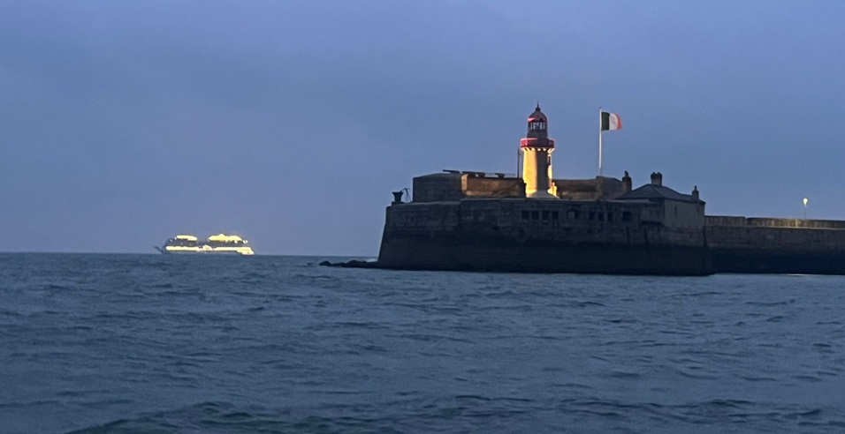
A Cruise Ship arriving into Dun Laoghaire Harbour early in the morning.

Projects:

National Watersports Campus
DLRCC in partnership with Irish Sailing and the Irish Underwater Council have been approved in principle for Stream 1 Grant funding for the development of a National Watersports Campus. We have responded to requests for additional information and are now finalising the grant process and agreements with the project partners. An MOU has been signed with Irish Sailing and Diving Ireland in order to set out and agree the objectives of the project.

A concept brochure was presented to the Elected Members during the February Council meeting and has since been published. It is hoped that this initiative will assist in building momentum and support for the project. This document was presented to Councillors in February 2023.

A scheme to apply for additional “top-up” funding was announced in July and DLRCC have been successful in securing an additional €410,952 for this important project. We are out to tender at present for a design team to commence design and permitting for this exciting project.

Dublin Array Windfarm
The developers of the Dublin Array Windfarm have approached the Harbour about the possibility of establishing an Operations and Maintenance Base for the windfarm. It is hoped that there might be synergies with the Ferry Terminal project. Early engagement is ongoing with the developer’s team to establish the exact requirements.

Harbour Masterplan
A project to create a Masterplan to guide the future development of the Harbour has been approved. Tenders for a design team were issued a consortium led by a Danish firm, Arrow Architects was the successful tenderer. The initial Pre-Draft Public and Stakeholder Consultation will commence early Sept 2024.

Forward Planning Infrastructure

(Local Infrastructure Housing Activation Fund (LIHAF) and Cherrywood Urban Regeneration Development Fund (URDF) - Progress Report

LIHAF
The Department of Housing, Local Government & Heritage (DHLGH) as part of their ‘Rebuilding Ireland’ programme announced in March 2017 that DLR were successful in their LIHAF application in respect of 4 projects, for which final approval for 3 of these projects was received in March 2018.

The underlying principle of LIHAF is to provide public off-site infrastructure to relieve critical infrastructure blockages which have been identified as one of the main impediments to the development of key sites for housing, thus enabling the accelerated delivery of residential units on these sites in both Dublin and urban areas of high demand for housing.

A website published by the DHLGH in August 2023 incorporates an interactive web map that highlights the progression of infrastructure delivery under LIHAF across the State:
https://storymaps.arcgis.com/stories/87cc342bff20462bb896087b0ce16215

As previously advised to the Members, there is 1 remaining active LIHAF project in DLR, an overview of which is as follows;

Project Name | Detail of Infrastructure | Total LIHAF allocation  €M | Amount to be funded by DHLGH  €M (75%) | Amount to be funded by DLR (S48 Cherrywood specific dev contributions)  €M (25%)
Cherrywood | Druid's Glen Road (road only); Druid’s Glen bridge - (short bridge structure traversing Cabinteely stream);  New N11 junction 'Q' at Druid Glen Road; Druid's Glen Road feature bridge (long bridge structure traversing Druid’s Glen and Carrickmines River) | €15.19 | €11.39 | €3.80

The status of the Cherrywood LIHAF project, which is split into 3 phases, is as follows:

- Phase 1 – Complete
Construction works on Phase 1 comprising Junction Q (a new signalised junction on the N11) and part of the Druid’s Glen Road (130m in length) are complete.

- Phase 2 (P* - P3) – Complete
Construction works on Phase 2 of this project comprises approx. 315m of road and a 40m short bridge spanning the Cabinteely Stream are complete from the perspective of Practical Completion

- Phase 3 –Consultants Appointed
The concluding section of the road will comprise approx. 60m of road and a 120m significant bridge feature.

DLR has appointed a multi-disciplinary team of consultants to bring the final Phase of the Druid’s Glen Road infrastructure project from concept design through to completion. Concept and Option Development is currently underway, which will help identify an emerging preferred alignment and bridge design in advance of stakeholder engagement and Preliminary Design.

LIHAF affordability proposal - update
DLR has had extensive discussions with the Cherrywood Landowners and the DHLGH in relation to landowner commitment to LIHAF. Given the passage of time and expiration of the original landowner affordability proposal, a revised landowner affordability proposal is required.

An updated landowner affordability proposal was received in April 2024, which DLR forwarded to DHLGH and subsequently met with DHLGH in May 2024 and more recently in July 2024. A tripartite meeting is to be scheduled for Q4 2024 with the Cherrywood landowners, DHLGH and DLR. In the meantime, the Council will continue to work with the DHLGH and the Cherrywood Landowners in addressing infrastructure deficits required to open up land for development, particularly for housing.

Within the Cherrywood SDZ Planning Scheme Area, statistics regarding grants of planning permission, live applications, commencements, and residential completion are all highlighted in the Planning Update below.

The commencement of the remaining homes granted will be dependent on developer construction programmes, but it is envisaged that the momentum of development that has accrued across the Planning Scheme Lands will continue, and these developers will commence as soon as practicable.

Cherrywood URDF Infrastructure
The URDF 2018 (first call) was established to support more compact and sustainable development, through the regeneration and rejuvenation of Ireland’s five cities and other large towns, in line with the objectives of the National Planning Framework and National Development Plan (NDP). This is to enable a greater proportion of residential and mixed- use development to be delivered within the existing built-up footprints of our cities and towns and to ensure that more parts of our urban areas can become attractive and vibrant places in which people choose to live and work, as well as to invest and to visit.

DLR was successful in obtaining funding under the URDF in respect of the Category A Cherrywood Parks, Greenways and Attenuation Project, the total cost of which is estimated at €17.8M and for which formal approval of the total project was received in June 2020. Funding is by way of 75% direct government funding and 25% funded by the separate Section 48 Cherrywood Development Contributions.

This will see the development of 4 distinct sub-projects comprising the Linear Park, surface water attenuation ponds 2a and 5a and completion of Tully Park Phase 2.

A brief update on the status of each sub-project is as follows –

- Linear Park – Part 8 Planning secured
Statutory Part 8 was approved by the Elected Members on the 13th of June 2022. It is DLR’s intention to progress this project in the second half of 2024 to procure a multi-disciplinary design team to progress the detailed design, procurement, and construction stages of the project. It is likely that the project will be delivered is stages noting the length of the project c. 5kms.

- Pond 2a – at Detailed Design and Tender
Statutory Part 8 stage is complete. Site clearance for ground investigations, ground penetrating radar and topographical surveys is complete. Site investigations including pre-development archaeological investigations have been completed. The tender documentation will be finalised at the completion of the detailed design.

- Pond 5a – at Implementation Stage
DLR has appointed Clonmel Enterprises Limited to undertake the construction works of Pond 5a and work has commenced on site. The construction stage is estimated to be completed in Q1 2025.

- Tully Park Phase 2 – Project complete
Construction commenced on site in June 2021 and is now completed. The Tully Park area (Phase 1 and Phase 2) opened to the public on 31st May 2023.

Urban Regeneration & Development Fund (URDF) Call 2
A second call for proposals under the URDF 2020 was advertised in January 2020. DLR submitted 5 applications for consideration under this Call 2 process on 29 May 2020.

These 5 applications are listed in their ranked order as follows:

- Cherrywood Public Access, Permeability and Amenity
- Dundrum – Civic & Community Centre
- Dún Laoghaire Greening Project
- Sandyford Green Infrastructure
- Shanganagh Park

In addition, a standalone request to initiate a study for Blackrock Village was also submitted. On the 5 March 2021, DLR was notified by the Minister for Housing, Local Government, and Heritage, that two of the applications submitted by the Council for funding, under Call 2, were successful. The DHLGH formally confirmed preliminary approval of the €44,361,115 funding on the 25 of August 2021 for the Dundrum and Cherrywood projects for the inclusion in the URDF supported capital programme and approval to move to the next stage of the project lifecycle, the preliminary business case stage.

Information in relation to the national announcement may be found via the following link: https://www.gov.ie/en/publication/56ef8-urban-regeneration-and-development-fund- urdf/

Cherrywood Public Access, Permeability and Amenity €40,361,115

The infrastructure being provided under ‘Call 2’ consists of the following:

- Castle Street Link - Completion of Cherrywood’s bus priority route to connect it to the existing Park & Ride facility at Carrickmines Luas stop. DLR has appointed a consultant to advance a flood mitigation review to inform the Castle Street Link project and this study is underway.

- Ticknick Park – Ballycorus Access – development of cycle, pedestrian and vehicular
access to Ticknick Park, which opened to the public on 31st May 2023. A prioritisation of options has now been identified and DLR is currently in the process of procuring a consultant to develop the preliminary design and bring the project through the planning stage.

- Town Centre Pedestrian & Cycle Link – development of an elevated pedestrian and cycle bridge within Cherrywood Town Centre. This project is at the concept design stage and is dependent on two of the Town Centre quadrants advancing.

- 3 Public Parks – creation of centrally located, multi-functional spaces providing a focal area for each of the associated village communities.

- Lehaunstown Park – Planning Permission in place​ and it is now intended to progress to the detailed design stage.
​
- Priorsland Park – To be progressed in line with Castle Street Link project​.
​
- Parade Green – To develop concept and commence preliminary design​ stage. The progress of this project will be informed by the adjacent progress of the development plots.

- Smart Parking Study – research and application of measures to create efficiencies in Cherrywood’s required parking provision. DLR established a Framework of technical consultants in May 2024 under a 2-stage statutory procurement process. This process is nearing conclusion with a new Framework being established and this study will be the commission awarded to the new technical consultant on the Framework.

- Beckett Link (& Barrington Rd Connection) – development of circa 2km pedestrian, cycle, and vehicle new link from the Kilternan Link to the Cherrywood Town Centre, to include the uncompleted portion of Barrington’s Road and the construction of an underpass under the Wyattville Link Road.

DLR received confirmation on 14th of March 2023 from the DHLG&H, that five URDF Call 2 projects will be approved to proceed to Decision Gate 2 of the Public Spending Code subject to further information being provided by DLR. This information was issued through an addendum to the Department on the 3rd of May 2023. The final URDF 2 project ‘Beckett Link’ was determined to require a standalone Preliminary Business Case, given the scale of the project which was subsequently approved by the Department on the 24th of July 2023.

This project will be delivered in 2 Phases - The landowner secured planning permission for Phase 1 of this project on 14th November 2022 and DLR has engaged a consultant to progress Phase 1 through detailed design, tender, construction, and handover and final close out. Stage 1 of the 2-stage procurement process to appoint a contractor was completed in Q1 2024. The project is progressing well and is currently progressing with the Detailed Design / procurement stage for this project with a target to commence on site in Q2 2025.

Cherrywood Strategic Development Zone (SDZ) – Progress Report.

The current Main Work Streams include:
- Cherrywood LIHAF - as reported above;
- URDF Call 1 Projects (2018) - Cherrywood Parks, Greenways and Attenuation
- as reported above;
- URDF Call 2 Project (2020) – Cherrywood Public Access, Permeability and Amenity application submitted to DHLGH on 29 May 2020 which received funding approval in the order of c.€40M - as reported above;
- The Cherrywood Steering Group, comprising the Chief Executive and Directors of Services in key service departments met 22 times since it was established in 2017. The Steering Group has been convened to provide oversight in all key aspects of the delivery of the Cherrywood SDZ that cover multi – disciplinary themes;
- Progressing the required legal agreements for the provision of the common infrastructure in the build out of Cherrywood;
- Approved Amendments 1 – 8 to the Cherrywood Planning Scheme 2014 (as amended) are all available to view on the dlr webpage at the following link: https://www.dlrcoco.ie/cherrywood-sdz-news/amendments-cherrywood-sdz-planning-scheme;
- Proposed Amendment No. 9: Car Parking Standards Review – DLR as Development Agency for Cherrywood submitted this proposed amendment to An Bord Pleanála on 31st May 2023. The purpose of this review was to update the approved Planning Scheme 2014 (as amended) to align with National, Regional and Local policy, promote sustainable public and active travel modes and address Climate change mitigation measures. An Bord Pleanála , as the competent authority, notified the DLR on 17 May 2024 that this proposed Amendment No. 9 constitutes a material change but which falls within the criteria set out in subsection 3(b) of the Planning & Development Act 2000, as amended and as such required a statutory public consultation. This process was undertaken and concluded on 1st July 2024. DLR submitted their report in accordance with Section 170(A) of the Act to the Board on 19th July 2024 and awaits their final determination.
- DLR has commenced a plan-led review of the Cherrywood Town Centre and Environs, the purpose of which is to ensure an appropriate mix, quantum and phasing of uses in this area to secure a balance of employment, commercial, retail, residential, community and social uses. A non-statutory Have Your Say public consultation concluded on Wednesday 31st January 2024. The DAPT are now in the final stages of their Review with the intention of lodging a proposed amendment with An Bord Pleanála in Q4 2024;
- The DAPT has established an internal cycling review group to draw from the expertise of the NTA and from within dlr to scope out enhancements to what has been provided in the area and explore new experiences in cycling (including technology). DAPT are also presently engaging with the NTA & TII in the context of further promoting and enhancing active travel modes with the Town Centre & Environs Area, and general connectivity to the wider SDZ Area. It is intended to report on the potential further opportunities for active travel modes and supporting infrastructure such as mobility hubs, within the coming months in Q4 2024.

Planning Applications – FOR NOTING

The Status of applications from 15th June 2024 to 27th September 2024 inclusive is as follows:

- DZ24A/0291/WEB - Domville Amendment to Planning Application DZ17A/0714 - Request for Further Information issued 18/06/2024.
- DZ24A/0366/WEB - Cherrywood Business Park - Building 8 Signage & Facia – Decision to Grant issued 17/07/2024.
- DZ19A/0863/E - Tudor Homes Extension of Duration – Decision to Grant issued 18/07/2024.
- DZ24A/0485/WEB - DLRP Block G3 Science & Technology-based office building – Request for Further Information issued 28/08/2024.
- D24A/0569/WEB - Golf Lane – Request for Further Information issued 20/09/2024.

There are currently 2 live SDZ applications for which reports are being prepared.

To date, the total no. of residential units permitted is 5,071 (this figure includes the application that was previously subject to Judicial Review which is now resolved). An additional 66 units are at Further Information Stage. There are 687 homes under construction and 1,671 units completed. The Tully primary school is also in operation with permission granted for the first post primary school. The Blackrock Educate Together post primary school is currently operating from the primary school site on a temporary basis since the beginning September 2024.

The total amount of non-residential development permitted is circa 113,724 sq.m of Town Centre Mixed use (retail/non-retail/commercial including HIE) including circa 35,340 sq.m of High Intensity Employment (HIE).

Stakeholder Engagement
The delivery of the Cherrywood Planning Scheme is complex requiring a number of stakeholders to engage and DLR, as Development Agency continues to actively promote the implementation of the objectives of the approved Planning Scheme through collaboration and engagement with all relevant stakeholders.

With the Government’s focus on the housing crisis the DHLGH has taken specific interest in progressing the Cherrywood Planning Scheme and has designated it 1 of 23 key strategic national Major Urban Housing Delivery Sites (MUHDS). Meetings with all key stakeholders are on-going with the DAPT facilitating progress meetings on key issues, as they arise, that require a coordinated approach from a number of state agencies and service providers including high-level engagement with the DHLGH on the main issues. In more recent times, Cherrywood has been identified as an optimum location for Transport Orientated Development (TOD) in the Dublin area.
https://www.gov.ie/en/publication/0b532-opportunities-for-transport-orientated-development-tod-in-major-urban-centres-dublin-study/

Funding
The new Development Contribution Scheme in respect of development in the Cherrywood Planning Scheme Area 2023-2028 (“the Cherrywood Scheme”), was adopted at a meeting of the Council on 9th October 2023 having undergone the statutory process in accordance with Section 48 of the Planning and Development Act 2000, as amended. All planning applications for development in the Cherrywood Planning Scheme area will be subject to financial conditions relating to development contributions under this Scheme.

In addition to the Cherrywood Scheme, government funding, LIHAF and URDF (Call 1 and Call 2) have been secured and contribute to the funding of internal common infrastructure. These current funding mechanisms, along with the new Cherrywood Scheme resolve the funding gap that existed in relation to the provision of the entire common infrastructure. The Report indicating the current Programme of Capital Projects 2025 – 2027, due to be presented later in 2024 will provide further detail.

With regard to the application for Cherrywood Public Access, Permeability and Access under the URDF Call 2 DLR received confirmation on 14th of March 2023 from the Department of Housing, Local Government and Heritage (DHLGH), that five URDF Call 2 projects will be approved to proceed to Decision Gate 2 of the Public Spending Code subject to further information being provided by DLR. This information was issued through an addendum to the Department on the 3rd of May 2023. The final URDF 2 project ‘Beckett Link’ was determined to require a standalone Preliminary Business Case, given the scale of the project, which DLR issued to the Department on the 21st of April 2023 and subsequently approved by the Department on the 24th of July 2023. The project is progressing well and is currently at the completion of the documents to advertise for a tender for a contractor Q4 2024.

Infrastructure and Climate Change
CAPITAL PROJECTS

Blackglen Road/ Grange Road Improvement Scheme – Blackglen Road/ Grange Road Improvement Scheme – the Blackglen Road Improvement Scheme was substantially completed on 14th June 2024. The contractor is finishing out snagging and repairs to defects and minor elements of accommodation works. Works to complete road alignment and accommodation works at, and adjacent to, Plot 17 have commenced in late September by a separate contractor. Access to Ticknock Drive to complete foul sewer connection is awaiting final confirmation and start date.

Glenamuck District Roads Scheme (GDRS) including the Enniskerry Road/Glenamuck Road Junction Upgrade (Golden Ball) – Contracts were signed with the successful contractor BAM Civil Ltd. – on the 19th March 2024, with the construction phase commenced in April 2024. The estimated construction period is 2 years. Good progress is being made on Glenamuck District Distributor Road (GDDR), and it is anticipated to have GDDR open to traffic towards the end of Q2 2025.

Druids Glen Road Phase 2 - The scheme was substantially completed and open to traffic on Friday 28th June 2024.

M50 Junction 14 Link Road Tender documents for construction are scheduled to be issued in October, with an estimated construction start date in early 2025. Estimated construction period is 12 months.

Blackrock DART to Park Active Travel Scheme – The former Dublin Bay Trail/S2s scheme now focuses on the link between Blackrock Park and Blackrock Dart station (Blackrock Link). Surveys have been completed and route options have been developed. Multi-criteria analysis has been carried out and preferred design has been developed to preliminary design. Part 8 public consultation closed on 9th August and the Part 8 report will be considered at the October County Council meeting. Discussions with the landowner are ongoing.

Bray Woodbrook Landfill Remediation Project - The Contractor has completed the revetment which stabilises the landfill from sea erosion. Following review of the landfill site as an amenity area, the contractor has imported material from nearby sites to complete the open space. Expected substantial completion October 2024.

Hillcrest Road Improvement Scheme – Surveys and options report have been completed. Preliminary design is substantially complete, and consultations have commenced. Plan to commence statutory process (Part 8) Q 4 2024.

Cherrywood Road Improvement Scheme – At feasibility stage.

SPECIAL PROJECTS

Lehaunstown Neighbourhood Road & Plot A Access – Projects Office is assisting the Client Department, Housing, for this project. SYSTRA has been engaged to carry out preliminary design (to 179A stage) of the neighbourhood road which connects Grand Parade to Lehaunstown Lane as per the Cherrywood Planning Scheme (CPS). Their brief also includes the preliminary design of an access point into the Council’s Housing Plot A. S179a Notice published on 26th July 2024. The proposed new neighbourhood road connecting Grande Parade to Lehaunstown Lane has been approved.
Infrastructure Capacity Assessment Study for Old Connaught and Rathmichael LAPs – Projects office is assisting Forward Planning with this project. ARUP has been engaged to carry out the study. Part 4 is nearing completion, with the expected overall completion due end of October 2024.

Dundrum Community, Cultural and Civic Hub (DCCCH) - An Urban Regeneration and Development Fund (URDF) Call 2 project application was provisionally allocated funding support (up to max of 75% of eligible costs) for advance Public Realm works. Architects Department is developing a project brief. Feasibility of emerging preferred site is under investigation. Indecon Consultants have completed the Strategic Assessment Review (SAR) which has been agreed. Indecon Consultants have completed the draft Preliminary Business Case which is being revised based on DLR comments. Upon direction from the Department there is now a requirement for an additional business case to cover the URDF allocation. Indecon Consultants to be appointed to carry out this additional report. Indecon Consultants have submitted a draft report for this which is under review. Traffico have been engaged to prepare the project brief for the Taney Cross Junction Upgrade Scheme.

Dún Laoghaire Baths Phase 2A (Accessibility/Mobility Works) - the accessibility ramps located at the Baths were opened in July 2024. The Serpentine Path and associated additional works are due for completion in November 2024.

Blackrock Seafront - Initial concept layout ingoing. Consultants to be appointed to carry out the preliminary business case. Early consultations underway.

Samuel Becket Phase 2A – Ballyogan Library - Construction due for completion October 2024

Samuel Beckett Phase 2B - Sports Campus and Swimming Pool. Indecon Consultants have been appointed by the Projects Office to prepare the Preliminary Business Case. The Part 8 was approved at the May County Council meeting. Design consultants are currently being appointed for the detailed design/tender stage.

URDF Call 3 – Dlr has been allocated €6m in funding under URDF Call 3 (DHLGH)for an initial approved programme of 24 properties. Call 3 is designed to address long term vacancy and dereliction across URDF cities and towns and the acceleration of the provision of residential accommodation.

Out of the original list of 27 approved properties, 12 properties were served Derelict Site Notices and several of them were put on the Derelicts Site Register (DSR). These properties have since been made non-derelict and will be removed from the DSR. The property owners have advised us that they plan to develop the site.

DLR submitted five additional properties to the DHLGH to be added to the approved list. The Department have approved two of these properties.

DLR are progressing to acquire two properties by agreement.

Shanganagh Castle Buildings and Grounds - Building ‘B’ (the dormitory building) and Building ‘C’ (sports hall): The DHLGH has decided that the property is no longer under consideration for use under the refurbishment programme.

For Building ‘A’ (Castle – a Protected Structure, RPS No. 1845 refers) the contractor has completed all propping works for immediate works for safe access to the building. Temporary fencing and safety signage has been erected around the immediate perimeter of Building ‘A’. A Shanganagh Castle feasibility report prepared by conservation consultants 7L Architects with assistance from CORA Consulting Engineers has been received. To ensure that further deterioration is limited, ongoing maintenance is required until such time as major capital works can be commenced. The next steps will be an outline brief for roof repairs and review of priority works identified in the conservation and structural reports prior to preparation for tender.

Offshore Windfarms and onshore grid connection - Dublin Array (RWE) will be one of Ireland’s first commercial offshore wind farms to be constructed, helping to meet the Government’s target of 5GW of offshore wind energy being connected to the Irish national grid by 2030. The project intends to apply for planning consent in 2024 and, subject to this being secured, construction of Dublin Array Project could begin in 2027. RWE are currently preparing planning application for submission to An Bord Pleanála (ABP). The application will encompass the entire development, onshore and offshore components, including planned operations and maintenance base in Dun Laoghaire.

IB-Green Corrig Park Sandyford Business Estate - This Sandyford Green Infrastructure Project, a collaborative effort between Dún Laoghaire-Rathdown County Council and Sandyford Business District, aims to transform 0.8 hectares of land into the Sandyford Business District Civic Park, strategically positioned at the junction of Corrig Road and Carmanhall Road, (consistent with SLO 57 CDP 2022-2028). This undertaking not only seeks to enhance the overall quality of public spaces but also addresses heat stress within the business park area. This project is an integral part of the Interreg North-West Europe Programme (NWE) known as IB-Green.

The Council and Sandyford Business District are 2 of the 11 project partners from 6 NWE countries representing local authorities, business park operators and managers, networks, sector organisations and science institutions in the field of climate adaptation who are joining forces to work on this challenge. Special focus lies on older industrial and business parks from the last century which are becoming less attractive. Here, the need for change is high but complex.

The Council’s Property Management Section is progressing engagement with affected parties.

Active Travel Projects

Project Name | Project Description | Development update
Bride's Glen (Cherrywood-Shankill Bridge) | Pedestrian and cycle connection from Bride's Glen Luas Stop via St Colmcille's Hospital grounds and the old viaduct to the footbridge over the N11 north of the Loughlinstown roundabout. | A quick build option that avoids CPO (Compulsory Purchase Order) and land acquisition using the N11 is being progressed. Public consultation period is completed, report to the Members was given in September and the scheme now progress to detail design.
Rochestown Avenue Multi-modal Transport Improvement Scheme | Design of walking and cycling facilities and bus routes along Rochestown Avenue. | Detailed design consultant has been appointed and work is underway.
DLR Connector | Design and implementation of walking and cycling facilities east / west across the County | Non statutory consultation on the project is planned for Q4 2024. Presentation to the DLR Project Governance Board in Oct. Engagement plan to be finalised thereafter.
Dun Laoghaire to N11 (Mounttown Road and Kill Avenue) | Design and implementation of walking and cycling facilities on Kill Avenue, Mounttown Road Upper / Lower, Glenageary Road Upper. | Tender for contractor underway. Construction programmed for Q4 2024
Cherrywood-Sandyford greenway | Design and implementation of a cycle route between Leopardstown Road and Ballyogan / Cabinteely area. | Options report received and being reviewed
Park to Park and Mountains to Metals Routes | Active School Travel Route commencing in Loughlinstown and ending in Blackrock via Loughlinstown Linear Park - Kilbogget Park - Clonkeen Park - Deansgrange - Rockville Park. | Deansgrange Road construction completed
Seafield Safe and Quiet Streets | Traffic calming and public realm enhancement scheme developed in conjunction with residents. | Construction underway
Love our Laneways | Upgrade of the existing laneways in Sallynoggin. | Construction underway
Cabinteely Park Greenway | Cornelscourt Road to Cherrywood. | Pre-design consultation completed and preparation of Part 8 documentation ongoing
Safe Routes to Schools | Carysfort NS, Holy Family, Holy Cross, St. Kevin’s, St. Patricks, The Harold, Sion Hill | Lot 1 consultation completed and progressing to detailed design. Lot 2 design underway.
Living Streets: Dun Laoghaire | Pathfinder project | Part 8 completed detailed design underway with first phase of works planned for Q4 2024
Living Streets: Blackrock | Permanent scheme for the village. | Detailed design continuing. Tender for contractor programmed for Q4 2024
Living Streets: Coastal Mobility Route | Permanent scheme | Public consultation completed. Scheme has been referred to An Bord Pleanála (ABP). Awaiting response from ABP
Deerpark Entrance Improvements | Accessibility improvements to the entrance off North Ave | Construction underway
Sandyford Business District | Active Travel improvements along Blackthorn Road | Revised general arrangement (incorporating the updated details from cycle design manual) completed and agreed with NTA. Detailed design progressing
Dodder Greenway | Quick build scheme along Dodder Road Lower | Public Consultation completed report to the Dundrum Area committee in October
Stillorgan Park Road | Active Travel improvements from N11 to Carysfort Avenue | Construction ongoing

Climate Action

- As a requirement of the Climate Action and Low Carbon Development (Amendment) Act 2021, each local authority prepared a Climate Action Plan in 2023/2024, addressing both climate mitigation and adaptation.
- Continued development of a roadmap for the implementation of the dlr Climate Action plan 2024-2029.
- Dublin Climate Action Week 2024 took place from the 9th to 15th September. Dlr scheduled 8 public facing events, two internal Smart Dublin events, and liaised and publicised concession offers with bike and car share schemes operating in the county. The week was widely publicised and saw the events listed highly subscribed and attended:

  - DCAW24 joint launch by four Dublin local authorities.
  - Love your leftovers – tackling food waste together.
  - Empowering Businesses for Climate Action
  - dlr Energy tune-up clinic for homes and small buildings
  - Integrated Constructed Wetland Tour - Kilbogget Park
  - Slang Greenway Guided Cycle, Dundrum to Marlay Park
  - Biodiversity Talk and Walk – Carysfort Park
  - Free take back of WEEE - Dart Station Car Park, Rathsallagh Drive, Shankill
  - Two internal dlr SMART Dublin events in Ballyogan and Co. Hall

Community Climate Action Fund

Applications for the Community Climate Action Programme were assessed by an in-house evaluation panel. Following the evaluation, a portfolio report containing a list of recommended projects was sent to DECC for approval. From the 35 applications received, a total of 28 projects were recommended for funding to DECC and were accepted to proceed. Dlr is currently working with successful applicants on project implementation.
The successful projects for funding are listed in Strand 1 table:

Project Size | Number Recommended | Funding Distribution by recommended projects | % of Fund
Small Projects | 12 | € 106,725 | 12%
Medium Projects | 11 | € 337,025 | 38%
Large Projects | 5 | € 439,250 | 50%
Total | 28 | € 883,000 | 100%

Strand 1 of the Community Climate Action Programme
 | Group Name | Grant Amount
1 | Dalkey Hillside Estate | € 5,170
2 | Fernhill Community Garden | € 4,850
3 | Foxrock Area Community & Enterprise CLG (FACE) | € 14,090
4 | Sallynoggin Estate Mgmt Forum | € 12,903
5 | Wedgewood Residents Association | € 17,475
6 | Pine Valley Residents Association | € 1,708
7 | Meadowbrook Residents Association | € 5,563
8 | Delbrook Park Residents Association | € 12,575
9 | Mount Merrion Community Centre | € 1,761
10 | Kilternan Parish | € 20,000
11 | St Patrick's Parish | € 9,140
12 | Sandyford Downes Residents Association | € 1,490
13 | Meadowvale Tennis Club | € 22,000
14 | The Bike Hub | € 50,000
15 | Blackrock Community Men's Shed | € 34,100
16 | Shanganagh Community Gardens | € 27,915
17 | Airfield Estate | € 27,231
18 | Wayside Celtic FC | € 28,519
19 | Dalkey Parish | € 31,972
20 | Shankill Old Folks Association | € 20,500
21 | Ballybrack Project Centre | € 43,770
22 | Dublin Society of Model and Experimental Engineers (DSMEE) | € 25,824
23 | Stillorgan Rathfarnham RFC | € 25,194
24 | Dundrum Methodist Church | € 78,869
25 | Shanganagh Park House and Stonebridge CC | € 86,333
26 | St. Anne's Parish Shankill | € 97,958
27 | Naomh Olaf GAA | € 96,090
28 | Ski Club of Ireland, CLG | € 80,000
 | Total Funding: | € 883,000

Environmental Awareness

- Under the dlr Community Clean-up Scheme, over 45 community groups received 1,530 blue bin bags, 130 litter pickers and 275 pairs of gloves to carry out local community clean ups in Q3.
- A total of 33 Residents Associations’, Tidy Towns, Tidy Districts and Estate Management Groups, entered and were evaluated for the Tidy Districts Awards 2024, including site visits from the Environmental Enforcement Wardens. The Tidy District Awards Ceremony will take place on 3rd October 2024.
- Over 40 people attended the ‘Love Your Leftovers’ workshop on food waste, which was held in Dundrum on 10th September 2024, as part of Dublin Climate Action Week. Partners included the Regional Waste Management Office, FoodCloud Kitchen, Composting Ireland, Learn Local, Community Collectives and My Waste.
- The Green School Program for 2024/2025 was launched in September and promoted to all 118 participating schools in Dún Laoghaire-Rathdown, including 75 schools who are eligible to renew their green flag or to rejoin following deferral.
- Multiple funded workshops and training opportunities for schools in 2024/2025 were promoted widely via email and social media including ReLove Fashion, the Rubbish Film Festival, Composting and Recycling for Schools and Picker Pals.
- A total of 86 dog owners responded to the Green Dog Walkers Campaign and took the pledge to be a responsible dog owner, as promoted via the Belly Bin campaign and by local business including vets, groomers, dog shelters, dog friendly cafes and doggy day care.
- The annual Gum Litter Taskforce Roadshow visited Blackrock Park on Wednesday 3rd July, and was welcomed by An Cathaoirleach, Cllr. Jim O’Leary with Blackrock Tidy Towns group.
- The Environment and Climate Action Grant 2025 was launched on 25th September and will remain open until 25th October 2024.

Green business

Green business work completed or ongoing in the period for the following items:
- Empowering Business for Climate Action event held during Dublin Climate Action Week received very positive feedback and stemming from that dlr will aim to run similar type events in 2025 specific to businesses.
- The Ardagh Group have provided funding to a local school for a long-term biodiversity project and have recently made further commitments to support several more schools for the next three years beginning in 2025. This is part of their corporate social responsibility drive.
- Dlr encouraged businesses to enter the Chamber Awards 2024 Climate Action Success for less than 50 employees and greater than 50 employee categories and liaised with the Chamber throughout the process.
- Commenced application for Green Hub grant to run a pilot project on the segregation of waste in Nutgrove Shopping Centre as part of the national drive to segregate more recyclables.

Property Management

Re-opening of Carnegie Library @ IADT - former Carnegie Library and ground floor Carnegie Offices, Library Road, Dún Laoghaire:
Formal launch of the library and offices took place 4th April, 2024. Up to 50 IADT staff are now in situ in the Carnegie Offices and the Library Building is in the process of being handed over for post-graduate, lecturing and tutorial usage. The IADT intend to appoint an Events Manager to prepare a schedule of calendar events for the library and will be working with local artists groups looking to utilise the former library building. Negotiations on a Lease agreement with IADT are progressing.

9 Georges Place & The Washhouse, Kelly’s Avenue, Dún Laoghaire:
The application for Strand 1 THRIVE funding for George’s Place, Dún Laoghaire was successful (subject to pre-agreement conditions).

The funding is for up to €200,000 for the renovation, renewal, and adaptive reuse of two vacant protected structures, nos. 9 George’s Place and the former Wash House and Council Stores, Kelly’s Avenue, Dún Laoghaire.

A Public Consultation Survey for the Integrated Urban Study of George’s Place and Kelly’s Avenue is now live on the dlr consultation portal. It will be open for responses until 31 October. https://dlrcoco.citizenspace.com/architects/integrated-urban-study-for-george-s-place-kelly-s/

Acquisition of 12.3HA / 29.4 Acres of land at Brennanstown / Lehaunstown, Co. Dublin
The Council intends to use the lands for the development of housing, including the provision of social and affordable housing, provision of land for Cherrywood Green Routes Network and for heritage & conservation purposes (Glendruid House, a Protected Structure).

Women’s Refuge, Sandyford: Draft Lease under review.

Disposal of Council owned lands adjacent to 1 St. Luke’s Crescent, Dundrum, Milltown, Dublin 14 APPROVED.

First and Fifth Floors, Block 2, Harbour Square, Dún Laoghaire, to RWE Renewables Ireland Limited - 10-year Leasehold Agreement APPROVED.

Pavilion, Dún Laoghaire – Engagement on-going with Lessee with regard to extending Lease.

Acquisition of new Property and Land Register: Property Management section have procured a new IT platform through eTenders called Property Portfolio Register (PPR) which has been developed by an Irish based supplier; Mallon Technology Limited. The product is tailored specifically for local authorities and can be utilized to centrally monitor and manage corporate buildings as well as the wider County Council estates, lands and property portfolio.

The procurement of Property Portfolio Register (PPR) will allow for the development of a Corporate Space Strategy for both occupied and vacant buildings and land holdings to ensure maximization of space usage, expand our Contract and Facilities Management Units to build frameworks that can support and maintain our corporate buildings.

Derelict Sites Register 30th September, 2024

Derelict Sites Reference | Location | Section 8(2) Notice served | Date Entered on Register
DS: 1223 | 95 Strand Road (Martello House), Killiney, Co. Dublin | Sep-14 | Dec-14
DS: 1549 | Saint Annes, Love Lane, Upper Dargle Road, Bray, Co. Dublin | Jul-17 | Dec-17
DS: 1528 | Larabeag, Tivoli Terrace North, Dún Laoghaire, Co. Dublin | Aug-17 | Mar-18
DS: 1622 | 31 O'Donnell Gardens, Glasthule, Co. Dublin | Apr-20 | Sep-20
DS: 1628 | Wynnstay House, Clonskeagh Road, Clonskeagh, Dublin 14 | Sep-20 | Apr-21
DS: 1604 | Torca Road, Dalkey, Co. Dublin | Sep-20 | May-22
DS: 1705 | 25 Glenageary Road Upper (former Nursing Home), Glenageary, Co. Dublin | Nov-23 | Jan-24
DS: 1714 | Old Dunleary House, Cumberland Street, Dún Laoghaire, Co. Dublin | Jan-24 | Feb-24
DS: 1712 | 17 Patrick Street, Dún Laoghaire, Co. Dublin | Jan-24 | Feb-24
DS: 1679 | 1 and 2 Annaville Avenue, Blackrock, Co. Dublin | Sep-23 | Mar-24
DS: 1696 | Waverley Lodge, 61 Carysfort Avenue, Blackrock, Co. Dublin | Jan-24 | Mar-24
DS: 1685 | 22 Woodlawn Park, Churchtown, Dublin 14 | Apr-24 | May-24
DS 1450/51 | York House, 30 York Road/ Tivoli Lodge, Tivoli Road, Dún Laoghaire, Co. Dublin | Feb-24 | Jun-24
DS 1646 | 65 Deerpark Road, Mount Merrion, Blackrock, Co. Dublin | Apr-24 | Sep-24
DS 1544 | 3 Upper Albert Road, Glenageary | Jun-24 | Sep-24

Letters of consent 1st Jan, 2024 to 30th September, 2024
- 26 Letters of Consent
- 6 Re-issues

Sandyford Commercial consents
23 Sandyford consents applications have been received for since 1st January, 2024.

*The Planning and Development Regulations 2001-2020 (Schedule 3, Prescribed Notices, Form No. 2, p426) specifically states that “If you are not the legal owner, please state the name and address of the owner and supply a letter from the owner of consent to make the application as listed in the accompanying documentation.”

Environmental Enforcement Section

Animal Control Unit
An awareness campaign was undertaken to remind dog walkers of their responsibilities under the Litter Pollution Act to clean up after their dogs in high traffic areas along the coast and in our parks. As part of this initiative, our Environmental Enforcement Wardens also educated the public on the requirements of the Control of Dogs Act to ensure dogs are accompanied in public and kept under effectual control, as well as the requirements of the Control of Dogs Regulations, which requires restricted breeds to be leashed and muzzled.

All staff in the section have also prepared for the enactment of the new regulations on XL Bully type dogs, due to come into force on the 1st October.

Litter Monitoring Surveys
The Environmental Enforcement Unit completed the majority of the 200 Litter Pollution surveys and 36 Litter Quantification Surveys as part of the National Litter Monitoring Programme in Quarter 3.

Air Monitoring
The section has now installed 12 air quality monitors in strategic locations around the County. All the sensors are available to view on https://airly.org/map/en/.

Waste Collection Permit Monitoring
The Enforcement Section will validate 2023 waste collection permit data returns from waste collectors that operate from dlr. Detailed audits will be undertaken with certain waste collectors in our county with a focus on waste streams such as construction and demolition waste.

Dublin Agglomeration Noise Action Plan 2024-2028
The Dublin Agglomeration Noise Action Plan was made on 18 August 2024 and is available on the dlr website. https://www.dlrcoco.ie/environmental-health/environmental-noise

Recommended Minimum Criteria for Environmental Inspections (RMCEI plan)
Recommendation of the European Parliament and the Council Providing for the Minimum Criteria for Environmental Inspections in Member States (2001/331/EC) Inspection & Compliance Plan under RMCEI 2024 has been supplied to the EPA. The Inspection and Compliance Plan (relates to the environmental enforcement (air, noise, waste, litter) and water pollution control in the functional area of dlr for the period 1 January to 31 December 2024.

The 2024 Plan continues to be implemented and encompasses both routine and non-routine environmental inspections to be carried out in the year. It includes monitoring and inspection of permitted activities and ensuring compliance by the public and the commercial and industrial sectors with regards to environmental legislation.

Waste Management Section
We provide 3 Recycling Centres and 37 Bring Centres throughout the County.

Ballyogan Recycling Park accepts a wide variety of waste types, Eden Park and Shanganagh Recycling Centres accept mainly mixed dry recyclables and the Bring Centres accept glass bottles and aluminium/steel cans and textiles. Hard Plastics were accepted on a trial basis at Shanganagh and this service is continuing.

We participate in the Rediscovery Paint Re-Use Scheme and the Rotary Bikes to Africa Scheme at Ballyogan Recycling Park.

WEEE Ireland held a free WEEE collection at Shankill Dart Station car park on 14th September and the annual free mattress collection or Mattress Amnesty was held at Ballyogan Recycling Park on 21st September. A total of 1,155 mattresses weighing 18.18 tonnes were collected for recycling into insulation and padding for the furniture and bedding industry.

National Waste Management Plan for a Circular Economy 2024-2030
The implementation of the Plan will be co-ordinated by the existing Regional Lead Authorities, Regional Waste Management Planning Offices, supported by the established regional waste steering groups.

Environmental Enforcement

DATE | Number | Comment
Enforcement Complaints – Opened | 153 | Air/Noise/Waste
Enforcement Complaints – Closed | 155 | Air/Noise/Waste
Environment Cases – Opened (Dumping/Litter) | 375 | Litter Section
Environment Cases – Closed (Dumping/Litter) | 387 | Litter Section
Abandoned car Cases - Opened | 138 | Waste Section
Graffiti Cases - Opened | 273 | Waste Section
Presentation/Storage of Waste – Opened | 76 | Waste Section
Litter Fines issued | 83 | Litter Pollution Act/Litter Bye-laws
Waste Fines issued | 22 | Waste Bye-laws/Waste Management Act
Legal Proceedings initiated | 9 | Litter Pollution Act/Litter Bye-laws/Waste Bye-laws/Waste Management Act

Routine Enforcement Section Inspections | Number completed
Air and Noise Incident/complaint related inspections (non-routine) | 29
Ambient Air Monitoring Programme | 6
Article 27 Inspections | 3
Construction & Demolition handling at development sites | 30
Commercial Food Waste | 18
Deco Paints Regulations – Vehicle Refinishers | 2
Hazardous waste (e.g., garages, mini-labs, C&D sites, industrial, healthcare & others) | 1
Inspections (environmental) in advance of grant/refusal of planning permission | 51
Inspections (environmental) of existing planning permissions | 60
Mercury inspections | 21
Solid fuel regulations | 12
Solvents Regulations (e.g., Dry cleaners, surface cleaning etc.) | 4
Tyres and End of Life Tyres | 39
Vehicle Checkpoints | 5

Dog Statistics from 21st June 2024 – 30th September 2024
No. of dogs on hand on 21st June | 3
No. of dogs entering the shelter | 21
No. of dogs surrendered | 0
No. of dogs rehomed | 4
No. of dogs reclaimed | 6
No. of dogs sent to rescue | 11
No. of dogs put to sleep | 2
No. of dogs remaining in the pound on 30th September | 1
Dog attacks in this period | 19 – 8 on person

  - Roads Admin
Roads Admin Stats | July 24 | August 24 | Sept 24
Taking In Charge Certs | 211 | 180 | 190
Footpath Dishings | 11 | 7 | 5
Hoarding Licences | 6 | 3 | 3
Surface Permits | 5 | 12 | 7
Road Opening Licences | 220 | 161 | 170
CRMs (Processed) | 410 Processed | 327 Processed | 353 Processed

  - Cleansing, Beaches & Coastal Protection Quarterly Section Statistics:

Cleansing & Beaches Stats | Jun  2024 | Jul  2024 | Aug  2024
Weight of Rubbish Collected from Streets/Beaches (tonnes) | 218 | 248 | 197
Clean-Ups Assisted | 89 | 91 | 73
Animal Removals from Public Spaces | 42 | 41 | 30
Bathing Water Samples Taken | 36 | 49 | 38
Gullies Cleaned | 753 | 1958 | 1611
Dumping Incidents Managed | 41 | 65 | 61
Bathing Water Pollution Incidents Detected | 1 | 3 | 7
Reported Overflows from Drainage Network to Bathing Water | No report received | No report received | No report received
Street Bin Collections | 5026 | 5089 | 5154
Filming/Event Licenses | Filming – 0  Events -5 | Filming – 0  Events - 8 | Filming – 0  Events –4

  - Road Restoration Programme

Public Lighting
Work continues on the replacement of the old lights with LED lighting which is more energy efficient, gives less maintenance and improved service. General maintenance including upgrading of brackets, columns and Networks is also on-going.

Public Lighting Maintenance
Number of repairs carried out in Q3 2024: | 550
Percentage of lights out at the end of Q3 2024: | 0.6%
Pole replacement carried out in Q3 2024: | 10
Bracket replacements: | 145
Tree trimming: | 35
ESBN Connections/ Requests: | 18
LED Upgrades | 213
Total lights upgraded to LED | 22,078
Total percentage (%) of lights as LED | 90.3%
(extra lines added)

LED Upgrading Program
ABBEY PARK | 1
ALBERT ROAD | 1
AVOCA AVENUE | 2
BALLINTEER ROAD | 4
BEAUMONT AVENUE | 1
BENTLEY VILLAS(OFF CLARENCE STREET) | 1
COLLEGE RD | 1
CROFTON AVENUE (GEORGES PLACE) | 1
CROMLECH CLOSE | 1
CROSTHWAITE PARK SOUTH | 3
DALKEY AVENUE | 2
DELBROOK PARK BALLINTEER | 1
FOXROCK GROVE | 1
FRASCATI PARK | 8
GEORGES PLACE (DUN LAOIRE) | 4
GLENAGEARY ROAD LOWER | 1
GRANVILLE PARK (NEWTOWNPARK AVE.) | 1
HARBOUR ROAD | 1
HYDE ROAD | 1
LORETO AVE | 1
LOUGHLINSTOWN DRIVE | 1
LUDFORD DRIVE | 2
MOUNT ANVILLE ROAD | 1
MOUNT MERRION AVENUE | 1
O DONNELL GARDENS | 1
OLD DUBLIN ROAD | 1
ORPEN ESTATE | 2
PAKENHAM ROAD | 1
ROCHESTOWN PARK | 1
St. Helens Wood | 2
STATION ROAD (GLENAGEARY) | 1
SWEETMOUNT AVENUE | 1
SYDNEY AVENUE | 1
TEMPLE CRESCENT | 8
TEMPLE PARK AVENUE | 3
THE MAPLES (OFF BIRD AVE) | 2
THE OAKS (CHURCHTOWN RD.UPR.) | 1
THE SLOPES | 1
TIVOLI TERRACE NORTH | 1
UPPER KILMACUD RD EXTENSION | 1
WOODLAWN PARK | 9
WYATTVILLE PARK | 2
ALBERT ROAD | 1
BEAUMONT AVENUE | 1
BEECH GROVE | 1
BRAEMOR PARK | 2
CARRICKBRENNAN ROAD | 4
CHARLEMONT AVENUE | 1
CHURCHTOWN ROAD LOWER | 1
CHURCHVIEW ROAD | 1
CLIFTON AVENUE | 2
DE VESCI TERRACE | 3
DUNDRUM BY-PASS | 1
DUNLEARY HILL | 1
FLEMINGTON PARK | 2
GLENCAIRN ESTATE (THE GALLOPS) | 1
GLENVIEW PARK | 1
GREY GATES (INCL. 6 LIGHTS IN GREEN) | 2
Griannan Fidh | 1
Harbour : Car Park Area Lighting | 1
HEATHER ESTATE | 1
HENLEY PARK | 1
KILMACUD ROAD UPPER | 1
LAMBOURNE WOOD | 1
LANDSCAPE ROAD | 1
LORETO AVE | 1
MARIAN PARK BLACKROCK | 2
MARINO AVENUE WEST | 1
MONKSTOWN CRESCENT | 2
MONKSTOWN ROAD | 1
MOUNT MERRION AVENUE | 1
MURPHYSTOWN ROAD (16 SERVICED BY DCC) | 3
N31 Harbour Road | 3
OLD DUBLIN ROAD | 2
ORPEN ESTATE | 1
ORWELL GARDENS | 5
OTRANTO PLACE | 2
PEARSE STREET | 2
ROEBUCK CASTLE ****** | 1
SANDYCOVE AVENUE EAST | 8
SANDYCOVE AVENUE WEST | 4
SEAFIELD AVENUE | 1
ST. FINTANS PARK | 1
ST. LUKES CRESCENT | 1
THE RISE(MOUNT MERRION) | 1
VICO ROAD | 1
WALKWAY PEARSE GARDENS/SALLYNOGGIN ROAD | 1
WALKWAY PEARSE PARK/PEARSE GARDENS | 1
WOODSIDE DRIVE | 2
ADELAIDE STREET | 1
BELGRAVE ROAD | 1
BROADFORD ROAD | 1
CHARLEMONT AVENUE | 1
CHURCHFIELDSDUNDRUM | 1
CLONSKEAGH ROAD | 2
CLONSKEAGH ROAD(CONTD. FROM DUB REGION) | 1
COPPINGER ESTATE | 1
DUNDELA PARK | 1
DUNEDIN DRIVE | 1
DUNEDIN TERRACE | 3
EDEN PARK | 2
Grange Hill | 1
HOLLYPARK | 1
IDRONE LANE | 1
KERRYMOUNT ESTATE | 1
KILCROSS ESTATE | 1
MARETIMO GARDENS EAST | 6
OLIVER PLUNKETT TERRACE | 1
RATHSALLAGH PARK | 1
ROSEHILL | 1
SAND.I.E. CARMAN HALL ROAD | 1
SHANDON PARK | 1
St. Helens Wood | 5
ST. KEVINS VILLAS | 1
ST. PATRICKS CRESCENT Monkstown | 1
ST. PATRICKS ROAD | 3
THE PALMS | 1
VICO ROAD | 3
WOODBROOK DOWNS | 1

Planning and Building Control

Applications analysed | 89
Inspections completed | 6

Requests
Light requested by stakeholders (completed)

Additions: | 1
Alterations: | 8
Legal requests: | 3

Roads Control
Ref. | Programme Type | STATUS
RCRP | Roads Control Programme 2024
1 | Landscape Road | Uisce Eireann (UE) have have agreed on the amount of funding towards the full rehabilitation of Landscape Road. The tender documents have been reviewed and the successful Tenderer has been notified, we are currently waiting a commencement date for the works. Footpath works added to the scheme and are being completed by the Contractor prior to the road surfacing works.

Road Opening Licences (26th August to 30th September)

National Maproad Roadworks Licensing MRL System
Applications Received | 208
Applications Not Processed Yet | 53
Applications Refused/Withdrawn | 5
Valid Licenses Issued | 131
Licensed Works Completed | 13
Applications Expired | 6

Section 254’s
Local Authorities, in their capacity as planning authorities, are tasked with the issuing of licenses for the placement of appliances, cables, signs, and/or other items on public roads under Section 254 of the Planning and Development Act 2000. The Road Maintenance Section is the area responsible for the issuing of such licenses for above ground telecommunications infrastructure.

Section 254 – Above Ground Telecommunications Infrastructure
26th August to 30th September
Applications
Received | 0
Granted | 0
Withdrawn | 0

Architects
Energy
The dlr Energy Team coordinated a dlr Energy Tune Up Clinic in the dlr LexIcon as part of Dublin Climate Action Week.

Open House Dublin
The annual architecture festival is taking place 12-20 October. There are a wide range of guided tours, workshops, presentations and discussions taking place, for all ages. Some events require advance booking https://openhousedublin.com/

Dangerous Buildings
Dangerous | 0
Potentially Dangerous | 13
Not Dangerous | 2
Total | 15

Conservation Q3 Report
Planning Applications  (inc.FI & comp reports) | 58
Section 5 Declarations | 18
Pre-planning | 9
Section 57 Declarations | 2

Community, Cultural Services & Parks
Community Integration Forum (formerly Community Response Forum)
The Community Response Forum has been renamed the Community Integration Forum. It met 7 times in relation to IPAs & Ukrainians between April to June 2024. The focus of the Forum is on co-ordinating the response to the arrival of both International Protection Applicants and Ukrainian refugees in the County. The wide range of stakeholders in the Forum remains in place.

A range of supports and activities are in place which include English language classes and employment support classes.

Joint Policing Committee (JPC) & Local Policing Fora (LPF)
A meeting of the Sandyford/Stepaside LPF took place on 13th August 2024.
A meeting of the Dundrum/Stillorgan LPF took place on 20th August 2024.
A meeting of the Central Dún Laoghaire LPF took place on 3rd September 2024.
A meeting of the Loughlinstown/Ballybrack/Shankill LPF took place on 17th September 2024.

Joint Policing Committee Meeting (JPC) & establishment of new Local Community Safety Partnership (LCSP)
In accordance with the Policing, Security and Community Safety Act 2024 the JPC has been replaced with the Local Community Safety Partnership (not yet established in LA’s). The last meeting of the JPC was the Public Meeting held on 28th May 2024.

During July 2024 dlr invited expressions of interest for consideration to the appointment of Chairperson of the new Local Community Safety Partnership (LCSP) which will be established in dlr in line with the Policing, Security and Community Safety Act 2024. The closing date was on 2nd August 2024. The submissions received are currently being assessed.

Community Integration Forum (formerly Community Response Forum)
The Community Response Forum has been renamed the Community Integration Forum (CIF). It met every second Monday to discuss and coordinate support services to IPAs & Ukrainians between July and September 2024. The focus of the Forum is on co-ordinating the response to the arrival of both International Protection Applicants and Ukrainian refugees in the County. The wide range of stakeholders in the Forum remains in place and the CIF is chaired by Chief Executive Frank Curran.

A wide range of supports and activities are in place which include HSE clinics and health services provision, English language, digital skills, employment and job seeking supports, support with school places, young people’s activities, volunteering opportunities, provision of sporting, health and wellbeing, social, cultural activities etc.

dlr Local Authority Integration Team (LAIT):
The dlr Local Authority Integration Team was established in the Community Section of dlr County Council at the end of July with an Integration Support Coordinator, two Integration Support Workers and an Assistant Staff Officer in place to support International Protection Applicants (IPAs) and Beneficiaries of Temporary Protection located in the various centres across dlr, working in collaboration with many other organisations supporting new arrivals to dlr. All local authorities are currently recruiting or have recruited LAIT’s which are funded and supported by the Department of Children, Equality, Disability, Integration & Inclusion (DCEDIY) and the Local Government Management Agency (LGMA). The LAIT’s report to their Local Authority Community Integration Fora and to the LGMA & DCEDIY on a regular basis.

During August & September, the dlr LAIT visited accommodation centres across dlr hosting clinics to meet residents and to assess their needs, assist with queries and to signpost and encourage engagement of new arrivals with local service providers appropriate to their needs - employment, developing English language proficiency, training, healthcare, volunteering, childcare & education, sporting, community activities etc.

The dlr LAIT have also been meeting the various organisations that are providing support to IPA’s and BOTP in dlr to map service provision, identify any gaps in service provision avoiding duplication and to identify collaborative projects to support residents and assist with integration in the community.

New initiatives such as Volunteering training with dlr Volunteering Centre; football, running and hiking activities with dlr Sports Partnership, Cuala GAA and Trail Criú; Creative Ireland funded Drumming & Dancing workshops etc. were initiated during September with the dlr LAIT. The dlr LAIT also continue to signpost, support and encourage new arrivals to avail of the services and supports provided by DDLETB, Southside Partnership DLR, Crosscare, HSE, dlr Libraries etc. and will be providing integration training over the coming months.

Community Recognition Fund
The Community Recognition Fund (CRF) introduced in 2023 by the Department of Rural and Community Development (DRCD) recognises the efforts made by communities in welcoming and supporting new arrivals coming to Ireland.

For 2024-25, DLRCC has been allocated €765,487 under the Community Recognition Fund 2024 and the dlr Local Authority Integration Team is administering the fund on behalf of the DRCD.

DLRCC accepted applications for the CRF 2024, Window 2 and the closing date was the 16th September 2024. All information on CRF 2024 is available to view on the dlrcc website at: https://www.dlrcoco.ie/community/community-funding-support/community-recognition-fund-2024

Two information evenings about the Community Recognition Fund 2024 were held in August in Blackrock Library and the Samuel Beckett Community Facility, Ballyogan. Recommended applications were sent to the DRCD by 30th September 2024 for assessment by the DRCD and successful applicants will be notified by DRCD in late 2024.

A further funding call will be made by Dún Laoghaire-Rathdown County Council in November/December 2024, with a list of recommended applications to be sent to the DRCD no later than 31st January 2025. These applications will be assessed by the DRCD, with applicants notified in Spring 2025.

Dún Laoghaire-Rathdown Local Economic and Community Plan 2023-2028
The Dún Laoghaire-Rathdown Local Economic and Community Plan for 2023-2028 has been developed to guide the sustainable economic and community development of the County over the next five years. The LECP 2023-2028 was adopted at the County Council meeting held on 8th April 2024 and the plan was launched in County Hall on Wednesday 25th September 2024. A copy of the plan is available at DLR LECP 2023-2028

LCDC
Meetings of the LCDC took place on the 25th July and the 25th September 2024.

Pride of Place 2024.

Judging of the 4 dlr entries for the 2024 Pride of Place Awards took place on the 19th and 20th August. This annual competition is an all-island competition that acknowledges and celebrates the work that communities are doing all over the island of Ireland. The four dlr entries for 2024 are as follows:

Group | Category
Shanganagh Community Gardens/Men's Shed | Climate Action and Biodiversity.
Dlr Men's Shed | Community Wellbeing Initiative.
Ballinteer Active Retirement Association | Age Friendly- Communities.
Shankill Village | Population over 5,000.

Local Enhancement Programme for 2024 under the Community Enhancement Programme
This DRCD grant fund closed for application in February with 68 eligible applications received for funding support. €140,317 is available to community groups for capital projects and €29,854.68 for ringfenced women’s groups funding. LCDC recommendations for grant funding were forwarded to the DRCD. The mainstream fund was approved for payment by the Minister on the 22nd of May 2024 and the ringfenced women’s groups funding were approved for payment by the Minister on the 5th June 2024. Letters have been sent to all applicants and payments are currently being processed.

Comhairle na nÓg
DLR Comhairle members continued to work on the topic of School Stress. 2 Steering Committee Meetings were held and actions were agreed to encourage topic progression. Outreach to Youth Service's continued. A three-day Summer Programme for members was conducted with a focus on team building and critical thinking. Promotion of Comhairle na nÓg's Bridging the Gap event continued with a radio interview on Dublin South FM. Two Members took part in a radio interview on RTE Radio 1 Promoting DLR Comhairle na nÓg and the upcoming Bridging the Gap event. The Bridging the Gap Event took place on Sunday 25th August in Dundrum Town Centre, and it was a great success with excellent interaction throughout the day. The event was attended by Cathaoirleach Cllr Jim O' Leary. In September, DLR Comhairle members made a presentation to DLR CYPSC Members.

Estate Management
Estate Managment Forum's continued to work through their annual action plans, supported by Community Team Staff. The Estate Management Manual was updated and shared at a County Fora meeting. Estate Management Forums were supported to apply for Tidy Districts 2024. 1 Estate Management Forum received notification of their successful application for the 2024 Community Climate Action Programme, this was supported in all stages by the Community Work Team. Final dates were agreed by Estate Management Forums to run their Community Recycling Skip Days

National Recovery Month September 2024
The DLR Community Addiction Team, DROP and other service providers organised numerous community events throughout the month of September culminating in the Recovery Festival held on Saturday 28th September. These events aim to promote, support and increase public awareness surrounding mental health and addiction recovery. There was great attendance at all events. The Recovery Festival itself was held in The People’s Park, Dun Laoghaire, included a community walk, entertainment for all the family, singing, facepainting, and much more.

Community Grants 2025
The Community Grants for 2025 opened on 24th September for applications and will close on 25th October. Information sessions will be held online and in person over the coming

Domestic Violence Refuge
The Council commissioned a Domestic Violence Refuge Needs Assessment to establish if there was a need to provide a Domestic Violence (DV) refuge within the County. The report established an evidence-based approach that underpins the need for a refuge in the Dun Laoghaire Rathdown area.

The Council is progressing this project under the Planning and Development Acts and the regulations made thereunder and more specifically the Planning and Development (Section 179A) Regulations 2023.

This project will deliver 12 units of accommodation and associated facilities to accommodate those affected by domestic abuse and their families.

Age-Friendly & Social Inclusion Unit:

Cuairt agus Cultúr 2024/2025
In conjunction with Arts Office and Libraries and funding from Creative Ireland Cuairt agus Cultúr is taking place again this year. This programme brings performers into both Residential Centres and Day Care Centres for a number of weeks to interact with residents.

The programme’s goal is to allow residents to express themselves through art and wellbeing activities and to deepen the value of arts and wellbeing in both Residential Centres and Day Care Centres. A call out to artists was made and 30 Artists/Performers submitted their interest. These Art/Performers are currently assessed. Meanwhile a call out to Residential and Day Care Centres for where these Artists/Performers will perform was made and closing date of 4th October.

dlr Integration Forum
The dlr Integration Forum meet regularly to organise activities and events and they held their AGM on the 3rd September 2024 to plan for 2024/25.

India Integration Fest took place in Kilbogget Park on the 24th August, organised by Social Space Ireland and supported by member groups of the dlr Integration Forum. Over 3,000 people were in attendance on the day with an array of Indian and international performers, food and family activities hosted and supported by Cabinteely Football Club.

dlr High Security Locks Scheme 2024
The dlr High Security Locks Scheme 2024 was launched during March and the closing date was the 31st May 2024. Applications were received from homeowners 65 years of age and over living in dlr to replace existing lock barrels or cylinders in external doors with high security anti-snap locks and covers the total cost for the replacement of lock barrels only, on up to maximum 2 locks per home – front door / back door / side door.

Over 200 applications were received online, over the phone and in the post with successful applicants notified during June and locks replacements took place during the months of July and August.

dlr Older People’s Council
2024 dlr OPC Transport Grants closing date was the 31st May and over 20 groups applied for Transport Grant’s worth €300 for day & evening trips taking place during 2024.

There are now 42 older people’s groups registered with the dlr OPC. Members of the dlr OPC are sitting on the National Committee of OPC’s, the National Commission on Care, Irish Senior Citizen Parliament.

The events subcommittee will be holding an older people’s variety show which will take place in Royal Marine Hotel on 9th October 2024.

Dalkey Age-Friendly DART Station
Iarnród Éireann have recently appointed a National Age-Friendly Manager and 10 train stations have been piloted nationally to become Age-Friendly train stations. An formal walkability audit will take place shortly.

dlr Age-Friendly Alliance Q3 meeting
The dlr Age-Friendly Alliance held their Q3 meeting on Tuesday 10th September in the New Council Chamber and presentations were made by HSE and Equality Officer. Updates and opportunities for collaboration were discussed between the 20+ older person’s groups and organisations operating in dlr.

Dormant Accounts Funding
dlr Libraries successfully received funding of €28,000 to progress 4 projects under Dormant Accounts Funding, provided by Department of Rural and Community Development.

- Event programming for Ukrainian families in the County
- Accessible Services – events and talks for those with additional needs and their families
- Sensory Equipment – including signage, sensory toys
- Literacy supports – LOTE (Languages other than English)

Creative Ireland Funding
2022 saw the completion of 50+ projects under the Creative Ireland Programme, with over an audience of 11,500 across the year.

Funding in the amount of €394,061 has been claimed by DLRCC in 2022 under the various funding strands including Creativity in Older Age, Social Prescribing, Cruinniú na nÓg and Economic Action Fund.
dlr Culture & Creativity Strategy 2023-2027
Draft document approved for the next 5 years of Creative Ireland.

Callout for event facilitators 2023-2025
68 successful applicants from 75 received.

Dún Laoghaire Baths Artists’ Studios
Following the extensive redevelopment of Dún Laoghaire Baths, the Arts Office has advertised opportunities for artists to apply for new workspaces. Six awards are currently available to support local artists with rent free, purpose-built artist workspaces and project funding. Two studios are available to assist local artists to develop their practice in Dún Laoghaire. A Public Art commission will fund a studio and the creation of new work in response to the theme of Home. A fourth opportunity will allow artists to engage in a series of 3-month residencies in a new large workshop space that invites the public into the Baths to engage with the creative process. The studios are provided rent free with additional funding support to assist with the purchase of materials, the making of new work or the presentation of workshops, talks and performances.

These opportunities are funding by Dún Laoghaire-Rathdown County Council Arts Office, the Arts Council, Creative Ireland and the Department of Housing, Local Government and Heritage.

https://www.dlrcoco.ie/en/municipal-gallery-dlr-lexicon/d%C3%BAn-laoghaire-baths-studios

Libraries
Q3: 21 June – 30 Sept 2024

Events Programme
Total No. of Events: 724
Overall Attendance: 15,508
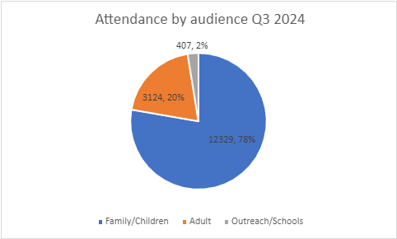

Selection of Feedback comments July - September 2024
July
• Neurodivergent Summer Camps (dlr LexIcon, 15-17 July, 6-8 August)
- “We are looking forward to it and thank you so much for going above and beyond for our kids!” Parent via email
- “I wanted to pass on my huge thanks. It is the perfect event for her. She is very creative and needs lots of movement breaks so this camp has been amazing and ideal for her. She has really enjoyed it, it has been so well run.” Parent via email
• Humans of Dublin and Dún Laoghaire Exhibition (dlr LexIcon, 5 June – 25 July)
- “This has undoubtedly been the best installation I have had the honour to experience. The powerful photos with a unique story for each are truly gripping. I wish you could do more for people to see. These are truly incredible. Thank you so much for bringing joy to my day and my experience in Ireland.” Visitor, visitors book

August
• Dundrum Library Junior Library
- “We visited Dundrum Library today and enjoyed all of the sensory equipment they have in the junior library section.” Visitor via Social Media
- “What an amazing initiative. The staff in Dundrum library are just amazing. We love coming here, our little teddy had the best time. Thank you so much, special memories made.” Parent via Social Media

September
• My Open Library
- “The Open Library initiative is wonderful. So far we have joined Dalkey and plan to join Deansgrange too.” Borrower via Social Media
• Neurodivergent Studio Saturday (dlr LexIcon, 5 Oct)
- “Just wanted to send you an email to say thank you so much for hiring us for Studio Saturdays on September 7th. We had such a lovely time with the children and families and you guys provided such wonderful support.” Facilitator via email

Creative Ireland Programme –

Creative Communities
Delivered through the Creative Ireland dlr Culture Team and in line with dlr’s Creativity and Culture Strategy a number of high-quality initiatives were funded across the county. These included:
- Puppets in July, hosted by dlr LexIcon, supported an engagement with puppetry for families, with a rich programme of events taking place over three weekends, including Irish and international puppeteers. Attendance figures across the three weeks was 2,150.
- Lios an Uisce a new performance project by Laura Sarah Dowdall took place in Blackrock Park over July and August. Devised and led by the Heritage Officer, it included 3 community dance workshops and a live performance response by Laura Sarah Dowdall and cellist Yseult Cooper Stockdale, with over 150 people in attendance on the day.
- Led by the Local Economic Development team as part of the Summer Heritage programme weekly tours of the An Seo street art project took place in July and August.
- A number of projects funded through the Arts Office’s Creative Ireland bursary awards took place during the period. Musicians Eamon Sweeney and Malachy Robinson, with singer Lisa McGuinness delivered the Lullaby project for families with young children in Ballyogan Community Centre. The highly acclaimed Festival in a Van toured to three residential care settings in dlr, these were Beechfield Manor Nursing Home, Shankill, Glebe House Nursing Home, Kilternan and Leopardstown Park Hospital. Blue Drum is working in collaboration with the residents and communities of Inagh and Ennel Court in Loughlinstown to engage in rich discussion around public spaces, with the aim to develop prototypes that respond to the particular context of these courts. A public event took place on the 26 September with and for the communities and a wider public. A further three projects were funded through this initiative.
- A new innovative Braille Sceal Trail was installed at Cabinteely Library. This story walk displays the story “Be Wild, Little One” by Irish author Olivia Hope in its original full colour format along with accompanying braille translation. The walk aims to provide access to good-quality children’s Irish literature in an outdoor setting whilst encouraging positive social inclusion and increasing library service accessibility.
- Southside Traveller Action Group archival project, Deirdre Nuttall from Adverbage was contracted through an open call process to deliver an archival project in collaboration with STAG. The aim is to assemble, catalogue and safeguard archival material representing the 40 year history of the group.

Additional Funding secured:
dlr has received additional Creative Ireland funding to expand on current projects. This includes: an expansion of the current dlr Scéal Trail Programme in the West of the County to include a Story Walk in Bracken Road Parklet, Sandyford and Dundrum Library Garden; an expansion of dlr Arts Offices Féile na Púca, Ballyogan, which is a local youth engagement project led by their Youth Engagement Officer; and 2024 funding for the Arts Office’s Cruinniú na nÓg commission which will begin in the autumn working with children in two local family support services, ‘My Project’ and ‘Springboard’ - an open call selection process is due to take place in early October. This brings dlr’s total Creative Ireland Creative Communities funding to €188,919 core funding (including €11,500 additional) and €93,475 Cruinniú na nÓg funding (including €18,475 additional).

Creative Health and Wellbeing:
Currently there are two Creative Health and Wellbeing projects underway. Music in the Moment is a live music performance programme which has been taking place since June in 5 residential care settings across the county and brings high quality music to older people. These highly responsive music experiences have had a positive impact on the lives of older people, including those living with dementia. In total 30 performances will take place, engaging with 428 older people by October 2024. Let’s Get Social dlr is a large-scale Health and Wellbeing initiative that will take place from 2024 – 2025, it builds on previous initiatives that have taken place in dlr and the partnerships that have been developed. Due to be launched in October with projects taking place in IPA settings with mothers and children, with older age communities, with Social Prescribing participants, older people in care settings and with more general audiences through the Creative Brainwaves talk series, this is an exciting and rich programme which seeks to combat social isolation and enhance wellbeing for marginalised communities. A capacity building programme facilitated by the Arts Office has already begun for 10 shortlisted artists.

Adult Literacy for Life Strategy
A literacy corner has been created near the entrance of the Lexicon with relaxed seating and resources for reading and writing available in a relaxed and welcoming setting.

Outreach programme – Ballyogan
Outreach in the community is continuing.
In June we attended Loughlinstown DDLEBT to promote Ballyogan library.
During the month of July, we organised 2 family outreach events in the Samuel Beckett Community Centre. As part of The Ballyogan Family Day dlr libraries staffed an information stand and engaged with the local community.
In August we presented an overview of dlr libraries resources to stakeholders from the Samuel Beckett Community Centre, Barnardo's, dlr Addiction Services and the dlr Community Department along with a VR session for the attendees.
We are liaising with local schools in the community.

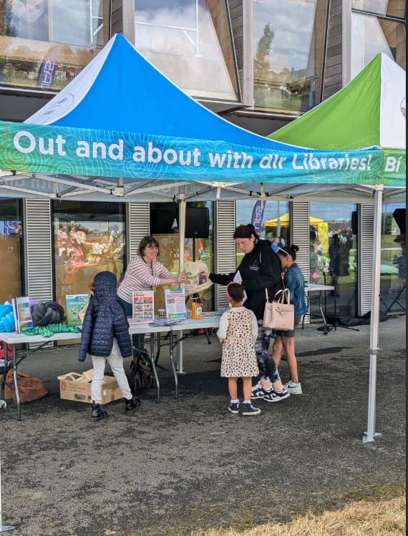

Capital Projects

Ballyogan Library at the Samuel Beckett Civic Campus
Work continues on the fit out of Ballyogan Library, by the builder. The main fitout is very near completion and snagging can commence in October. There is a delay with handover of the site however as the Building Management System still requires some work before being fully commissioned. The loose shelving has arrived and is being assembled, and essential IT infrastructure is now in place including a 1gig broadband line for the Library. The loose furniture has also now been ordered. The Library is still due to be opened in late 2024 once it has been fully furnished.

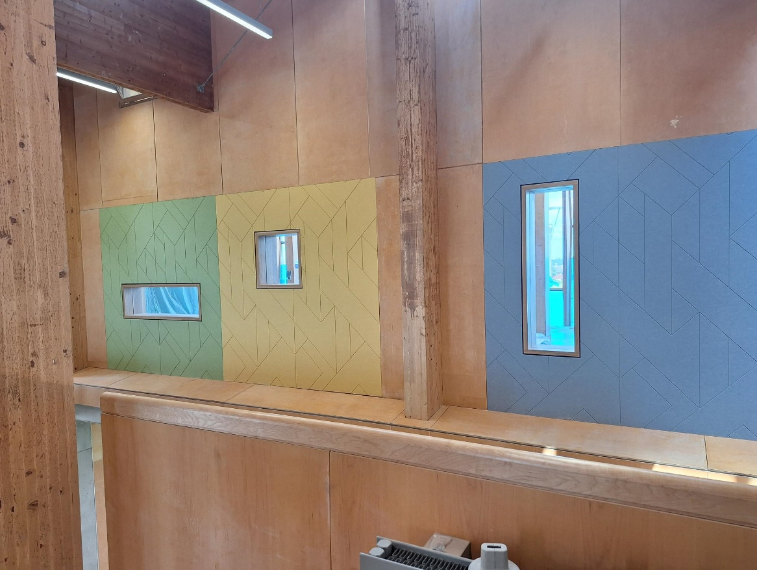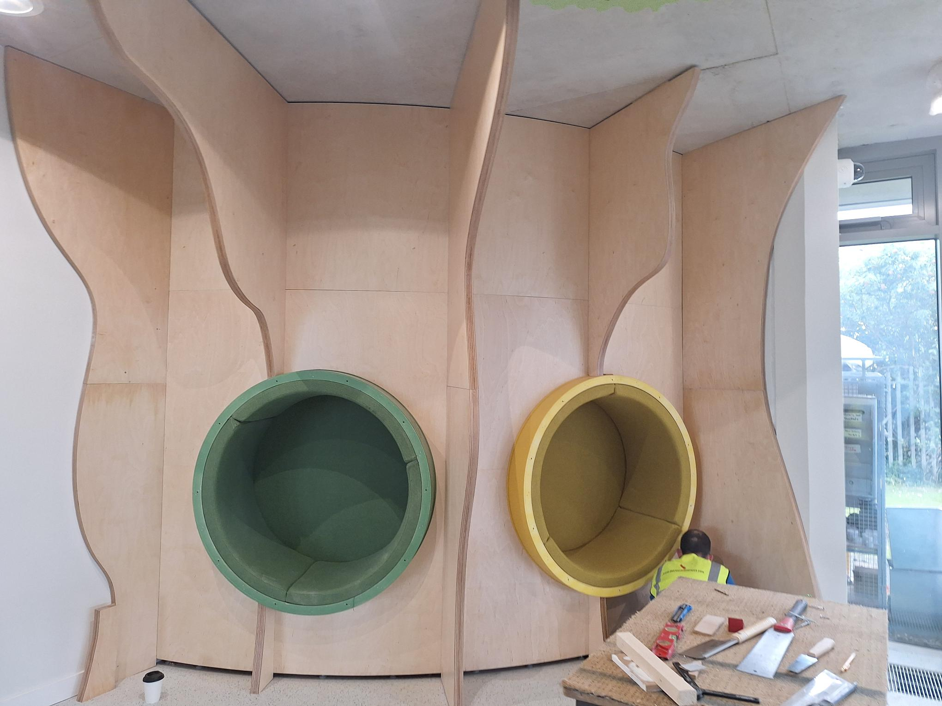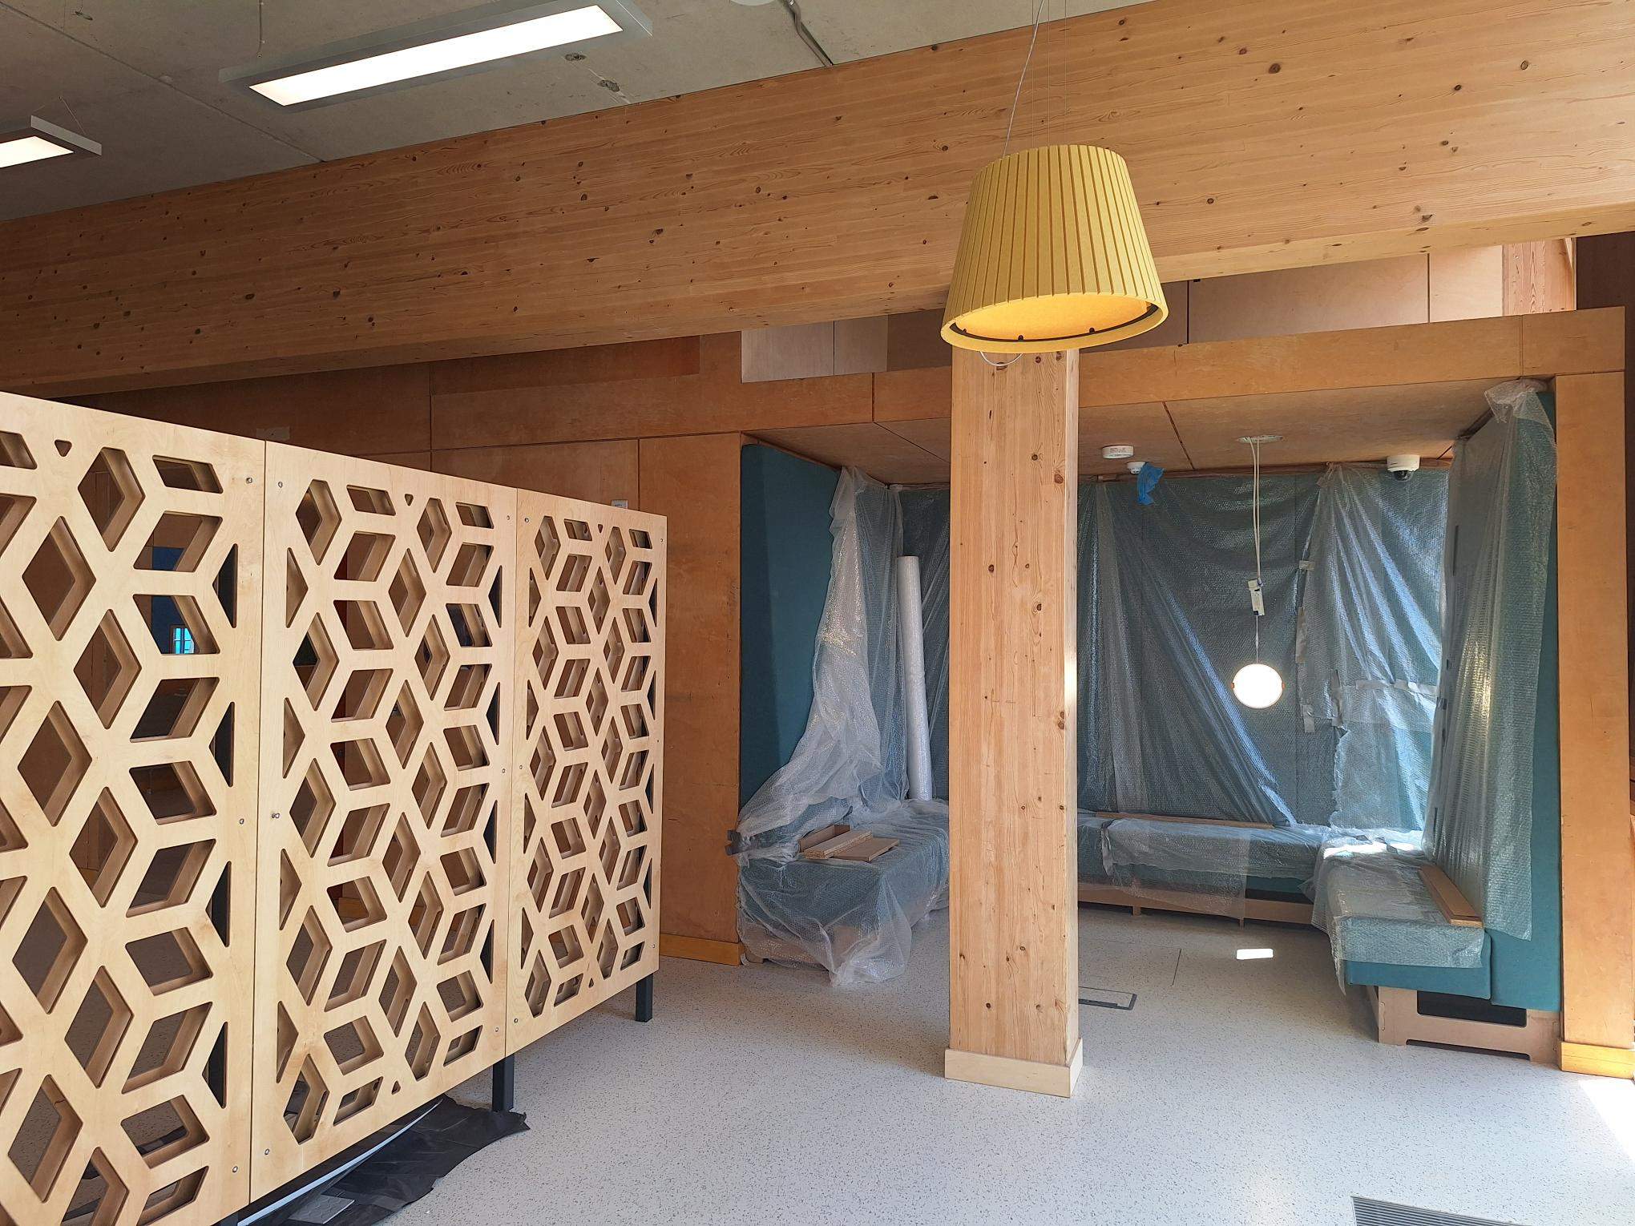

Stillorgan Library
There is good progress on the site of Stillorgan Library with lift core in place, cement floors poured and the prefabricated steel frame is in manufacture at the moment offsite. Meanwhile work on the layouts has begun in earnest. Study spaces, a messy play room, meeting rooms and sensory facilities are planned as well as all the other essential library services on offer. The My Open library service which will enable it to extend opening hours beyond the staffed hours, operating 8am to 10pm 365 days a year.

The project is still very much on track for the planned estimated 100 week build, aiming for completion at end of 2025 with the library opening early the following year. Meanwhile the temporary library upstairs in the Stillorgan Village shopping centre continues to serve & keep its local users supplied with books, newspapers, laptops, and other resources; with 49,000 visitors a year to the compact 75 square meter space, it works very hard to tide them over in the interim!

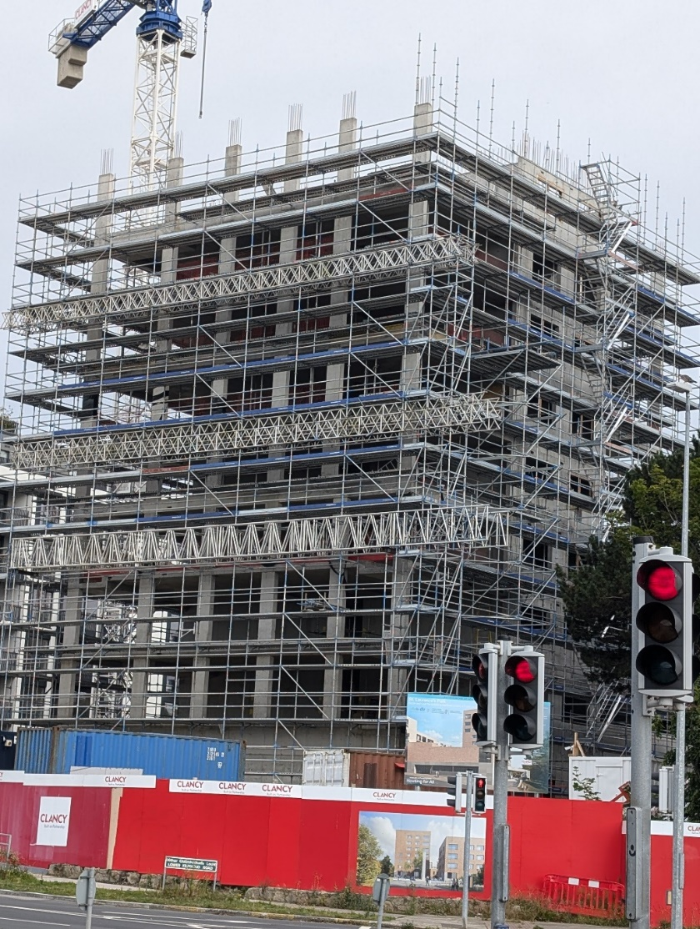
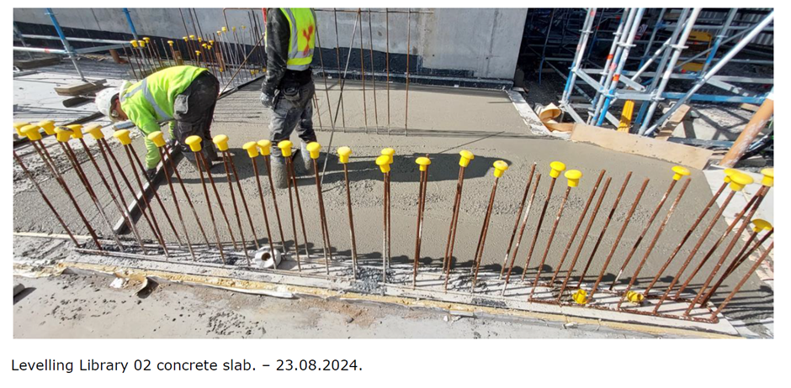
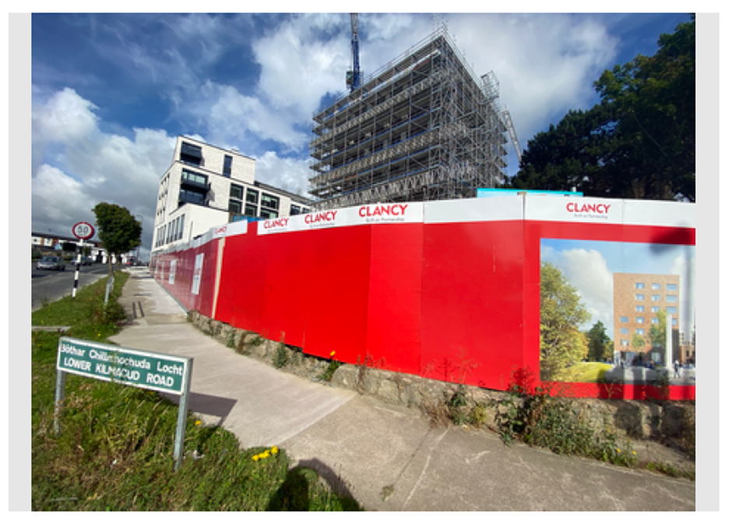

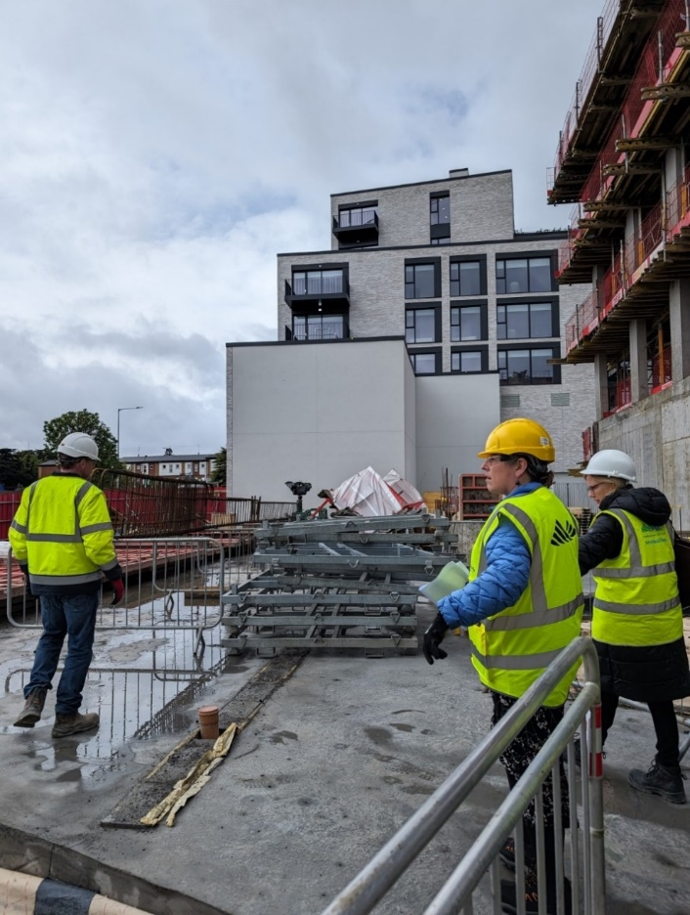

Above: Stillorgan Library redevelopment

Markets

Source | Date applied | Dún Laoghaire | Marlay Sat | Marlay Sun | Category
Email | 23-Jun |  | 1 |  | Craft
Email | 24-Jun | 1 |  |  | Hot Food
Email | 25-Jun | 1 |  |  | Artist
CRM 328255 | 27-Jun | 1 | 1 |  | Craft
Email | 01-Jul | 1 | 1 |  | Craft
Email | 15-Jul | 1 |  |  | Hot Food
Email | 24-Jul | 1 |  |  | Hot food
In Person | 01-Aug | 1 |  |  | Artist
Post | 02-Aug |  | 1 | 1 | Other food
CRM 333350 | 07-Aug | 1 |  |  | Craft
Email | 01-Aug | 1 |  |  | Craft
Email | 01-Aug | 1 |  | 1 | Craft
email | 13-Aug | 1 | 1 |  | Craft
Email | 15-Aug |  | 1 | 1 | Producer
email | 21-Aug |  | 1 | 1 | Other food
CRM 334169 | 22-Aug | 1 | 1 | 1 | Hot Food
CRM 335066 | 26-Aug | 1 |  | 1 | Hot Food
CRM 335570 | 01-Sep | 1 | 1 | 1 | Hot Food
CRM 336161 | 03-Sep |  |  | 1 | Craft
Email | 10-Sep | 1 | 1 | 1 | Other
CRM 337615 | 16-Sep | 1 |  |  | Craft
CRM 337757 | 18-Sep |  |  | 1 | Other Food
CRM 337740 | 18-Sep | 1 |  |  | Other Food
Email | 20-Sep | 1 |  |  | Hot Food
Email | 22-Sep | 1 |  |  | Hot Food

Benches/Trees
Source | Date Applied | Tree | Bench | Location
CRM 327918 | 24-Jun |  | 1 | Clonmore Park
Email | 02-Jul |  | 1 | Ballaly Park
Email | 03-Jul |  | 1 | Kiliney beach
Email | 04-Jul |  | 1 | Seapoint
CRM 322911 | 17-Jul |  | 1 | Seapoint
Email | 25-Jul |  | 1 | Pier
Email | 06-Aug |  | 1 | Marlay
Email | 09-Aug | 1 |  | Killiney
Email | 19-Aug |  | 1 | Deer Park
Email | 23-Aug |  | 1 | Blackrock
Email | 24-Aug |  | 1 | Mountown Road Lower
CRM 335244 | 27-Aug |  | 1 | Marlay
CRM 337590 | 16-Sep | 1 |  | Kiliney
Email | 23-Sep |  | 1 | Shanganagh
Email | 24-Sep |  | 1 | Cluny Park

Allotments
Castle:
- Plot 6 and 63 have been reallocated to new plot holders.
- Plot 81 will have raised beds installed week of 29th July 2024.
- New posts have been ordered.
- Old posts have been replaced at Castle Allotments.
- Site inspection carried out 28/08/2024 by admin staff.
- The raised beds are ready to be allocated. Current plot holders will be contacted to see if they are interested in downsizing.
- One plot holder has returned their plot. This will be reallocated

Mount Anville:
- 19 New plots have had soil turned; will be ready soon for allocation to people on waiting list.
- New plots turned
- Telephone calls and emails sent to people on Mount Anville Waiting list offering available plots.
- The lock has been changed on the gate at Mount Anville allotments, and plot holders have been given new keys.
- People on waiting list are being contacted to see if they are interested in plot.

Filming in the Park
We received the below request for filming in DLR Parks in July, August and September 2024:
CRM Source or Email | Location | Date Request Received | Date of Filming | Permit Granted (Y/N) | Reason (if refused)
329958 | St. Helen’s Wood | 02/07/2024 | 09/08/2024 |  | Ongoing application
Email | Sandycove | 01/07/2024 | 04/07/2024 | N | Applicant decided to not proceed
330268 | Cabinteely Park | 05/07/2024 | 20/07/2024 & 21/07/2024 | N | Applicant decided to not proceed
Email | Ballawley Park | 19/07/2024 |  |  | Ongoing application; awaiting documents and date.
333512 | Cabinteely Park | 07/08/2024 | 29/08/2024 | Y
Email | Marlay Park Courtyard and Orangery | 17/07/2024 | 26/08/2024 | Y
334909 | Killiney Hill | 21/08/2024 | 27/08/2024 | N | Company didn’t go through with filming due to weather
Email | People’s Park | 15/08/2024 | 20/09/2024 | Y
Email | Shanganagh Park | 16/09/2024 | 26/09/2024 – 27/09/2024 | Y
Email | Deansgrange and Killabbey Cemeteries | 24/09/2024 | 08/10/2024 – 09/10/2024 | Y

Parks Operations:
- Ongoing Countywide Landscape Maintenance works including Meadow & Pollinator site Autumn harvest cuts and commencement of Hedgerow maintenance
- Works underway on the redevelopment of Deerpark, The Gallops and Belarmine Playgrounds
- Works commenced on upgrading steps at St Patrick's Park, Kilgobbin Rd
- Repair works under way on Marlay walled garden fountains
- Works completed on new path upgrade works at Shanganagh Cliffs
- New 3G Carpet installed at Hyde Road Pitch (previously Mugga)
- New entrance upgrade works underway at O’Rourke Park Open Space
- On going watering of newly planted trees
- Numerous Wayleaves and Road Opening Licences processed
- 2025-2029 Landscape Maintenance Tender was completed and is currently out to tender
- Works on the restoration of the railings at Stillorgan Wood has commenced

Biodiversity
- Biodiversity Events – Churches Rewilding talk, Mayflies talk online collaboration with all biodiversity officers, Loughlinstown Woods Bat walk and talk, water species biodiversity event in collaboration with LAWPRO Carysfort, Biodiversity talk at Fernhill with our Acting Sports Inclusion Disability Officer, Kilcross community biodiversity talk
- DLR Biodiversity Officer also attended the Climate Action week launch event
- Dalkey Quarry wetland creation project – engineer, specialist design development stage with our parks staff and engagement with residents and locals planned for Oct
- Local seed project with Uisce Eireann for the reinstatement of the Shanganagh site with seed harvested from the Shanganagh meadows. Similarly, a project proposed with the LDA project at Shanganagh Castle. All of these projects are assisted by our parks staff.
- Killiney Hill Woodland Management Plan ongoing
- Fitzsimons Woods pNHA Management Plan ongoing
- Loughlinstown Woods pNHA actions of Management Plan commence with Bat surveys and invasive species actions.
- Meeting with NPWS re- Marlay meadows and EU habitat status achieved in these meadows
- Dalkey Island Tern Project completed for this year. Terns nested and young successfully fledged this year. DLR funded increased ecologists and our parks staff presence on island to engage with the public, visitors and other users. New dedicated bird surveys in July/Aug provide new data and show the value of the island also for migrating and roosting terns - post tern nesting. Flora monitoring this summer and surveys show recovery to habitats as a result of rabbit management. Wintering bird surveys planned for Dalkey Island over this winter given its known use by Brent geese and Curlew. Continued rat and rabbit management ongoing.
- Review of the Dalkey Island Conservation Management Plan ongoing
- Development of Biodiversity Net Gain guidance ongoing and Green Factor opportunities for its implementation
- Review of Cherrywood Biodiversity Plan
- Management and monitoring of Tully Park orchid translocation area with assistance from our parks staff
- Development of the DLR Goat grazing project with the OIGS ongoing. DLR goat herder and support herder training to commence Oct/Nov in Howth
- Development of Management approach to key wintering birds sites within Dublin region with FCC and DCC
- DLR Countywide Wetland, Rivers and Streams Restoration Plan tender awarded
- CMH ecology meetings re Badger management plan
- Meetings with An Taisce regarding their query re the possibility of purchase of Booterstown Marsh by DLR and also on our collaborations re Booterstown Marsh and continued invasives treatment, further conservation initiatives including bat and bird surveys.
- Coastwatch meeting regarding the management of invasive Sargassum along dlr coastline and collaboration with dlr
- Dublin Bay Biosphere meeting
- Ongoing liaison and advice to internal dlr sections

Heritage
- Summer of Heritage 2024 programme, 26 weekly free heritage tours/walks, all month, including events for Coastival and a genealogy advice day, new for 2024 – Historic Killiney, Hotels of Dún Laoghaire, All Saint’s Church
- Support for organisers of National Heritage Week events – 56 events https://www.heritageweek.ie/event-listings?q=&where%5B%5D=dublin-dunlaoghaire-rathdown#listings
- Meetings with conservators in relation to enhancing visitor access at the Oratory
- Heritage Council funded projects underway
    - Research project on Killiney Obelisk base
    - Made in Blackrock, audio trail/podcast on garment industry
    - A Long Shadow – presentations on the experience of WW1 soldiers in dlr
- Creative Ireland funded project
    - Lios an Uisce:Water’s Edge; dance/heritage project in Blackrock park: three public movement workshops, filmed performance and public performance, update/reprint of Martello Towers of Dublin book
- Community Monument Fund projects underway
    - Cill Iníon Léinín graveyard wall repair – complete and reopened
    - Shankill Castle Conservation Plan
    - Puck’s Castle restoration works
- Heritage Council funded projects underway
    - Gathering the archive of 40 years of the Southside Travellers Action Group (in collaboration with dlr Community/Creative Ireland/Heritage Council)
    - Dublin Mountains Community Archaeology programme Year 4 in collaboration with Dublin Mountains Partnership and SDCC
- Slang Greenway Heritage Cycle for Dublin Climate Action Week
- Support for The women of Cuala and Dun Emer/Irish Guild of Embroiderers exhibition - Dundrum library and dlr Lexicon in collaboration with dlr Libraries and the Yeats Sisters Commemoration Project
- Opening of dlr Heritage Grant scheme 2024 – deadline October 25th
- Budget meetings
- Carrickbrennan cemetery wall repair underway
- Copies of Sléibhte Séadchomhartha Bhaile Átha Cliath to An Siopa Leabhair for distribution
- Biodiversity and heritage resources to Monkstown Tidy District for Harvest Festival
- Dalkey Castle and Heritage Centre Strategy development
- Carrickmines Castle site ecology surveys
- Tender documents preparation - restoration of haha at Marlay Park
- Naming and numbering planning compliance reports
- Ongoing liaison and advice to internal dlr sections, citizens, and community groups
- Ongoing maintenance of dlr heritage properties
- Dublin Bay UNESCO Biosphere meeting

