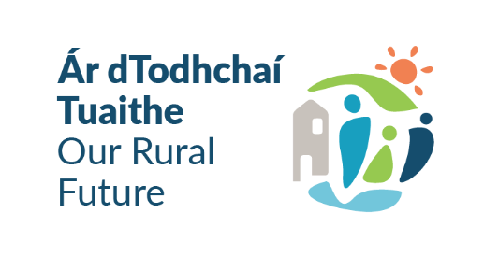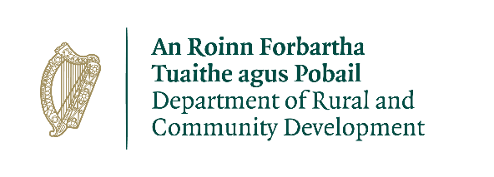

**Community Recognition Fund 2024 – Dún Laoghaire-Rathdown**

**Information and Guidelines**

The Community Recognition Fund was introduced in 2023 by the Department of Community & Rural Development (DRCD) to recognise the huge efforts made by communities in welcoming and supporting people coming to Ireland.

Through the 2023 Scheme, funding of €50 million was approved for some 900 projects in cities, towns and villages nationwide and see information on successful applicants here: <https://www.gov.ie/en/collection/3a749-community-recognition-fund-2023-list-of-successful-applicants/>

Based on the continued impacts on communities throughout the country and the need to support these communities in welcoming new arrivals where large numbers of citizens from other countries are currently living, a further €50 million is being provided under the Community Recognition Fund 2024.

**Dún Laoghaire-Rathdown (dlr) County Council has been allocated €765,487 by the DRCD to deliver projects over 2025 and 2026, with funding being allocated across 2 application windows as outlined in the table below:**

|  |  |  |
| --- | --- | --- |
| **Application** | **DRCD Approval Timeline** | **dlr County Council**  **Call Timeframe** |
| Application Window 1 | CLOSED | dlr County Council  did not seek  applications |
| Application Window 2 | 1st August to 30th September 2024 | **dlr County Council**  **sought applications from**  **16th August – 16th September ‘24** |
| Application Window 3 | 1st January 2025 to 31st January 2025 | **OPEN NOW**  **dlr County Council**  **seeking applications from**  **25th Nov 2024 – 22nd January 2025** |

**Funding:**

Funding is targeted to invest in the communities, villages and towns in Dún Laoghaire-Rathdown where the highest level of new arrivals are located including Beneficiaries of Temporary Protection or International Protection Applicants and where a clear need for investment is identified.

Projects will not be deemed eligible for funding in areas that do not have high levels of new arrivals, and the **areas identified in dlr to be prioritised for funding include:**

* **Ballyogan**
* **Blackrock**
* **Dundrum**
* **Sandyford**

Projects to be funded will be capital in nature and shall deliver medium to long term benefits for the communities in which they are located.

The delivery of the project must be completed over the course of 2025 and 2026. A minimum spend of 50% of the allocation must be incurred by October 2025 and eligible projects will receive funding for capital costs. Projects relating to ongoing operational/running costs are not eligible for funding.

**The minimum level of funding for an individual project is €50,000 with a maximum of €500,000 applying to any single project.** Smaller projects cannot be artificially combined to meet the minimum threshold of €50,000. The 2023 Community Recognition Fund provided funding for small scale investment in communities, **however the focus of the 2024 Scheme is on capital projects of greater scale and impact.**

Local authorities have scope to invest the funding based on local needs, as identified through a “bottom-up” approach based on community engagement.

Local Authorities must ensure that where rate of aid of less than 100% is sought, the project must be achievable and completed in the timelines given.

**The type of projects eligible for funding under the Community Recognition Fund 2024 are:**

* development, enhancement or refurbishment of community or cultural facilities including play areas, walkways, parks, community/sensory gardens, allotments, and recreational areas;
* development, enhancement or refurbishment of local club and sports facilities including facilities such as community swimming pools, changing rooms, toilets, digital aids such as score / information boards etc.;
* enhancement to school/parish facilities which are open to use by all of the community after school hours;
* purchase of equipment for local clubs, festivals, community events and organisations e.g. music, arts or sports equipment;
* transport infrastructure such as the purchase of community vehicles, bus shelters and attendant information boards; (any vehicle funded must be in good condition and not more than 5 years old)
* projects that help address dereliction and/or wider local economic and community development objectives;
* purchase and refurbishment of vacant or derelict buildings for community use where a clear need is identified.
* purchase of land and associated works for the development of community facilities such as play areas/ Multi Use Games Areas (MUGAs) or town parks/ community gardens, recreational areas etc. (Purchases must only be administered by the local authority).

The Department of Rural and Community Development has published the full details of the scheme at <https://www.gov.ie/en/service/e626a-community-recognition-fund-2023>

**See** [Community Recognition Fund 2024 Scheme Outline HERE](https://www.kerrycoco.ie/wp-content/uploads/2024/05/Community-Recognition-Fund-2024-Scheme-Outline.pdf)

**Amounts approved to applicants will be subject to the total number of applications approved and the overall budget made available to Dún Laoghaire-Rathdown County Council, which is: €765,487.**

This funding scheme will provide large capital grants ranging from **€50,000 to a maximum of €500,000** with a requirement that projects are fully complete by **October 2026**.

**Applications in excess of €200,000 will require a completed business case (see Appendix B in the Proposal Form)**

# **Guidelines:**

* Under this scheme, grants will be provided towards large scale capital costs.
* Capital costs incurred for the purchase of equipment are eligible.
* Repairs and refurbishment of existing facilities can also be funded.
* The scheme does not provide funding for operating costs (e.g. the employment of staff, electricity costs, heating costs, etc.) or administrative costs.
* Only expenditure incurred after the date of grant approval will be eligible.
* The grant may cover all, or part of, the purchase or works in question. However, the full cost of the project must be provided on the Application Form.
* This funding cannot be used to fund or co-fund any scheme operated by the Department of Rural and Community Development or any other Government Department or as a co-funding source for any project funded under CRF 2023.
* **Projects situated in the 4 areas, namely Ballyogan, Blackrock, Dundrum & Sandyford will be prioritised** for funding.
* All projects submitted for funding must be made available and for the benefit of all the community.
* The information supplied by the applicant must be accurate and complete. Incomplete applications will not be considered for funding.
* Misinformation may lead to disqualification and/or the repayment of any grant made.
* All information provided in respect of the application for a grant will be held electronically. The Department of Rural & Community Development (DRCD) reserves the right to publish a list of all grants awarded on its website.
* The Freedom of Information Act applies to all records held by DRCD & dlr County Council.
* The application must be signed by the Chairperson or CEO/MD of the organisation / group / school.
* It is the responsibility of each organisation to ensure that it has proper procedures and policies in place (evidence of minimum 3 quotes sought) as well as including appropriate insurance where relevant.
* Successful applicants will be required to provide evidence that they have engaged the services of a Procurement Consultant or have within their committee an individual with professional procurement experience in advance of formal letter of offer issuing.
* Evidence of project costings, quotations / Estimates as well as Procurement Plan / Procurement Consultant details are required for this application
* Expenditure, receipts / invoices must be retained and provided to the dlr Local Authority Integration Team (dlr LAIT) who are managing this fund, when requested to drawdown funds.
* If applications are successful, further documentary evidence of below will be required:
  + Tax Registration Number / Tax Clearance Access Number / Charitable Status Number
  + Documentary Evidence of Title / Lease for Premises / Consents / Property & continued access to site / property for capital allocations etc.
  + Title for Schools where the Minister of Education owns the land.
  + Proof of Planning Application, Permission or Exemption from Planning
  + Other evidence as required
* Publicity guidelines must be adhered on all materials associated with the purposes of the grant in accordance with requirements and appropriate signage must be erected at the location and a template will be provided.
* Generally, no third party or intermediary applications will be considered.
* Breaches of the terms and conditions of the grants scheme may result in sanctions including disbarment from future grant applications.
* By completing this Application Form, you consent to the data on the form, as required, being transferred to the Department of Rural and Community Development to enable a decision to be made on your application.
* Successful applicants may be subject to audit by the Department of Rural and Community Development.
* Documentation relating to the purchase of equipment or the completion of works should therefore be maintained for inspection for a period of 7 years.

**Closing Dates & Queries:**

* Applications in any form (hardcopy or e-mail) should arrive not later than **13:00 / 1:00p.m Wednesday 22nd January 2025 via email to** [**integration@dlrcoco.ie**](mailto:integration@dlrcoco.ie) **/ or by post to:**

**Community Recognition Fund 2024,**

**dlr Local Authority Integration Team,**

**Community & Cultural Development Department, Dún Laoghaire-Rathdown County Council, County Hall, Dún Laoghaire, Co. Dublin, A96 K6C9.**

* **Late applications will not be considered.**
* **Further information & queries to:** [**integration@dlrcoco.ie**](mailto:integration@dlrcoco.ie) **/ 01 205 4893**